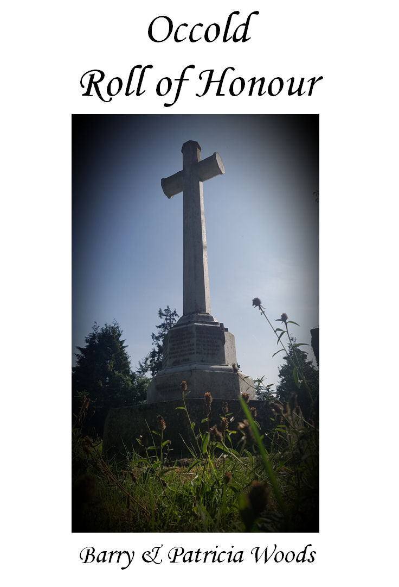
Acknowledgements

Publisher: Occold Parish Council
Authors: Barry and Patricia Woods
Editor: Sue Hubner
Project liaison: Caroline Emeny (Parish Clerk)
Additional material: Alan Moore
Front cover: Jillian Woods Setchell

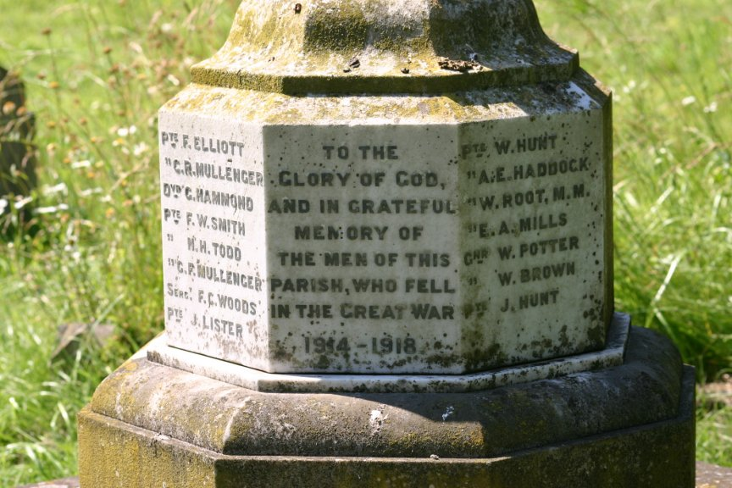
Foreword

The First World War, or Great War, was contemporaneously described as “a war to end all wars”, ceased one hundred years ago.

At the beginning of the last century more modern elements of warfare appeared such as tanks, aircraft, heavier artillery, submarines and the horrors of trench warfare. All were designed with one motive, to kill the enemy’s military force quickly, efficiently and in greater numbers.

This book looks at losses in France and Flanders, of which the British Army suffered 564,715 deaths which included 32,098 through their injuries or disease.

Barry and Patricia have taken 15 of these losses, ordinary working men from the village of Occold. They have given us more background, depth and personalisation other than names on a memorial, bringing their memories to life again.

Being a researcher myself, although in a different war and service, I can appreciate the hard work, diligence, professionalism and time that has been taken in the collation of these records.

Although we have computers to research with, it must be borne in mind that they can only supply information that is known. During “the Blitz” on London during the Second World War, the Army Records Office received a direct hit and over 60% of these records were destroyed.

I would like to congratulate Barry and Patricia on compiling this collation not only for ourselves but future generations and others who seek this information.

“In reading lies knowledge
In knowledge lies wisdom”

Colin Cripps
Chairman
Occold Parish Council
August 2018
In Memoriam
We live in a highly competitive and commercial world, in which signs and symbols are extremely prevalent; jostling with one another to grab our attention and direct our thoughts in one direction or another; almost whatever we do or wherever we look there seem to be signs and symbols, but among this plethora there are two that stand out above all others. There must be very few people indeed who do not instantly recognize the ancient symbol of the cross of Christ and I would suggest that the poppy has become one of the most recognized and powerful symbols of modern times.
The poppy tends to be a short-lived flower, and the type of poppy that has become synonymous with remembrance has red petals of incredible fragility. It grows wild in many areas, but poppy seeds may lie dormant for many years, until a sudden disturbance of the ground prompts them to grow and flower, often with glorious profusion. This is what happened to some of the battlefields of the First World War. The fields on which thousands upon thousands died in battle came to bloom with thousands upon thousands of poppies, which –almost eerily- suggested themselves as symbolic of all the blood that had been shed on those same fields, and of all the lives that had been lost in that terrible conflict.
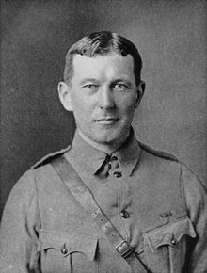
And yet, it was not just the flowers themselves that were the immediate catalyst of adopting that particular flower as the symbol of remembrance of all who have died as a result of war; the poppies inspired a poem, written by Officer John McCrae, who in Belgium in 1915 knelt at the grave of his friend and was moved to write his famous poem In Flanders’ fields the poppies blow. John McCrae (below right) didn’t think very much of his own poem and he screwed up the piece of paper on which he had written it and threw it away, but it was picked up by another officer, who recognized its worth and eventually the poem was published in Punch Magazine and the poppy was adopted by an influential French Lady living in America, so one way and another the poppy became the great symbol of remembrance.
In Flanders fields the poppies blow
Between the crosses, row on row,
That mark our place; and in the sky
The larks, still bravely singing, fly
Scarce heard amid the guns below.
We are the Dead. Short days ago
We lived, felt dawn, saw sunset glow,
Loved and were loved, and now we lie
In Flanders fields.
Take up our quarrel with the foe:
To you from failing hands we throw
The torch; be yours to hold it high.
If ye break faith with us who die
We shall not sleep, though poppies grow
In Flanders fields.
In 2014 the most amazing thing happened at the Tower of London, where –to mark the one-hundredth anniversary of the outbreak of the War, a sea of ceramic poppies was planted, beginning as just a few during the summer and added to day by day until the total number reached 888, 246, which is an estimate of the total number of military deaths from the United Kingdom alone during World War I, though even this horrendous figure pales besides the total of millions who lost their lives in that global conflict. This temporary work of art at the Tower was called Blood Swept Lands and Seas of Red and was the work of artist Paul Cummins and stage designer Tom Piper.
It captured the imaginations of many and around 4 million people went to see it, the humble poppy had done it again. That little flower stirs our emotions and expresses what we feel in ways that words often fail to do. It brings us together as one; it is iconic in the true sense of the word; the poppy remains a powerful reminder.
However, after a hundred years it is inevitable that our memory of the First World War has become an inherited one and it is my belief that this wonderful, moving book will help us to perpetuate the memory of the fallen as their names on our war memorial are now more than just names; they have become real people to those of us who did not know them. We will remember them and may they rest in peace.

The Rev’d Dr Guy Sumpter
Rector of Occold
Dedication
In grateful remembrance of the 15 men of Occold, who died in the service of their country in the Great War, 1914-1918.

They shall grow not old
As we that are left grow old
Age shall not weary them
Nor the years condemn
At the going down of the sun
And in the morning

WE WILL REMEMBER THEM

Pte William BROWN
Pte Frederick ELLIOTT
Pte Ernest Alfred HADDOCK
Pte George HAMMOND

Pte James HUNT
Pte Walter William HUNT
Pte James LISTER
Pte Ernest Arthur MILLS
Pte Charles Robert MULLENGER
Pte George Frederick MULLENGER
Pte William POTTER

Pte William ROOT, MM
Pte Frederick William SMITH
Pte Nicholas Herbert TODD
Sgt Frank Carter WOODS
Table of contents
Occold – The Village 10
Domesday Book 1086 10
Location 11
Map 11
Kelly’s Directory 1901 11
Photo gallery 14
Census demographics 15
GRO Registration Districts 15
Suffolk parishes 16
Pte Frederick ELLIOTT 18
Self 19
Wife: Anna Maria HUNT 19
Parents: William ELLIOTT and Laura EVERSON 19
Paternal grandparents: Alfred ELLIOTT and Frances WARREN 20
Maternal grandparents: Unknown FATHER and Elizabeth EVERSON 20
Descendant son - Frederick Ernest ELLIOTT 21
Descendant: Daughter - Mary ELLIOTT 21
Pte Ernest Alfred HADDOCK 23
Self 24
Relationship to other KIA 24
Parents: Alfred HADDOCK and Leah EVERSON 24
Paternal grandparents: Alfred HADDOCK and Rose HUNT 25
Maternal grandparents: Samuel EVERSON and Eliza WILDING 26
Descendants: 26
Pte George HAMMOND 29
Self 30
Parents: William HAMMOND and Julia CANHAM 32
Paternal Grandparents: Robert HAMMOND and Elizabeth WARD 32
Maternal Grandparents: George CANHAM and Sarah Ann EBBAGE 33
Field Will for George Hammond 33
Pte James HUNT 36
Self 37
Parents: Walter William HUNT and Eliza BARNES 42
Inter-relationships 43
Paternal grandparents: Lewis HUNT and Sophia LAST 44
Maternal grandparents: James BARNES and Sarah BAILEY 44
Pte Walter William HUNT 46
Self 47
Wife: Florence Rose HAMMOND 47
Parents: George HUNT and Mary CHAPMAN 47
Paternal grandparents: Unknown FATHER and Mary Ann HUNT 48
Maternal grandparents: William CHAPMAN and Sophia WARD 48
Pte James LISTER 50
Self 51
Parents: George LISTER and Caroline HUNT 51
Inter-relationships 51
LISTER family in 1911 52
Paternal Grandparents: William LISTER and Sarah KNIGHTS 53
Maternal Grandparents: Lewis HUNT and Sophia LAST 53
Brother: Reginald LISTER and Agnes E HARVEY 54
Brother: Arthur LISTER and Agnes HARVEY 55
Brother: Frederick LISTER and Annie KERRY 56
Pte Ernest Arthur MILLS 58
Self 59
Parents: William Samuel MILLS and Fanny CHAMBERS 59
Paternal grandparents: Charles MILLS and Elizabeth MARTIN 60
Maternal grandparents: George CHAMBERS and Maria CASON 60
Descendants 61
Pte Charles Robert MULLENGER 63
Pte George Frederick MULLENGER 64
Selves 65
Parents: Robert MULLENGER and Mary Ann POTTER 66
Paternal grandparents: Matthew MULLENGER and Lucy FULCHER 66
Maternal grandparents: Robert POTTER and Ruth WRIGHT 66
Pte William POTTER 68
Self 69
Parents: Arthur George POTTER and Mary Ann TUFFS 69
Paternal Grandparents: George POTTER and Emma GARRARD 70
Maternal Grandparents: James TUFFS 70
Pte William ROOT, MM 72
Self 73
Parents: John Walter ROOT and Maria Sophia ELVISH 74
Paternal Grandparents: Walter ROOT and Jane SALTER 75
Maternal Grandparents: Daniel ELVISH and Maria GANT 75
Annex A – Battalion War Diary 76
Annex B – London Gazette 19 Feb 1917 78
Pte Nicholas Herbert TODD 81
Tribute 82
The Sedbergh School Obituary 82
A Tribute from a Schoolmaster Colleague 83
Bronze Plaque in Ss Michael & All Angels 84
His Poetry 85
Conclusion 86
Self 87
Parents: Horatio Lovell TODD and Frances Catherine TODD 88
Paternal Grandparents: Horatio TODD and Rhoda Maria (Vigurs) BLUETT 89
Maternal Grandparents: John TODD and Frances HILL 89
Sgt Frank Carter WOODS 92
Self 93
Wife: Ida CUTTING 94
Parents: Alfred WOODS 94
Paternal grandparents: Isaac Tipple WOODS and Mary Maria BILHAM 94
Maternal grandparents: David CARTER and Drusilla LARTER 95
Descendant: Daughter: Frances Ida WOODS 95
Pte William BROWN 97
Pte Frederick William SMITH 98
Index of Surnames and Place Names 99

Occold – The Village
Domesday Book 1086

Formerly Acolt meaning ‘Oak-tree wood’
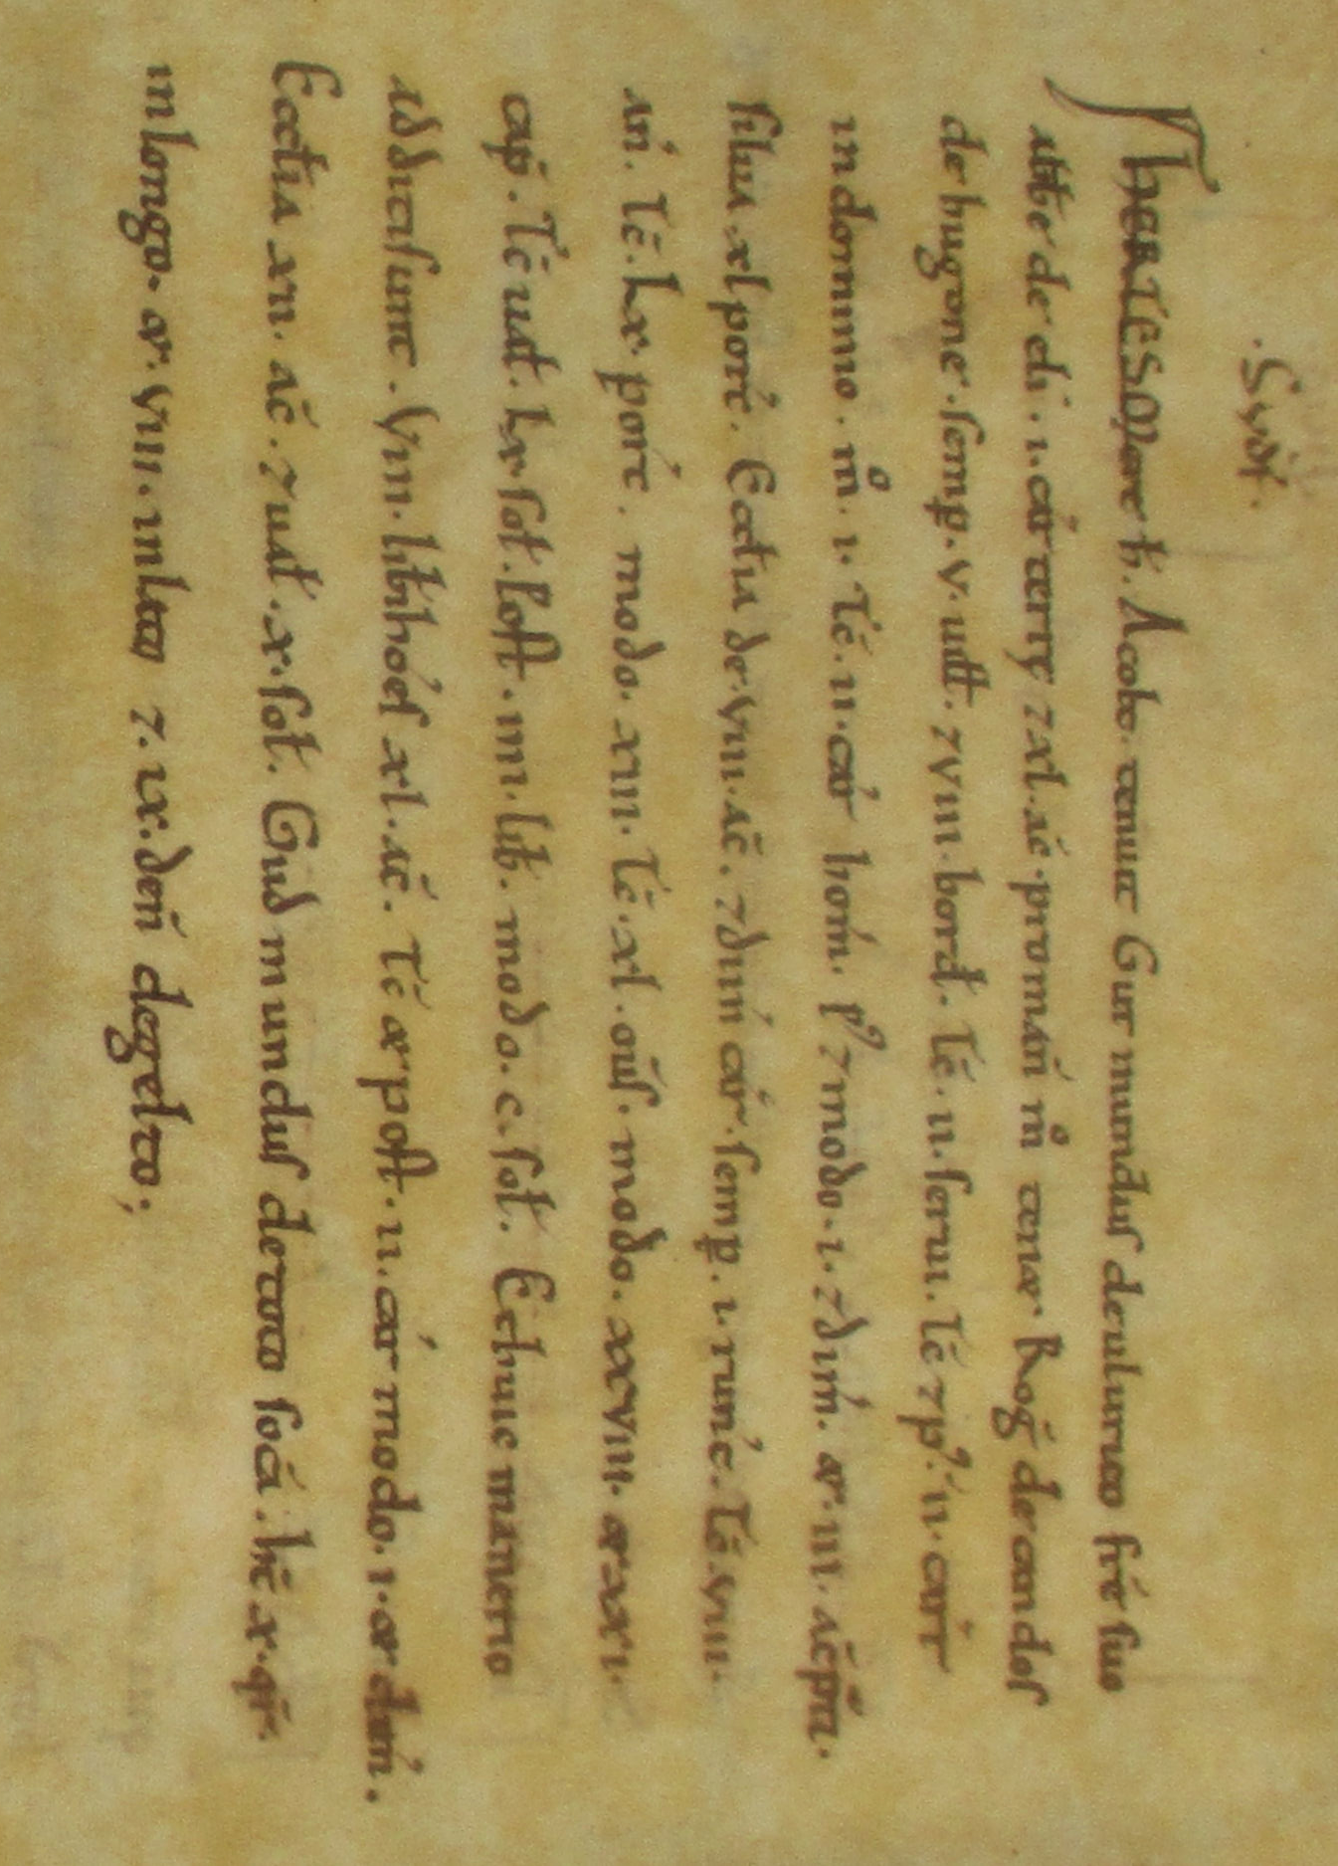
Hundred of Hartismere

Guthmund held Occold from his brother, Wulfric abbott of Ely, with one carucate of land and forty acres as a manor. Now Roger de Candos holds it from Hugh.

Then as now 5 villans and 8 bordars. Then 2 slaves. Then and afterwards two ploughs in the memesne, now one. The 2 ploughs belonging to the men, afterwards and now one and half; three acres of meadow. Woodland for 40 pigs.

A church with 8 acres and half a plough. Then as now one horse. Then 8 head of cattle. Then 60 pigs now 13. Then 40 sheep, now 28 and 21 goats. Then it was worth 60s afterwards £4, now 100s. And to this manor have been added 8 free men with 40 acres. Then and afterwards 2 ploughs, now 1 and a half.

A church with 12 acres, worth 10s. Guthmund had the soke over the whole. It is 10 furlongs long and 8 broad. 9d in geld.

Location
Occold is a small, rural village located in Suffolk.

Latitude: 52.1748 deg N, longitude 1.0980 deg E
Altitude: 180ft (55m) AMSL. (Above Mean Sea Level)
Postcode/GPS IP23 7PW
Ordnance Survey: TM 1554 7085 • X/Y co-ords: 615542, 270852
Map
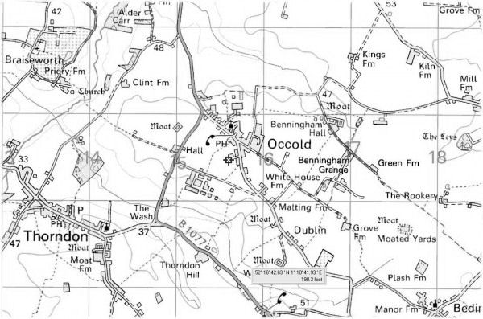
Kelly’s Directory 1901
Parish
Occold is a parish and village 2 miles south from Eye terminal station on a branch from Mellis of the Great Eastern Railway. In the North Eastern division of the county, Hartismere hundred, petty sessional division and union, county court district of Eye, rural deanery of North Hartismere, archdeaconry of Suffolk and diocese of Norwich.

Church
The church of St Michael, an edifice of flint with stone dressings, was originally a Norman building, repaired in 1854, re-seated and re-roofed, and consists of chancel, nave, south porch and western embattled square tower with pinnacles, clock and 5 bells. The tower was built in 1426, but has since undergone considerable alterations. The church was re-seated with open benches in 1877; there are 150 sittings. The registers date from the year 1681.

Buildings
The living is a rectory, net yearly value £270, with 46 acres of glebe and residence, built in 1846, in the gift of and held since 1908 by the Rev Herbert Edward Champion MARSHALL, M.A. of Christ's College, Cambridge.

Ed: Glebe - also known as Church furlong, Rectory Manor or Parson's Close(s), is an area of land within an ecclesiastical parish used to support a parish priest. A holder of a benefice could retain the glebe for his own use, usually for agricultural exploitation, or he could lease it to others and retain a rent as income.

The burial ground was enlarged by the addition of half an acre in 1902.

There is a Baptist chapel, erected in 1832, with sittings for 300 persons.

St Catherine's Hall was erected in 1909 in memory of Mrs Frances Catherine TODD, wife of the Rev Horatio Lovell TODD, M.A., rector 1868-1908.
Charities
Lee's charity arising from the rent of land, produces about £58 yearly; £13 annually is distributed in equal portions, every Friday, in bread to the poor; the remainder of the net income being given in clothing.

Denny's charity of £1, arising from the Occold Hall farm, is distributed in bread every Ash Wednesday.

Henman's charity produces about £50 yearly; part of the net income is distributed to the poor in coal at Christmas and part goes toward repairing the church.
Lords of the Manor
The rector is lord of the manor of part of Occold. The trustees of the late Rev Charles CHAPMAN, vicar of Church Coniston, Lancs, are lords of the manor of Occold Hall and Mrs BURROWS has the manorial rights of Benningham. The chief landowners are the trustees of the late Rev Charles CHAPMAN and the trustees of the late Douglas MILLER.
Land
The soil is good heavy land, subsoil clay. The chief crops, which are on the four course system, are wheat, good barley, clover, roots, peas and beans. The area is 1,508 acres, including the hamlet of Benningham Green. Rateable value is £1,593. The population in 1911 was 436.

Sexton John BAKER
Ed: A sexton is an officer of a church, congregation, or synagogue charged with the maintenance of its buildings and/or the surrounding graveyard. In smaller places of worship, this office is often combined with that of verger. In larger buildings, such as cathedrals, a team of sextons may be employed.

Post Office
Mrs Clara PATRICK, sub-postmistress. Letters through Eye arrive at 6:40am and dispatched at 9:30am and 6:55pm. Sundays 9:40am.Eye is the nearest money order and telegraph office, 2 miles distant. Wall letter box, near the Church, cleared at 9:45am and 7pm, Sundays at 9:30am.

School
Public Elementary School (mixed), Opened in 1879, for 126 children, average attendance 101. George BOSWORTH, master.

Private Residents
GOOCH, Edmund, Winfields
OLIVER, Mrs, The Cedars
MARSHALL, Rev Herbert Edward Champion (rector), Rectory

Commercial
BALLS, Frederick William, farmer, Benningham Green
BREESE, Frank, farmer, Benningham Hall and Poplar Farm
BREESE, William, farmer, Occold Hall and at Wood Farm, Rishangles and Southolt Park Farm, Southolt
BRUNDLE, Cornelius, carpenter
BRUNDLE, George, bricklayer
CAPON, Edwin Benjamin, maltster
Ed: Son of Edwin Benjamin CAPON, landlord of The Beaconsfield Arms, ~1881-1901
EVERSON, Ezekiel, news agent
EVERSON, John, shopkeeper
HAVERS, David, blacksmith
HINES, Thomas, farmer
LAST, Herbert Henry, grocer, draper, boot, shoe, china & glass, patent medicine dealer and farmer, Grove Farm
Ed: Postcard photographer of many notable scenes around Occold,
LAST, James, threshing machine owner, High House
LAST, William, farmer, threshing machine owner and landowner, Church Farm
Ed: Father of Eric William LAST who sold off the Threshing Tackles in 1947
MILLS, William Samuel, beer retailer.
Ed: Landlord of The Beaconsfield Arms and also father of Ernest Arthur MILLS, KIA, France & Flanders, 1917
MOORE, Thomas Spencer, farmer and landowner, Benningham Grange & Winfield's Farm
MOYSE, George, boot and shoe maker
PALLANT, Henry, farmer
PALMER, Francis & Son, wheelwrights
PATRICK, John, tailor
REYNOLDS, Ambrose, Bottles PH
Ed: Landlord of The Bottles Inn
SHULVER, James, blacksmith
WOODS, Alfred, farmer, White House Farm
Ed: Father of Frank Carter WOODS, KIA, France & Flanders, 1916
Reading Room & St Catherine's Hall, George BLAKE, Hon Sec

Photo gallery

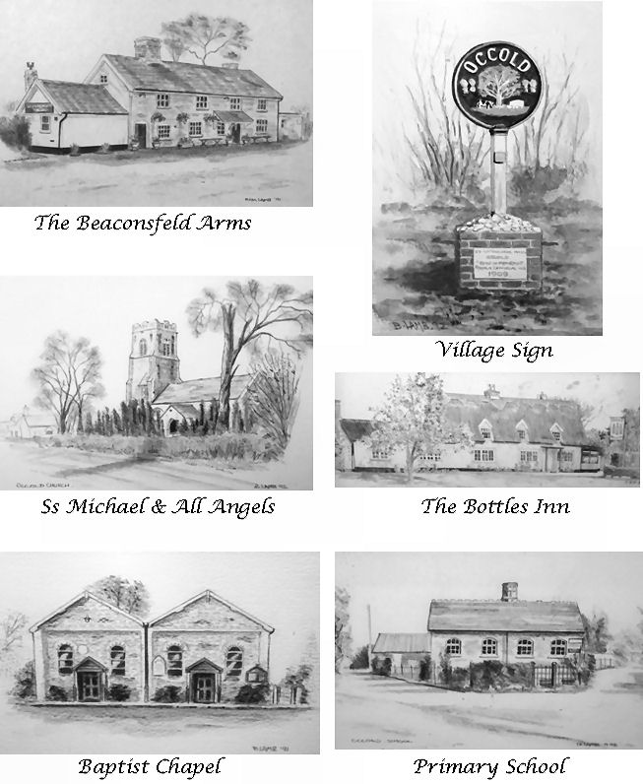

Census demographics
2001 census information summarised from the Office of National Statistics
Item | 1841 | 1851 | 1861 | 1871 | 1881 | 1891 | 1901 | 1911 | 2001
Population | 578 | 543 | 570 | 558 | 532 | 513 | 436 | 284 | 490
Males | 288 | 259 | 295 | 290 | 265 | 259 | 219 | 136 | 246
Females | 290 | 284 | 275 | 268 | 257 | 254 | 217 | 148 | 244
Households | n/a | 110 | 128 | 128 | 118 | 115 | 103 | 68 | 196
Average persons per household | n/a | 4.9 | 4.5 | 4.4 | 4.5 | 4.5 | 4.2 | 4.2 | 2.5
Children (0 - 14yrs) | 242 | 211 | 190 | 221 | 215 | 207 | 159 | 104 | 114
Adults (15 - 55yrs) | 287 | 272 | 322 | 274 | 231 | 230 | 214 | 145 | 233
Seniors (56yrs+) | 49 | 60 | 58 | 63 | 86 | 76 | 62 | 35 | 143
Average age | 26.2 | 28.8 | 29.2 | 27.9 | 29.3 | 28.9 | 29.8 | 27.3 | 38.7
Born in Occold (Suffolk)* | n/a | 337 | 350 | 312 | 307 | 286 | 240 | 142 | n/a
Strays (not born in Suffolk) | 23 | 53 | 54 | 61 | 58 | 41 | 36 | 26 | n/a
Strays (not born in England) | n/a | 4 | 7 | 13 | 13 | 2 | 4 | n/a | n/a
GRO Registration Districts
GRO (General Register Office) has been responsible for recording all births, marriages and deaths since 1837. A GRO entry looks like:

Quarter, GRO District, County, Vol number, Page number

The ‘Quarter’ is either Mar (Jan-Mar), Jun (Apr-Jun), Sep (Jul-Sep) or Dec (Oct-Dec)

‘District’ is a geographical area but a district can cover up to 50 parishes - thus it is not possible to identify the specific parish.

‘Vol number’ and ‘Page number’ refer to the reference numbers of the index and is required if you wish to purchase a copy of the relevant birth, marriage or death certificate.

Registration Districts are used in pedigree charts where the parish of the event cannot be established. Occold is in district Hartismere but the following districts are also in Hartismere…..

Aspall, Athelington, Bacton, Badingham, Bedfield, Bedingfield, Botesdale,
Braiseworth, Brome, Brundish, Cotton, Denham, Dennington, Eye, Finningham, Fressingfield, Gislingham, Horham, Hoxne, Kenton, Laxfield, Mellis, Mendham, Mendlesham, Metfield, Monk Soham, Oakley, Occold, Palgrave, Redgrave, Redlingfield, Ricklinghall Superior, Rishangles, Saxtead, Southolt, Stoke Ash, Stradbroke, Stuston, Syleham, Tannington, Thorndon, Thornham Magna, Thornham Parva, Thrandeston, Thwaite, Westhorpe, Wetheringsett cum Brockford, Weybread, Wickham Skeith, Wilby, Wingfield, Worlingworth, Wortham, Wyverstone, Yaxley

Suffolk parishes
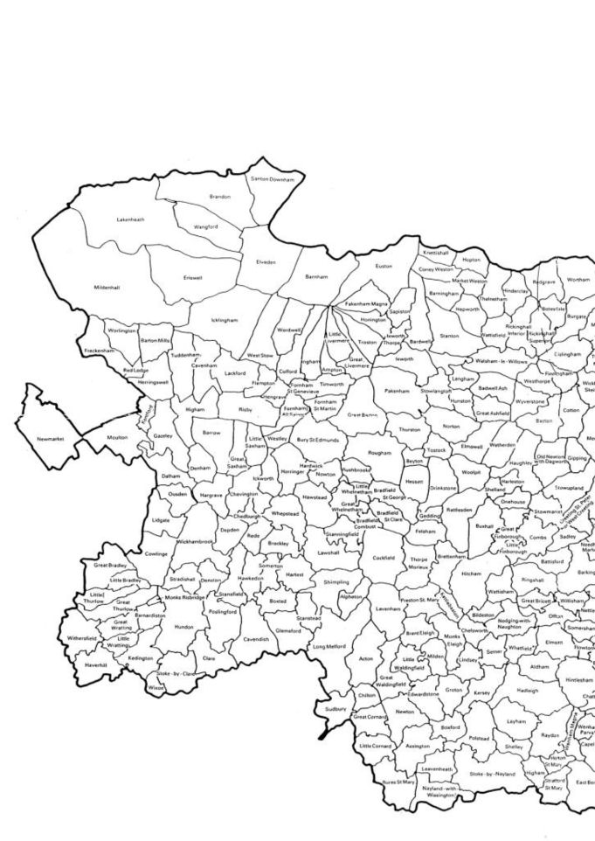
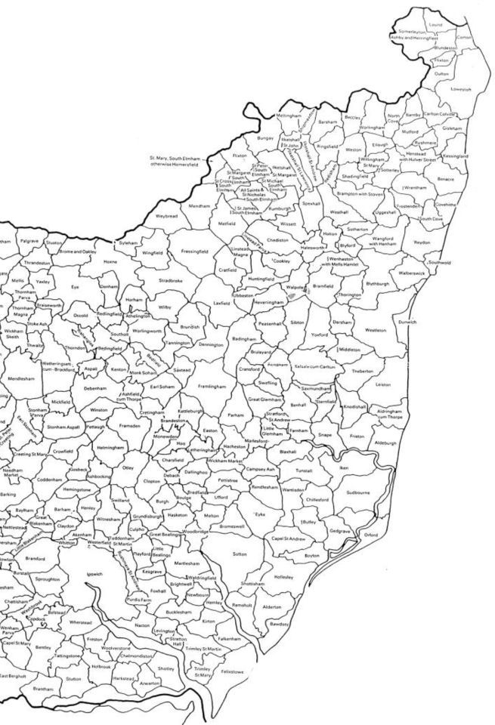
Pte Frederick ELLIOTT

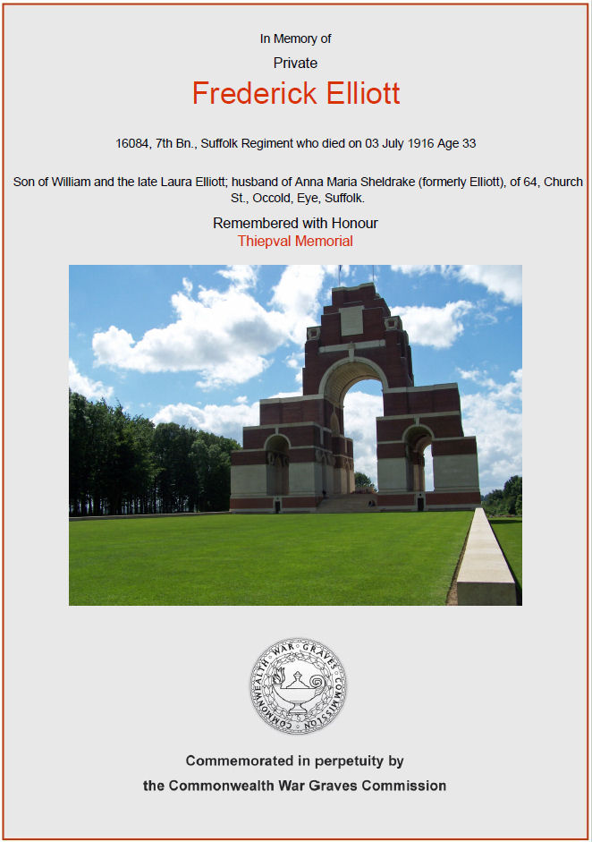
Self
Frederick was born 1883 in Bedingfield, the son of William ELLIOTT and Laura EVERSON. Siblings were Emma, Rosa, Charles and Alfred.

In 1891, he was living at The Plash, Bedingfield with his parents. In 1901, he was at Thorndon Road, Rishangles and described his occupation as ‘teamster’ (horse team driver).

Note: The Plash, Plash Farm, Plash House and Plash Lane are not marked today but Plash Lane is the narrow road linking Dublin Road to Bedingfield Church.

In 1906, he married Anna Maria HUNT and they had two children, Frederick Ernest ELLIOTT, born 1907 and Mary ELLIOTT, born 1910 both in Occold.

In 1911, he was living with his wife and children in Occold and described his occupation as ‘cowman on farm’.

He enlisted at Eye into the 7th Battalion, Suffolk Regiment with Service number 16084, served in France & Flanders but was KIA, Monday, 3 Jul 1916. He is commemorated at Thiepval Memorial, Somme, France.
Wife: Anna Maria HUNT
Anna Maria was born 1883 in Occold, the daughter of George HUNT and Mary CHAPMAN. Siblings were Clara and Walter William, also KIA, 1917.

She had a base born son George in 1904, not possible to identify the father. In 1911, he was living with his grandparents George HUNT and Mary.

But by 1917 she had not only lost her husband but her brother (Walter William) as well.

In 1919, she married Charles SHELDRAKE but he passed away 1924 in Occold without them having any children. She married again in 1927 to Charles PRETTY from Wortham but he passed away in 1951 again without them having any children.

Strangely, it has not been possible to find a death record for Anna.
Parents: William ELLIOTT and Laura EVERSON
His father William was born 1860 in Monk Soham to father Alfred ELLIOTT and mother Frances WARREN. From 1861 to 1891 he lived in Plash Lane, Bedingfield and started work as a farm boy at age 11 before spending the rest of his life as an ag lab (agricultural labourer) in common with around 90% of males at the time.

In 1883, he married Laura EVERSON probably in Bedingfield. Soon after, he moved to Rishangles where he worked as an ag lab until his death in 1936, aged 76.

His mother Laura was base born 1856 in Occold to Elizabeth EVERSON but not possible to identify her father. About age 14, she started work as a general servant to Thomas EVERSON, blacksmith in Occold. We have not established whether Laura was related to Thomas but given that he born 1803 in Occold, he could have been her great-uncle. She continued to work as a general servant until her marriage to William.
She passed away in 1917, aged 61 rather strangely in Woodbridge whereas her husband remained local to Occold. It is pure speculation but a possible reason for this is that immediately after losing her son Frederick in 1916, she may have had some sort of breakdown and been sent to Suffolk District Asylum in Melton, near Woodbridge. This is verified from her death certificate.

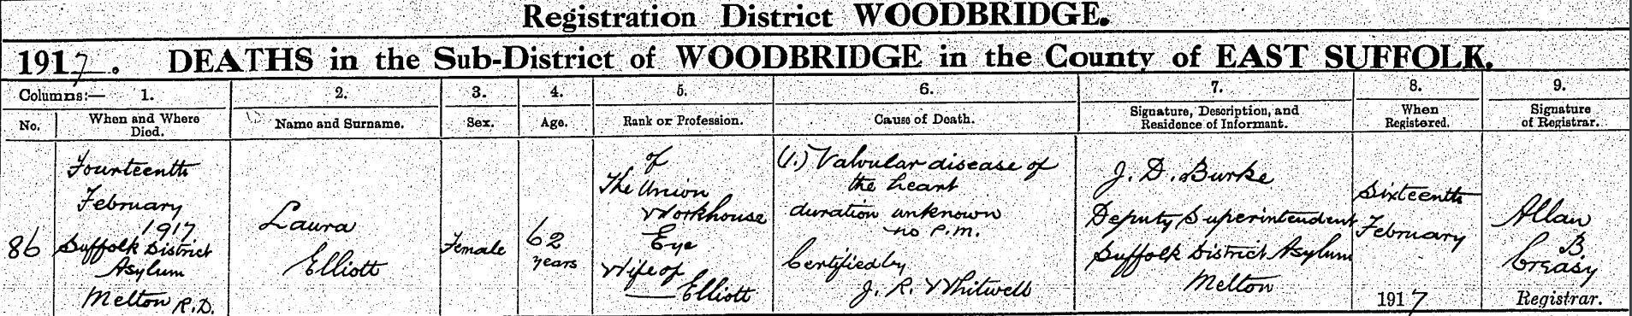
Paternal grandparents: Alfred ELLIOTT and Frances WARREN
Alfred was base born 1825 in Bedfield to Frances ELLIOTT (born 1805 in Monk Soham) – father not known. In 1841 he was an ag lab in Gislingham but thereafter moved to Bedingfield where he spent the rest of his life as an ag lab until his death in 1907. He married Frances WARREN in 1858 (probably in Bedingfield) and they had 9 children – William, Frederick, Harriett, Arthur, John, Emma, Minnie, Bessie and Lunna (!)

Frances WARREN was born 1841 in Thandeston to parents Charles WARREN (born 1815 in Southolt) and Elizabeth GRAY (born 1815 in Palgrave). She moved with her parents to Southolt before 1851 and then to Bedingfield where she probably met Alfred. In 1911 following Alfred’s death, she worked as a charwoman until her death in 1925, probably in Bedingfield.
Maternal grandparents: Unknown FATHER and Elizabeth EVERSON
Elizabeth was born 1823 in Occold to parents William EVERSON (born 1800 in Occold) and Charlotte BARHAM (born 1795 in Shelfanger). She lived with her parents in Occold St together with her base born daughter Laura but never married thereafter.

She had siblings William, Mary, Mary Ann, Rose, John and Esther.

In 1871, she was a cook and dairymaid to Henry WELLS, farmer at White House Farm, Occold and then a charwoman from 1881 until her death in 1890, almost certainly in Occold.
Descendant son - Frederick Ernest ELLIOTT
Frederick Ernest was just 9 years old when his father was KIA. In 1936, he married Mabel Kate CATLING (born 1909 possibly in Stradbroke) but they had no children hence there are no further descendants to trace.

Mabel died in 1982 and Frederick in 1995, both in this area but neither were buried in Occold. Of course, a death certificate for Frederick would reveal the informant and hence might identify an indirect descendant. And he did not leave a will that might have told us something!
Descendant: Daughter - Mary ELLIOTT
Tracing descendants coming forward is much more difficult than going back in time. Mary probably got married since we cannot find a death in her name but her name is sufficiently common that we cannot pin down with any certainty who her spouse might have been.
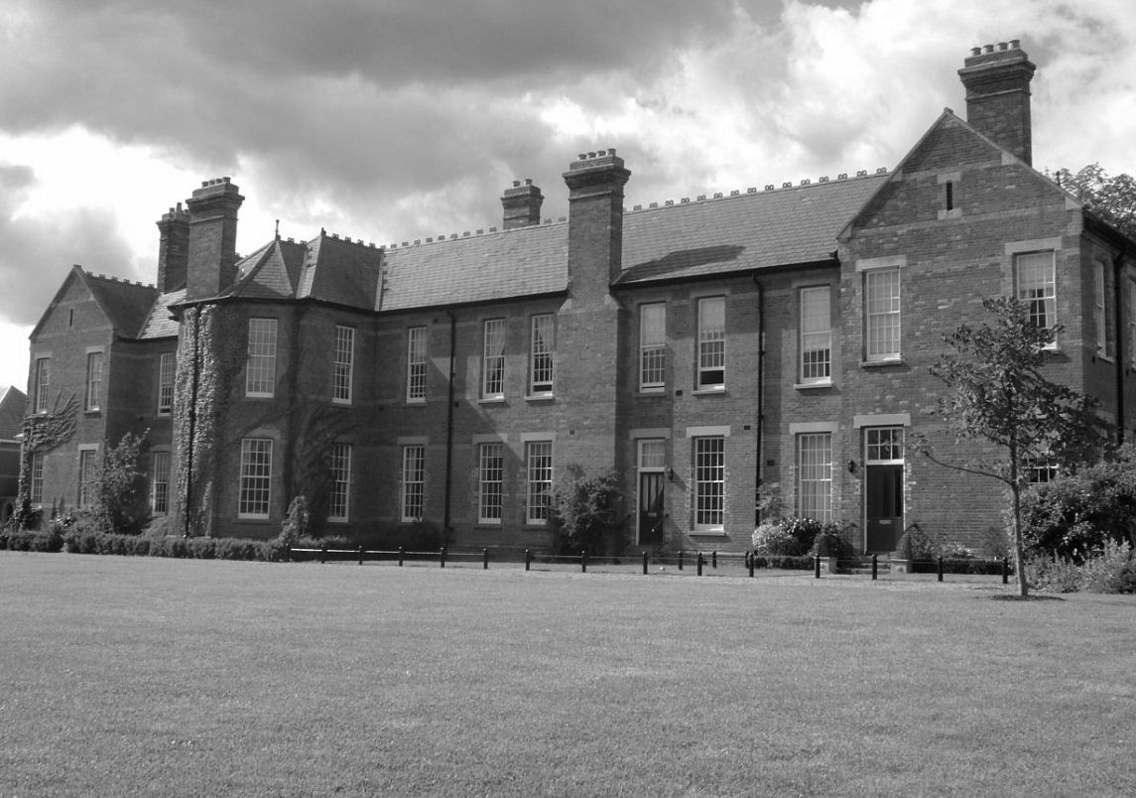
Suffolk District Asylum, Melton, Woodbridge
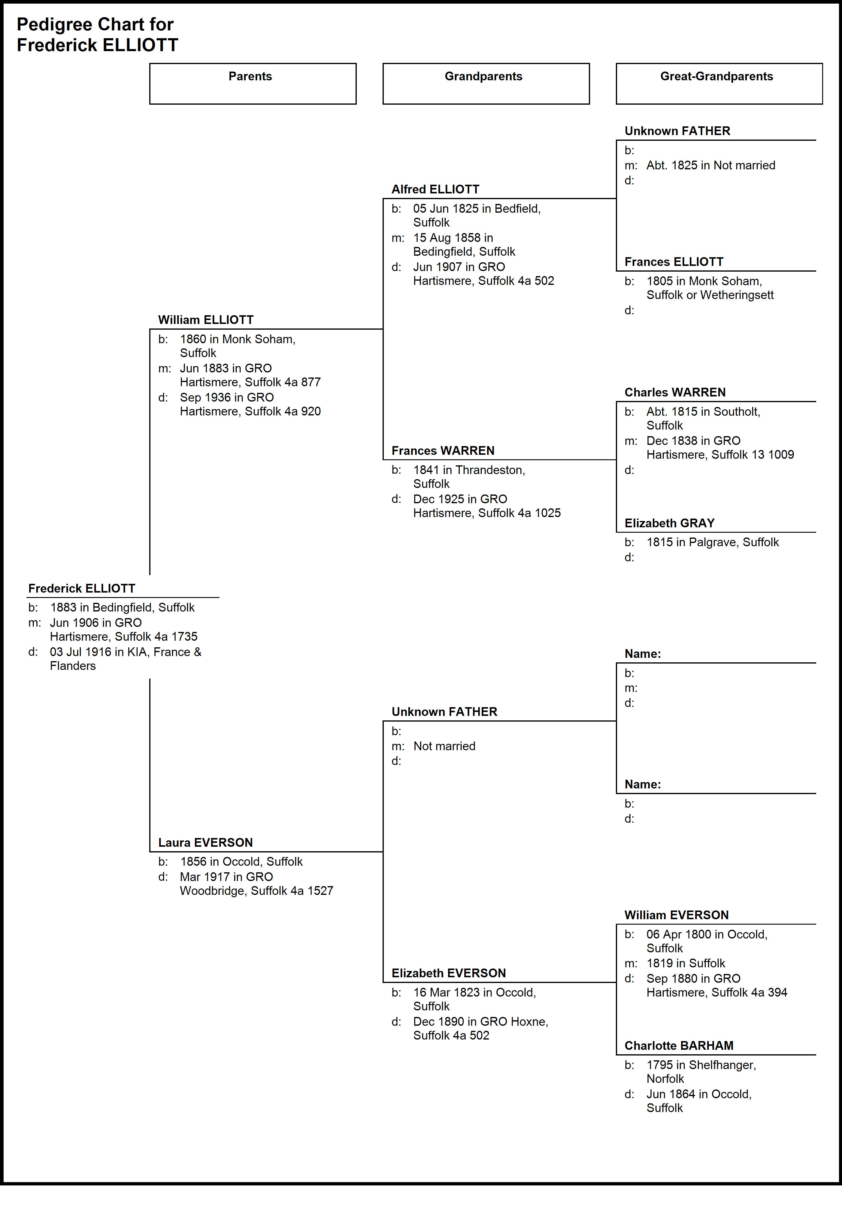

Pte Ernest Alfred HADDOCK

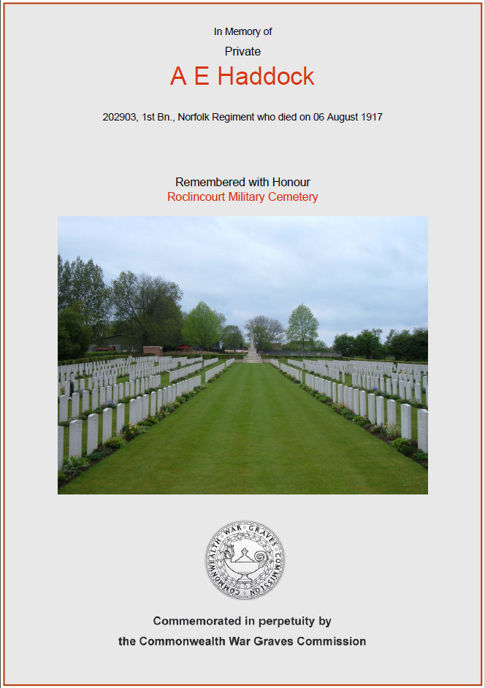
Self
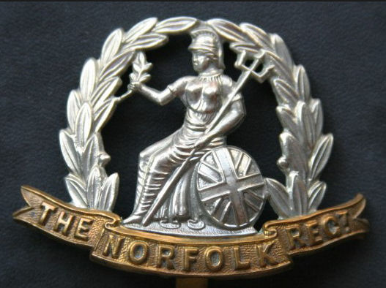
Ernest Alfred was born Alfred Ernest in 1892 to parents Alfred HADDOCK and Leah EVERSON. He came from at least three generations of HADDOCKS – all born in Occold. For the most part, they were ag labs as was Ernest. They married into other well known Occold families e.g. EVERSON, HUNT and WILDING.

From birth, he lived in Eye Rd, Occold and was a farm lab in 1911. He had siblings Jesse, George William, William, Edith and Harry.

About 1915, he enlisted in the 1st Bat, The Norfolk Regiment, serial no 202903 and served in France & Flanders until KIA on Monday, 6 Aug 1917.

He never married so has no direct descendants.

Like many others, Ernest was related to others commemorated on the Occold Roll of Honour. He was a 2nd cousin of Walter William HUNT, James HUNT and James LISTER. He was also brother-in-law of 1st cousin 1x removed of Ernest Arthur MILLS.
Relationship to other KIA
Ernest is related to some of the other KIA as follows:

Frederick ELLIOTT – Husband of his 2nd cousin Anna Maria HUNT

George HAMMOND – Brother-in-law of his 2nd cousin Walter William HUNT

James HUNT – 2nd cousin via Walter William HUNT (senior) (father of James) who is 1st cousin 1 x removed

Walter William HUNT – 2nd cousin

James LISTER – 2nd cousin via Caroline HUNT (mother of James) who is 1st cousin 1 x removed

Ernest Arthur MILLS – Brother-in-law of 1st cousin 1 x removed

Parents: Alfred HADDOCK and Leah EVERSON
Alfred was born 1861 in Occold, the son of Alfred HADDOCK and Rose HUNT. Leah was born 1863 to parents Samuel EVERSON and Eliza WILDING. Alfred and Leah were married in 1884. They spent all their life in Occold living variously at Castle Hill and Eye Rd albeit in 1881, Leah was working as a servant to George G BISHOP, grocer in Eye.

He had 4 siblings all born between 1848 and 1869 - Eliza, Amelia, Rose and Emma.

In his early years, Alfred worked as an ag lab but from 1901 onwards was a horseman on farm. Their last address in Eye Rd was next door to The Bottles Inn – not far to stagger after the usual Friday night beers – an Occold custom after the men got paid on a Friday!

Leah passed away in 1938, aged 75

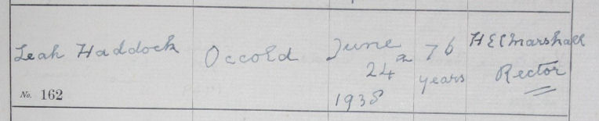

and Alfred soon after in 1941, aged 80.
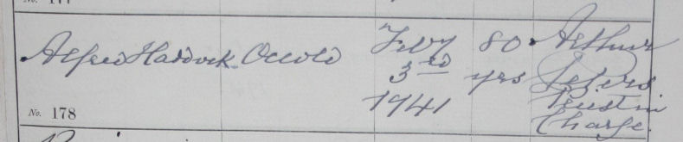

Both are buried in Occold cemetery but would probably have been too poor to have had a headstone.
Paternal grandparents: Alfred HADDOCK and Rose HUNT
Alfred was born 1828 in Occold, the son of James HADDOCK and Amelia ABBOTT. He spent his entire life in Occold starting as an ag lab at age 13 and eventually becoming a stockman on farm in the 1890’s before passing away in 1901. He is buried in Occold cemetery – grave unknown.

He had 8 siblings all born between 1823 and 1844. They were Elizabeth, George, Hannah, James, Sarah Ann, Emma, Phineas and Amelia.

Rose was born 1826 in Occold to parents Benjamin HUNT and Mary LOVET. She was the eldest of 4 siblings – Seymour, Lewis, Benjamin and Mary Ann.

Alfred and Rose were married 1846 in Witham, Essex. Since all parties came from Occold, getting married in Witham seems a bit strange. Furthermore, both Alfred and Rose were living in Occold in both 1841 and 1851. So why Witham? Perhaps the marriage certificate would help!!

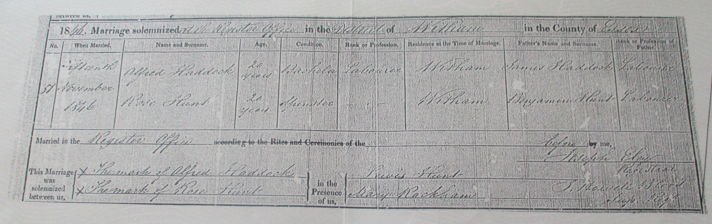

Not really!! Both were labourers including the fathers and they say they are resident in Witham. It is possible they moved there briefly but no way of knowing. One of the witnesses was Lewis HUNT, Rose’s sister. The other was Mary RACKHAM, unknown. So it remains a mystery!!

In 1851, they were living at Occold St, Occold next door to Rose’s father Benjamin HUNT. She passed away in 1905, 4 years after Alfred and aged 78.
Maternal grandparents: Samuel EVERSON and Eliza WILDING
Samuel was born 1828 in Braiseworth, the son of Robert EVERSON and Sarah TALBOT but moved to Occold in his early years.

Eliza WILDING was born 1829 in Wetheringsett, the daughter of George WILDING and Eliza ALLUM. She had a base born daughter Clara WILDING in 1855 but Clara adopted the name EVERSON when she married James OFFORD in 1872 as a result of her mother marrying Samuel EVERSON.

Samuel and Eliza were married 1859 in Occold and had only 4 children – Emily, Leah, Hutty and George. Samuel spent his entire life as an ag lab before passing away in 1906 just a year after Eliza passed away in 1905.
Descendants:
Ernest never married so has no direct descendants. However, his brother George William had several children and descendants whom we have traced.

George William was born 1887 in Occold, 5 years older than his brother Ernest. He lived and died in Occold and worked variously as a stockman and a horseman. In 1910 he married Olive Annie WILDING who was also his 1st cousin 1 x removed. They lived in Church St next door to the old Rectory.

George William also served in WW1 both in the Queens Regiment (no 562245) and the Labour Corps (no 74259) albeit we’re not sure where and when. He was awarded the British War Medal and the Victory Medal (aka “Mutt and Jeff”).

They had children Jesse (1910 – 1934), Edith (died at birth), Aileen May (married William SELF), Daisy Victoria (married James G EVERSON) and Edward Abraham (1921 – 1978, married Ruby DONALDSON.
Postscript: On 19 May 2015, John Herbert EVERSON (grand-nephew) laid a wreath on the grave of Ernest Alfred HADDOCK in the name of the “People of Occold” – below….
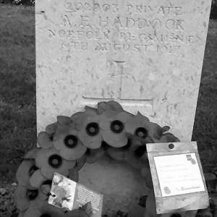

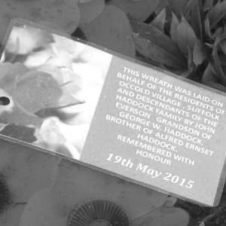
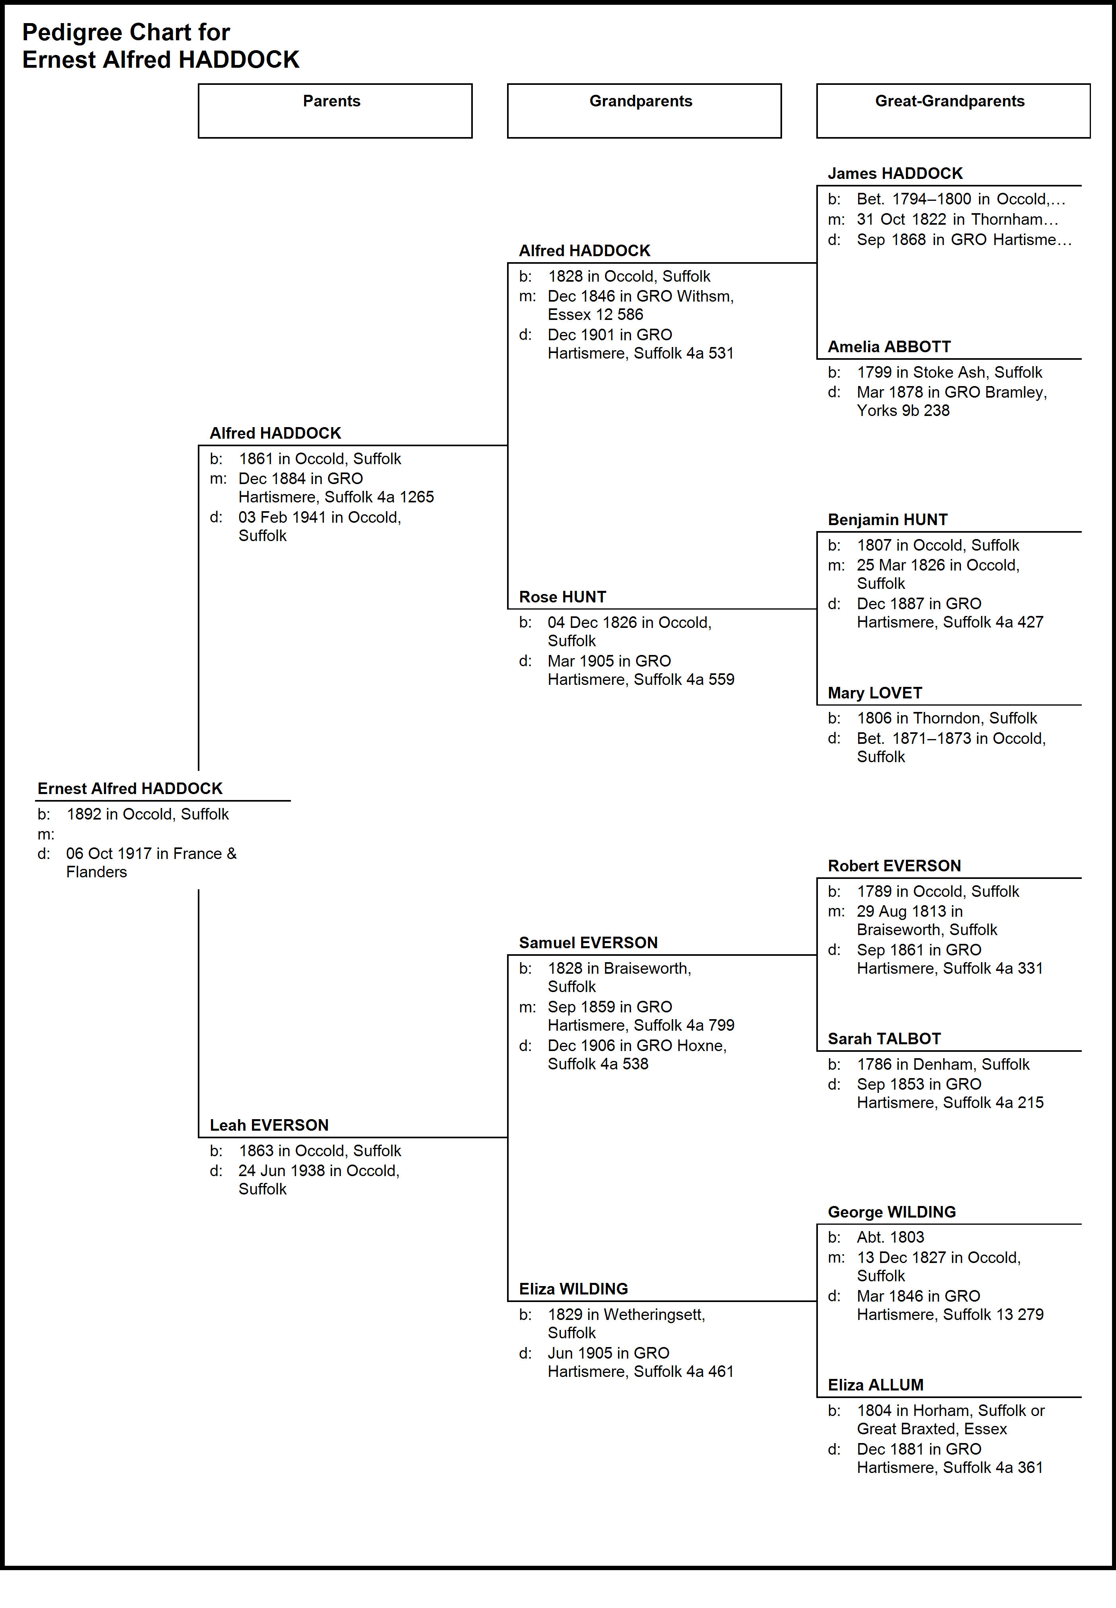
Pte George HAMMOND
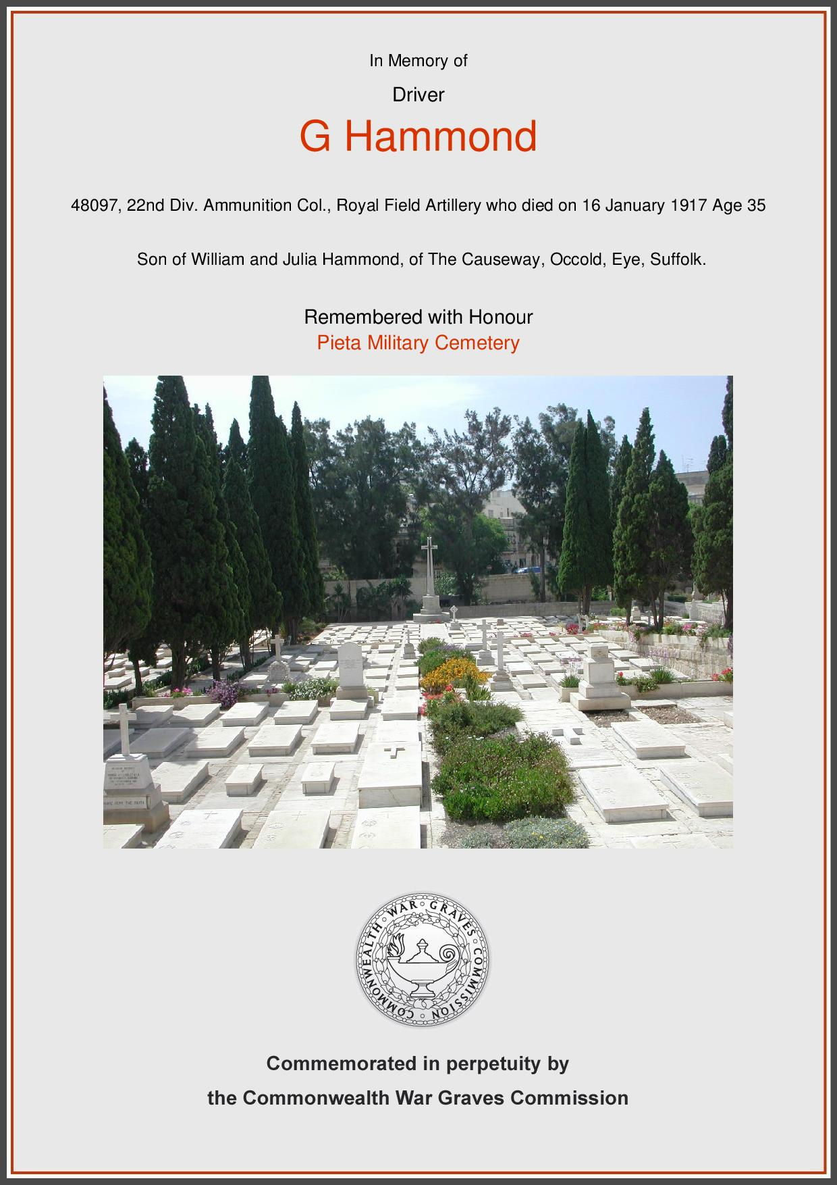
Self
George was born 1882 in Occold, the son of William HAMMOND and Julia CANHAM. He came from three generations all of whom were born, lived and died in Occold, Rishangles, Bedingfield or Thorndon. For the most part, they were relatively impoverished farm labourers.

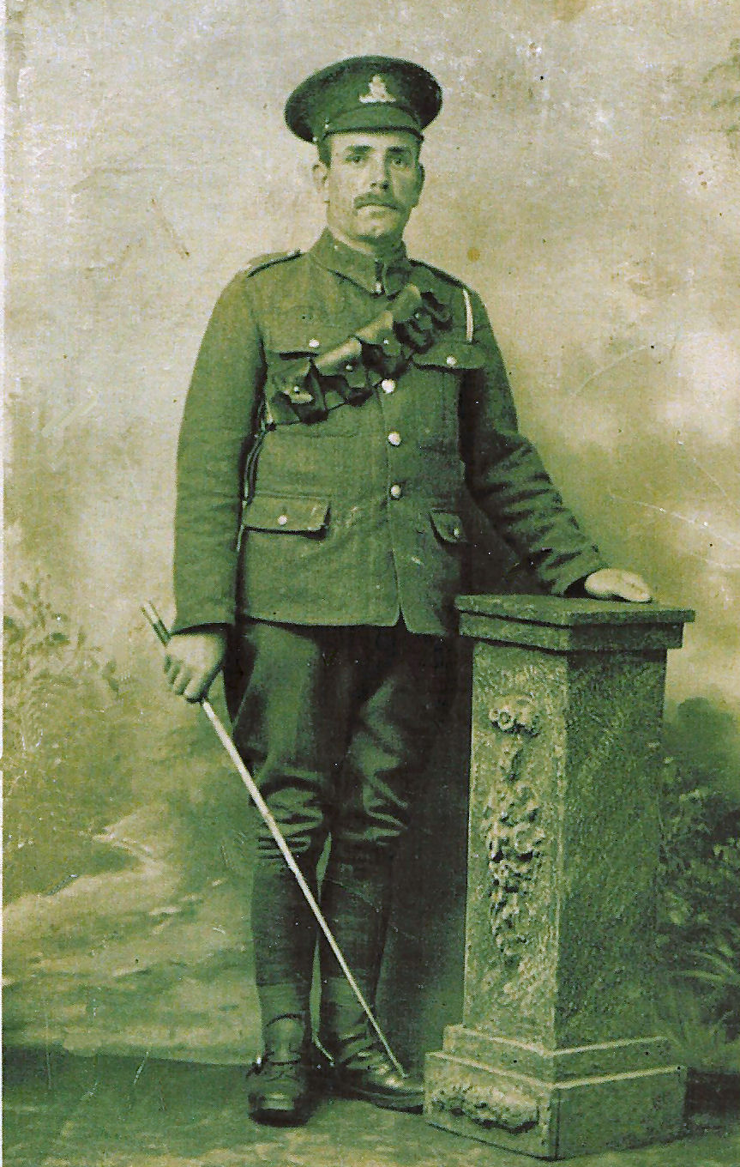
In 1891 he was living in Rishangles but moved to The Causeway, Occold by 1901, working as a farm labourer. Strangely, he appears in the census as Herbert George albeit we have no idea why. In 1911, he was living with his siblings Frederick, Arthur, Ernest and Forence and his mother Julia who was on her own as his father William was working as a dock labourer at Parkeston Quay.

He joined as a driver in the Royal Field Artillery, service no 48097, and saw action in Gallipoli and Salonika where he was injured. He died in the Military Hospital in Malta on Tuesday, 16 Jan 1917 – see below. He is commemorated at Pieta Military Cemetery, 2km west of Valetta, Malta.
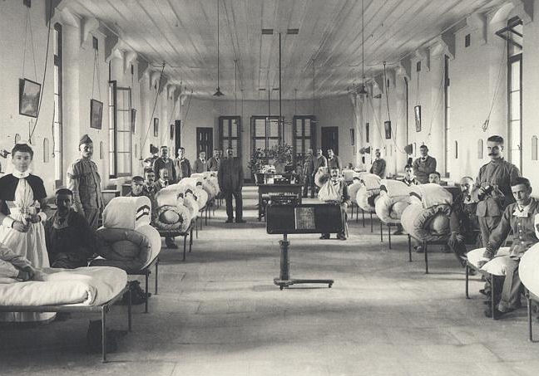

During WW1, it was common for soldiers to write a will and we have managed to locate a copy of the will made by George in which he leaves everything to his mother still living in The Causeway, Occold.

A copy of the document which recognises it as a valid will is attached at the end of this document

A slight digression at this stage. George had an uncle Syer HAMMOND, brother of George’s father, and an aunt Susannah ‘Annie’ HAMMOND (no relation!) living in Thorndon. Syer and Annie had 8 children.

Of these, Albert Edward was KIA 23 Feb 1915 whilst serving in Belgium and his brother Nathan Alfred was KIA 21 Jun 1916 whilst serving in France. Both are commemorated on Thorndon War Memorial.

George had 5 siblings including Charles, Arthur and Ernest and…..

His brother Frederick HAMMOND, born 1877, died 2 Feb 1916 and is buried in Occold Cemetery aged just 39. There is no evidence that his death was attributed to service in WW1.

His sister Florence Rose HAMMOND married Walter William HUNT in 1913 but he was KIA 3 May 1917 after action in France & Flanders at almost the same time as his daughter Gladys R HUNT was born.

Thus, George’s parents lost not only a son and a son-in-law but two close nephews.
Parents: William HAMMOND and Julia CANHAM
His father William was born 1857 in Bedingfield to parents Robert HAMMOND and Elizabeth WARD. He grew up initially as a farm boy in 1871, a stockman in 1881 and an ag lab in 1881 at Rishangles in 1891. At this point, he must have wanted a career change. In 1901 we find him as a navvy in Walthamstow, Essex and a dock labourer for the Great Eastern Railway Co. at Parkeston Quay in 1911.

During these past 20 years, he has spent most of his time away from his wife who remained living at The Causeway in Occold. He must have returned at some point as he died on 29 Dec 1931 and is buried in Occold – no grave found.

He married Julia CANHAM in 1876. She was born 1856 in Occold to parents George CANHAM and Sarah Ann EBBAGE. She remained in Occold all her life apart from a brief spell in Rishangles and, since 1901, lived in The Causeway. She remained there until her death on 29 Feb 1934, buried in Occold but no grave found.

They had 6 children – Frederick, Charles, George, Arthur R, Ernest E and Florence Rose.
Paternal Grandparents: Robert HAMMOND and Elizabeth WARD
Robert was born 1816 in Bedingfield to parents John HAMMOND and Hannah CRACKNELL. He was a fairly typical male in rural Suffolk and spent he entire life working as an ag lab in Bedingfield. He died 1889 aged 73 whilst living at Bucks Green Cottage, Bedingfield – and as it looks today:

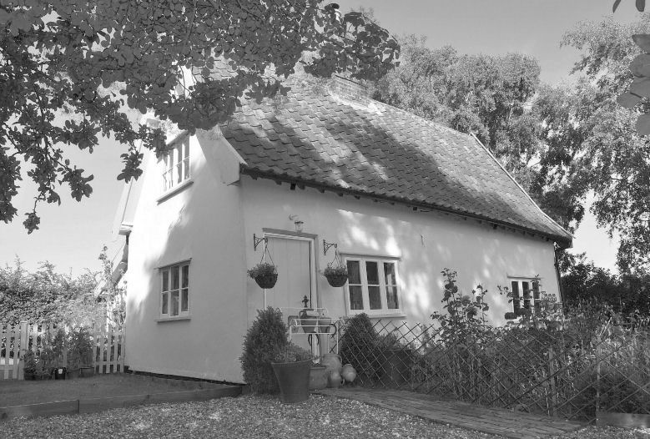
He married Elizabeth WARD in 1838. She was born 1823 in Bedingfield to parents James WARD and Maria SMITH and spent her early years in Bedingfield. She died 1881 aged just 63, again living at Bucks Green Cottage.

They had eleven children – George, James, John (died 1844), John, Syer, Eliza, Robert, William, Charles, Albert and Emma – so just 2 girls and 9 boys!
Maternal Grandparents: George CANHAM and Sarah Ann EBBAGE
George was born 1832 in Occold to parents Joseph CANHAM and Ann SHIP. He spent his early years in Occold primarily as a groom and in 1891 as a farm steward at Bridge House, Badingham. By 1901, he was a pork butcher at Fore St, Framlingham and later expanded to being a butcher and general shopkeeper. He died 1920 probably in Framlingham.

He married Sarah Ann EBBAGE in 1854. She was born 1830 in South Walsham to parents Henry EBBAGE and Hannah UNKNOWN Strangely, we cannot find when or where she died.

They had just 5 children – David George, Julia, Frederick, Anna and Rosa.
Field Will for George Hammond
He leaves all his belongings to his mother Mrs W Hammond of The Causeway, Occold
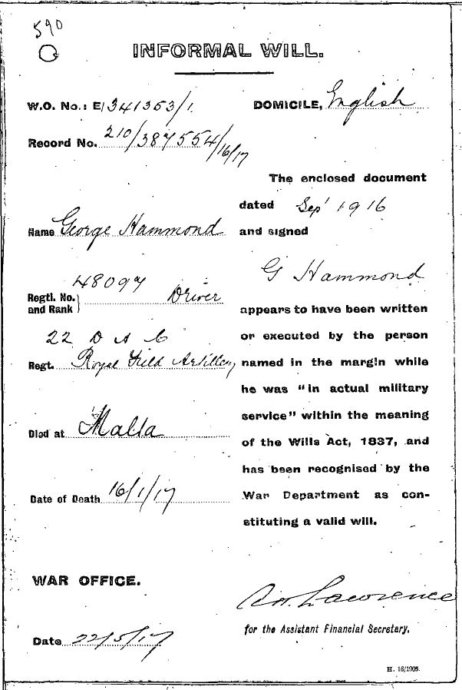
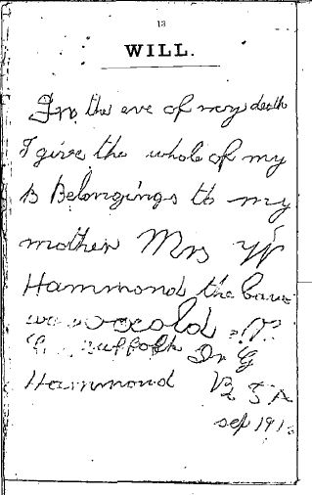
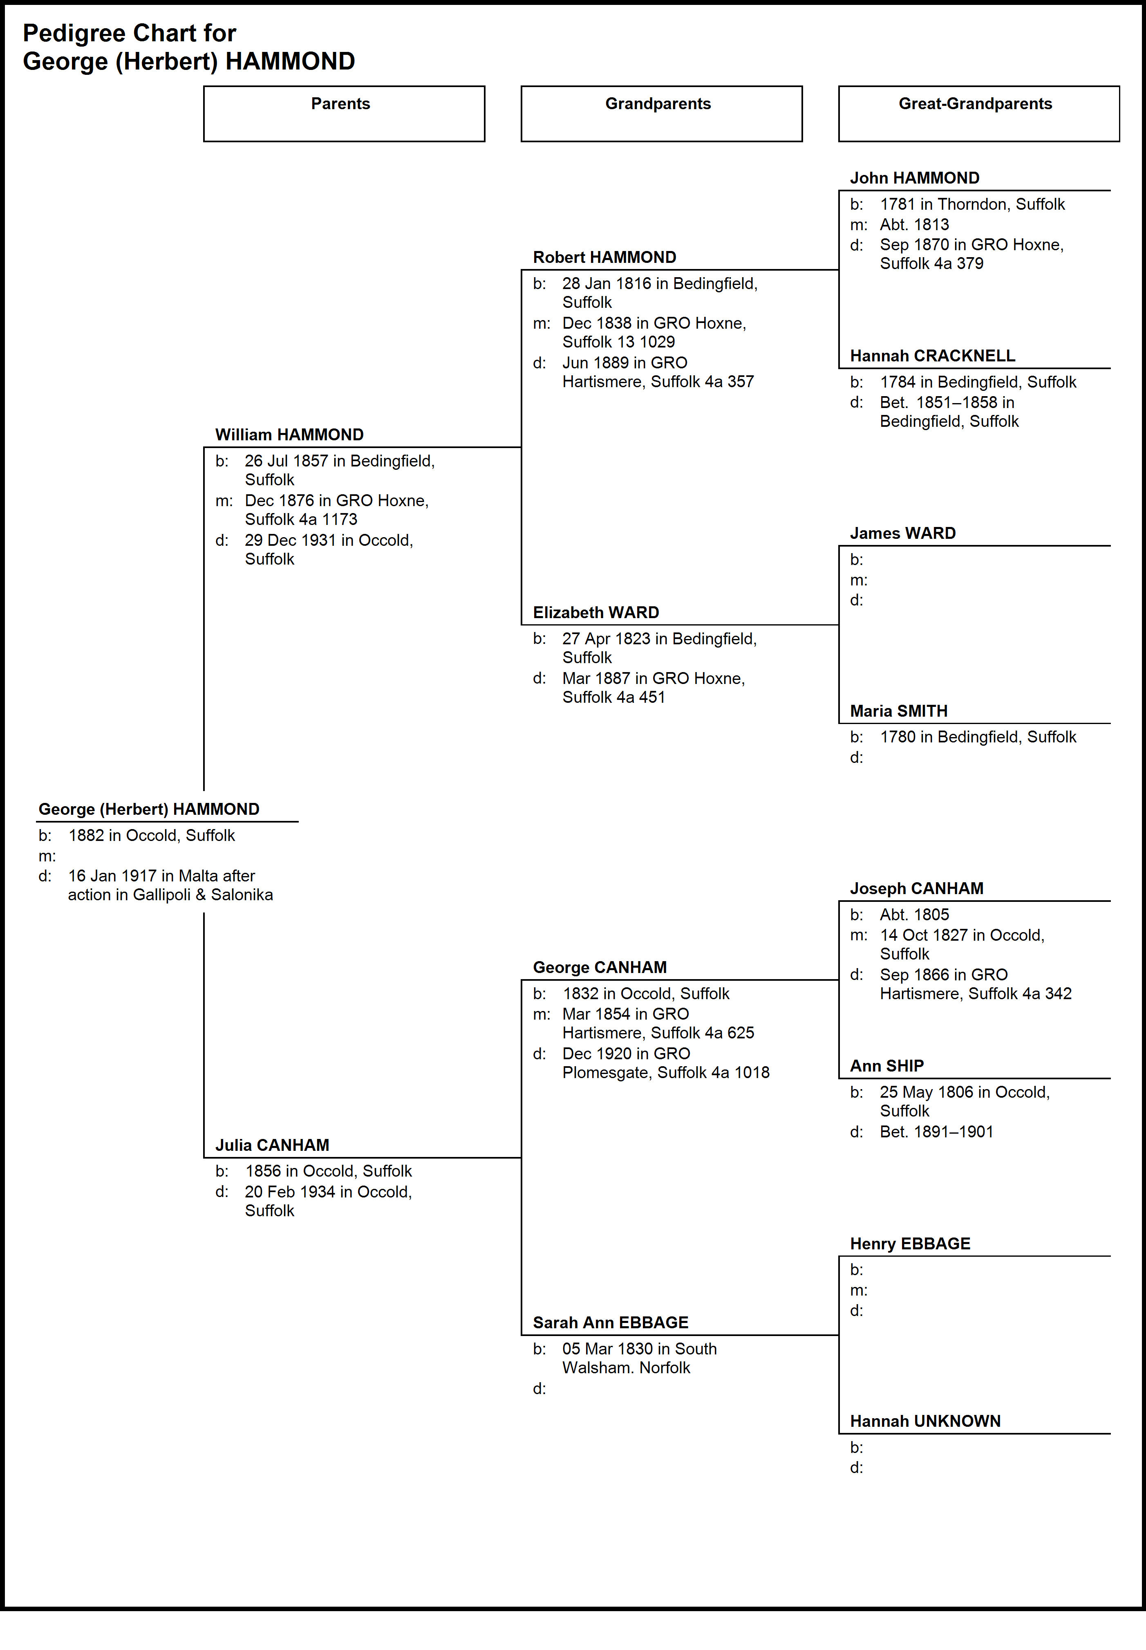

Pte James HUNT

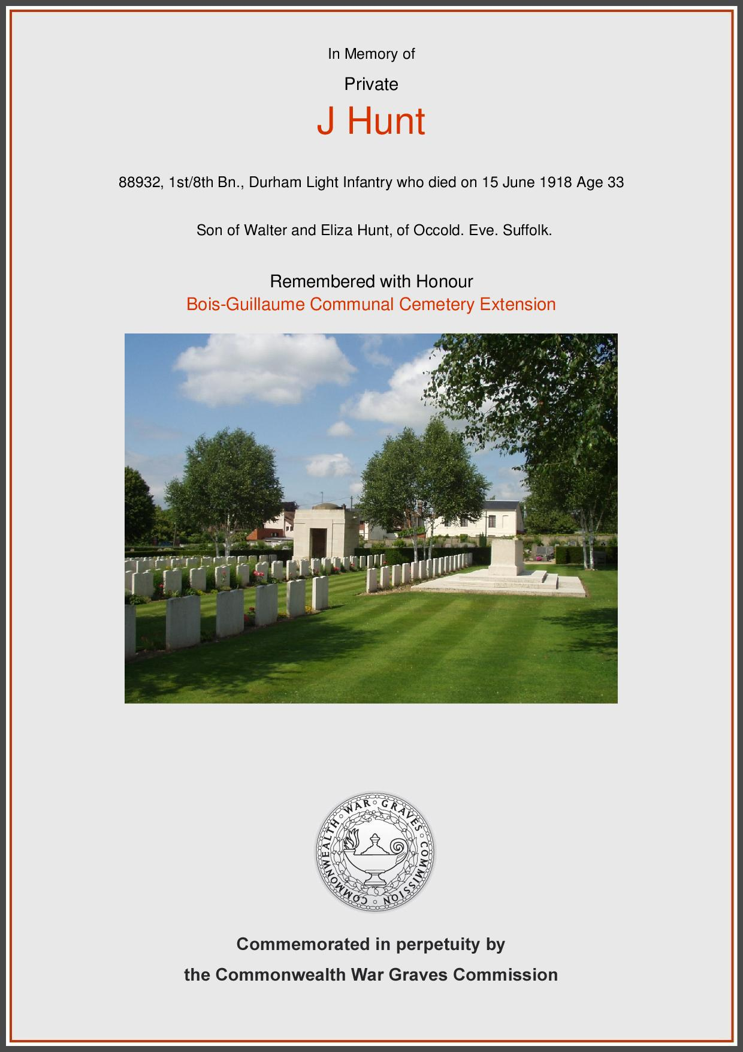
Self
James was born 1882 in Occold to parents Walter William HUNT and mother Eliza BARNES. Until 1911, he lived in Redlingfield Rd, Occold and was working initially as an ‘ag lab – horse’ and then as a ‘horseman on farm’. In 1911, the family were living in a 7 room house in Redlingfield Rd so a fairly substantial property in those days where most houses in Occold would have been 2-4 rooms.

He had siblings Jessie, Alfred Lewis, Ernest and Gladys Hilda.

In 1912 on Aug 25th, Sep 1st and Sep 8th banns of marriage were announced in St Michaels Church between James HUNT and Elizabeth LISTER (nee ROOT), widow of Walter LISTER and 11 years older than James. She was also sister of William (Willie) ROOT, KIA in 1917.But on 8th Sep the banns were objected to by his mother Eliza HUNT (nee BARNES) albeit no reason was recorded. There are no records to suggest that the marriage took place and, in his subsequent Army record, he describes himself as unmarried hence has no direct descendants. A bit surprising as, in 1912, James would have been 27yrs old so no longer a minor.

Also interesting to note is that, in all the 310 banns held in St Michaels Church Parish Records since 1870, this is the ONLY one which was objected to.

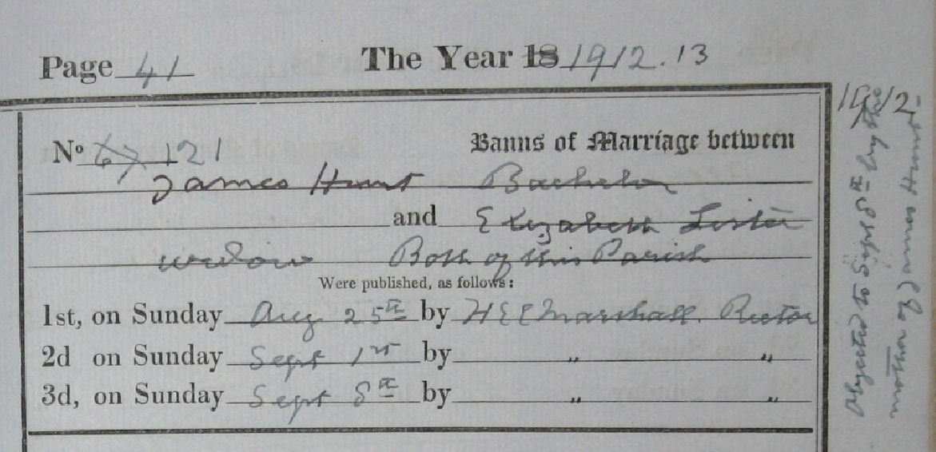

Now here comes the interesting bit. Unlike most of the KIA’s, we have managed to locate James HUNT’s Army Service Record, not too many of which have survived. These run to around 25 pages of handwritten notes, often illegible or faded, detailing every aspect of the soldier. And the most startling fact to emerge is that James was not KIA but died of natural causes prior to attempting suicide!!

So we can see from this that James enlisted in the Army Service Corps at Driffield, Yorkshire on 7 Jul 1913 on a 1 year service i.e. before the outbreak of WW1. His Regimental number was 235.

One interesting fact on his attestation is that he claims to have served in the 3rd Grenadier Guards and was discharged in Dec 1910; reason given was ‘purchased’. We can find no record of this.

His medical record at the time described him as a farm worker, 5ft 10½ tall, weight 158lb, chest when fully expended 39in with range of expansion of 3½in. He had 4 vaccination marks on his left arm.

So why Yorkshire when he was previously living in Occold? But it was not uncommon for young men to leave a very poor rural economy to seek better paid jobs elsewhere including heavy industry around Birmingham, clothing mills around Manchester, shipbuilding at Liverpool and Newcastle and coal mining in Cumbria, Yorkshire, Nottinghamshire and Kent.

He was re-engaged in the Army Service Corps on 3 Jul 1914 for 1 year as a ‘wagoner’ at Langtoft, near Peterborough, Cambs. He would have been responsible for looking after the horses and wagons that took vital supplies to the Front Line.

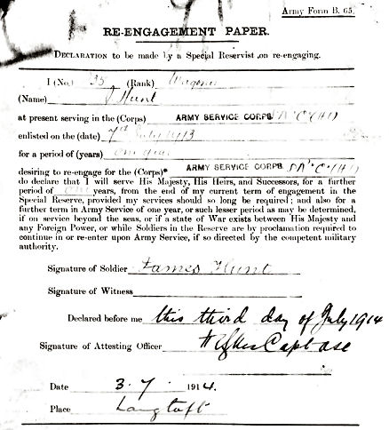
We have a record of his service from the day he joined to the day he died but much of it is either illegible or too faded. However, the following is the best we can do:

From 7 Jul 13 to 17 Aug 14 he was stationed in England albeit we know not where. From 20 Aug 14 to 1 Dec 17, he was transferred, we think to Expeditionary Force somewhere (probably France) but impossible to decipher. He returned to England on 2 Dec 17. During this period of service, he was given leave from 5 Dec 15 to 12 Dec 15 and again from 5 Feb 17 to 15 Feb 17 – so not a lot!

On 8 Dec 17 he was transferred back to England as a ‘skilled ploughman’ and required to report for duty to No 1 HT (?) Deport, Park Royal, London. He came back from Le Havre aboard the troopship SS Archimedes (below) and disembarked at Southampton.

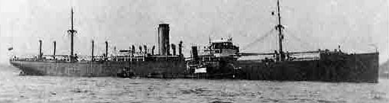

He returned to France embarking at Southampton and disembarking at Le Havre on 4 Apr 18.

On 20 Apr 18, he was compulsorily transferred to 1/8th Battalion, Durham Light Infantry; reason given as ‘Benefit of the Service’. His serial number was 88932.

When he was discharged from the Army Service Corps on 14 Dec 1918, he was described as:

- Employment in the Army: Driving
- Sobriety: Excellent
- Reliable: Yes
- Intelligent: Yes
- Any special aptitude in civil life: Yes with horses

On leaving the Army Service Corps, he was awarded a bounty of £10.

Around 10 May 18, he was declared ‘sick’ whilst in the field (possibly in Italy) and on 14 May 18 his medical record shows he suffered a self-inflicted wound (SIW) to his throat which was diagnosed as an incision. On 12 Jun 18 he was transferred to Rouen General Hospital, France. He died there on Saturday, 15 Jun 18. Cause of death was ‘melancholia suspected diphtheria due to exposure while on Active Service’.

Diphtheria was widespread at the time and often fatal. Melancholia is a bit of strange one. He did serve in France and possibly Italy prior to his death so it could be the equivalent of Post Traumatic Stress Disorder as we would call it today, especially in view of the self-inflicted wound.

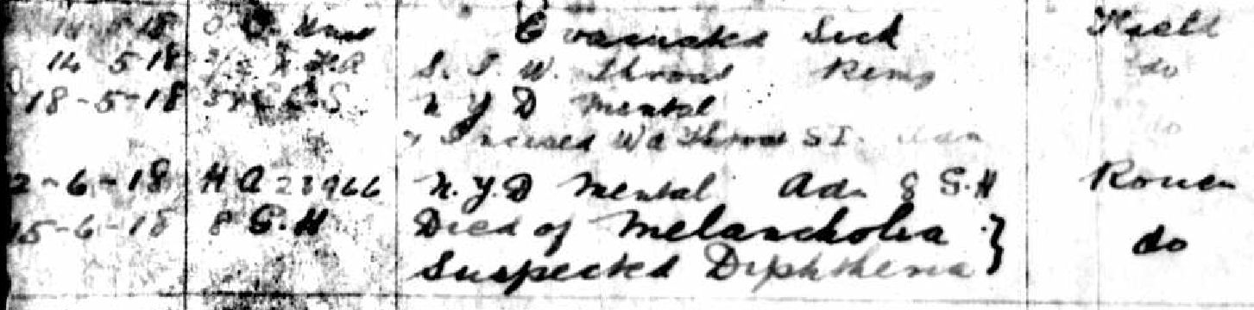

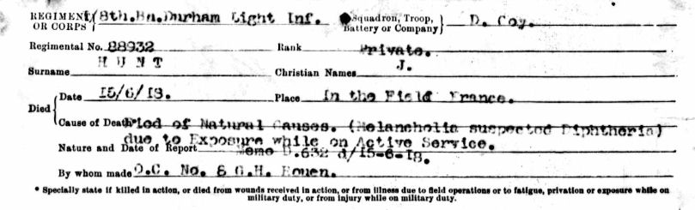

Following his death, his father, Walter William HUNT, received a memorial scroll (illegible) so I guess, since James was on active service when he died, he was treated as KIA. Certainly he is commemorated by the Commonwealth War Graves Commission as well as the Occold Roll of Honour.

His father, of The Causeway, Occold, was also asked to acknowledge receipt of the following items:

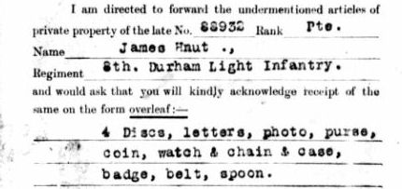

On 18 Oct 1819, his father, Walter William HUNT, living in The Causeway, signed (with his mark) a statement of his son’s family. The statement was witnessed by Rev Herbert Edward Champion MARSHALL, Rector of Occold at the time.

One item to note. His brother Alfred Lewis address seems to be ‘NE2 Germany’ – a bit puzzling? But this was after WW1 ended – so is it possible Alfred Lewis also served in the Army and ended up in Germany after their defeat? We can find no surviving Army record for Alfred Lewis.

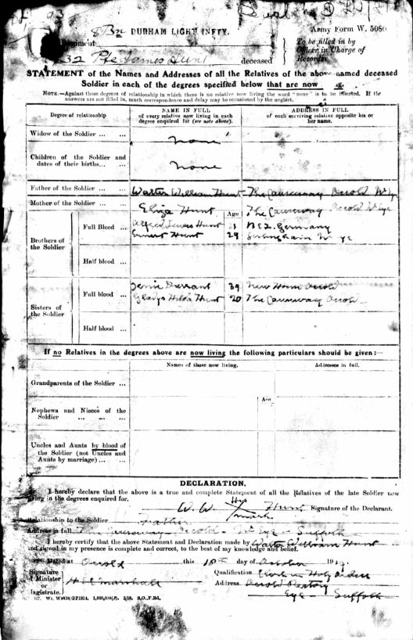
On 18 Dec 1919, father Walter William received the 1914 Star medal in honour of James and then the British War Medal and the Victory medal on 21 Dec 1921. Families of those KIA did not normally receive these 3 medals (affectionately known “Pip, Squeak and Wilfred”) but we guess it was because he died of natural causes.

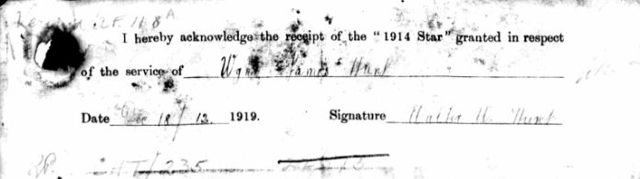

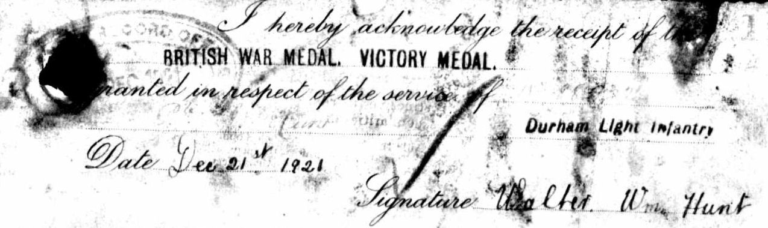
Parents: Walter William HUNT and Eliza BARNES
His father Walter William was born 1857 in Occold to parents Lewis HUNT and Sophia LAST. He led a fairly typical rural existence as an ag lab all his life until his death and burial in Occold Cemetery on 18 Oct 1932, grave unknown.

As well as James, they had children Jessie, Alfred Lewis, Ernest and Gladys Hilda.

We know in 1891 and 1901 that he was living in Redlingfield Rd but we also know from receiving his son’s effects, memorial scroll and medals that he was living in The Causeway in 1919 onwards if not before.

On 10 Nov 1878, he married Eliza BARNES, born 1860 in Syleham or Stoke Ash to parents James BARNES and Sarah BAILEY as shown by their banns, witnessed by Horatio Lovell TODD, Rector of Occold who lost his own son Nicholas Herbert TODD.

Interestingly, also married on the same day was Emma BARNES, 1st cousin of Eliza, to Job REYNOLDS. Job’s brother Ambrose later became landlord of The Bottles Inn and remained so until his death in 1914.
In 1861, Eliza was living at London Rd, Braiseworth but moved to Redlingfield Rd, Occold probably close by where Walter William lived. She died in Occold and was buried 18 Jul 1834 just 2 years after Walter William passed away.

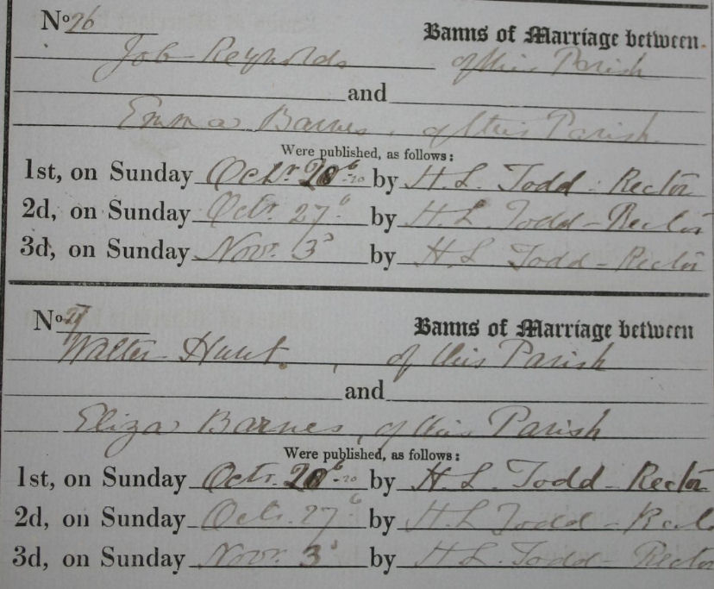

Inter-relationships
As well as losing his son, Walter William was also related to 6 others on the Roll of Honour:

Frederick ELLIOTT – 1st cousin 1 x removed

Ernest Arthur MILLS – Brother-in-law of 1st cousin of wife of 1st cousin

George HAMMOND – Brother-in-law of uncle of wife of 1st cousin 1 x removed

Walter William HUNT – 1st cousin 1 x removed

James LISTER – Nephew

Ernest Alfred HADDOCK – 1st cousin 1 x removed

Just goes to show how inter-related everyone was in a small community like Occold!
Paternal grandparents: Lewis HUNT and Sophia LAST
Lewis was born 1832 in Occold to parents Benjamin HUNT (1807-1887) and Mary LOVET (1806-1871) and led a fairly typical life as an ag lab until 1881. He then became an engine driver (illustration below) most probably driving one of the traction engines making their debut in Occold and later a coal seller living in Redlingfield Rd.

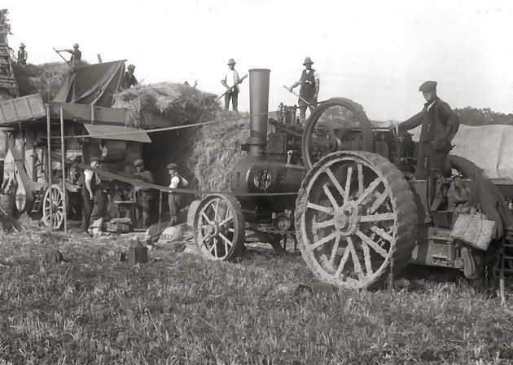

He died Mar 1896 at the age of 64 and probably buried in Occold.

He married Sophia LAST in 1854 and they children Maria,, Caroline (mother of James and Reginald LISTER both KIA), Anna and Levi. Sophia was born 1833 in Eye to parents William LAST (1803-1880) and Eliza CANHAM (1812-1876). Sophia died in 1896 about 6 months after husband Lewis.
Maternal grandparents: James BARNES and Sarah BAILEY
James was born 1826 in Denham to parents John BARNES (1796-1863) and Martha BOYCE (1800-1828). He led a fairly uneventful life as an ag lab but moved around quite a bit from Denham to Syleham, Braiseworth, Redlingfield Rd, Occold, Cranley Green, Eye before returning to Redlingfield Rd in 1901 living with daughter Eliza HUNT and where he died in 1903.

Note that Private James HUNT, his parents and both sets of grandparents all lived in Redlingfield Rd at some point.

He married Sarah BAILEY in 1849. Sarah was born 1827 in Hoxne, one of 12 children born to parents Robert BAILEY (1789-1858) and Hannah RUSH (1799-1876). Like most married women, she had no occupation. She died in 1895 aged 67 and 8 years before husband James.

As well as Eliza, James and Sarah had children James, George, Ammer, John and Henry.
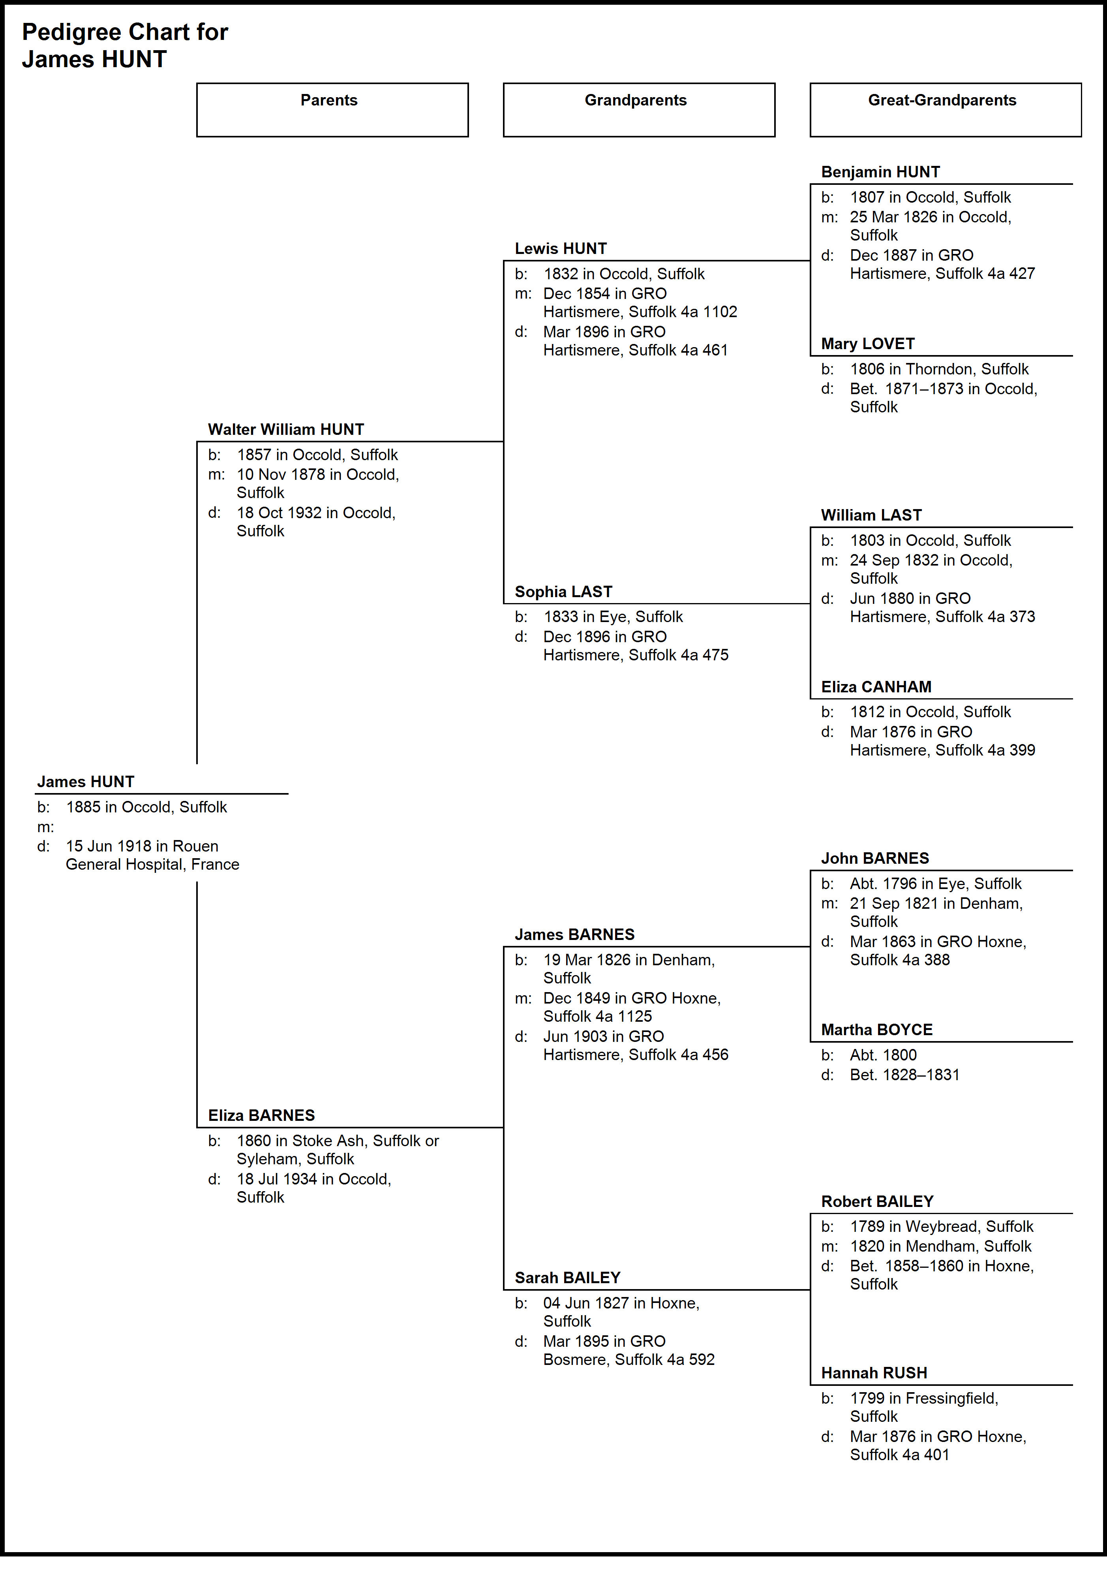
Pte Walter William HUNT
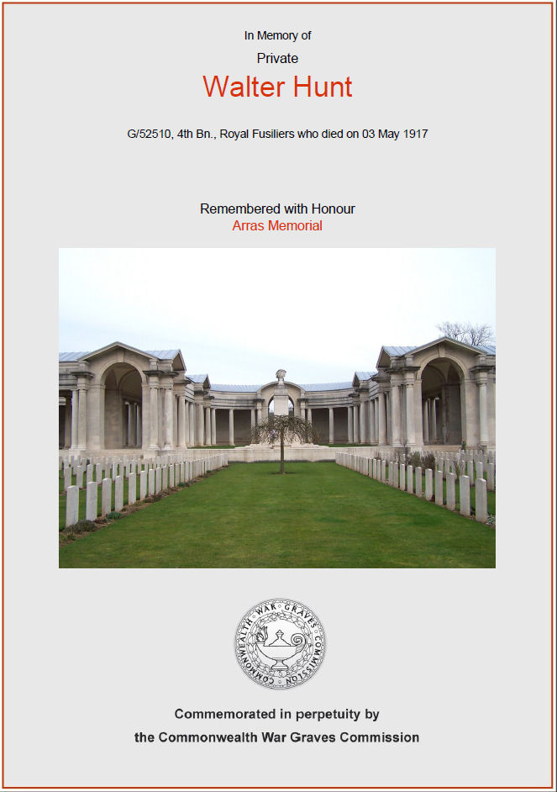
Self
Frederick was born 1892 in Occold, the son of George HUNT and Mary CHAPMAN. Siblings were Clara and Anna Maria (who married Fredrick ELLIOTT, also KIA 1916).
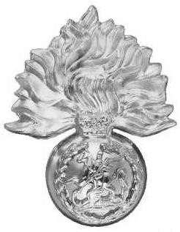
He lived at Church St, Occold in 1901 and in 1911 was working as a stockman on farm. He married Florence Rose HAMMOND in 1913 and they had children:
an infant boy, born and died in 1914 followed by Albert G (1915) and Gladys Ruby (23 Mar 1917).

He joined the 4th Battalion, Royal Fusiliers (left), serial no G/52510, saw service in France & Flanders but was KIA, Thursday, 3 May 1917. He is commemorated at Arras Memorial, Pas de Calais, France.
Wife: Florence Rose HAMMOND
Florence was born 1890 in Occold to parents William HAMMOND and Julie CANHAM. She was living in Dublin Rd, Rishangles before moving to The Causeway, Occold in 1901. In 1911, she was employed as a Work at Home. At this time, her mother lived on her own whilst her father was a dock quay labourer at Parkeston Quay.

She had siblings Frederick, Charles, Arthur and Ernest and also a brother George who was KIA 1917 – so she lost both a husband and a brother.

So his wife Florence had a new born daughter Gladys Ruby on 23 Mar but her husband was KIA just 41 days later on 3 May. Just shows the grief that can arise amongst the families left behind.

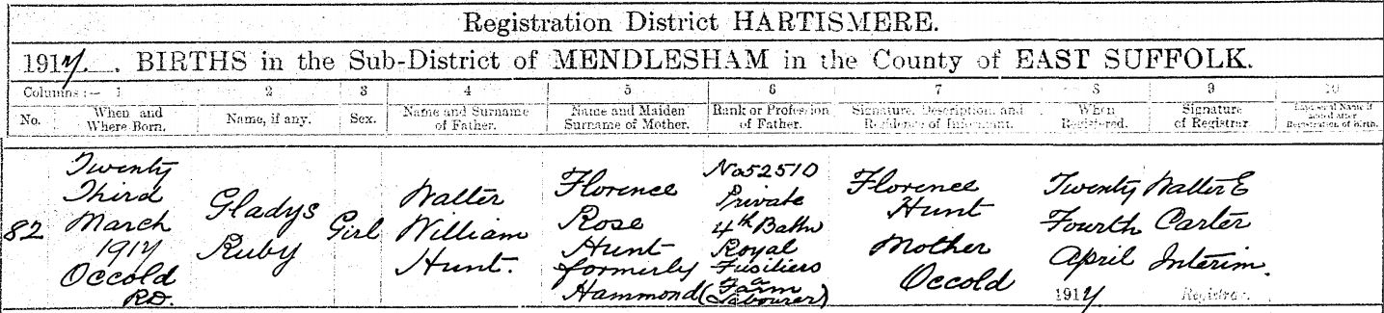

She married Arthur PLOWMAN (17 years her senior) in 1927 in Occold and they had one daughter Ena A in 1930. Florence died in 1968 and Arthur in 1969, both buried in Occold but grave unknown.
Parents: George HUNT and Mary CHAPMAN
His father George was born 1857 in Occold to single mother Mary Ann HUNT. Up until he married in 1880, he lived at Mill St, Occold with his grandfather Benjamin HUNT and started working as an ag lab at age 13.

He married Mary Ann CHAPMAN in 1880 in Occold and they had children Clara, Anna Maria (who married Frderick ELLIOTT, KIA 1916) and Walter William (KIA 1917). Thus, they lost both a son and a son-in-law.

He continued to work as an ag lab in Occold until his death in1928, buried in Occold, grave unknown.

His mother Mary was born 1859 in Monk Soham to parents William CHAPMAN and Sophia WARD. She only had one sister Maria since her father died in 1860, just 4 years after getting married.

She died in 1937 and buried in Occold, grave unknown.
Paternal grandparents: Unknown FATHER and Mary Ann HUNT
Mary Ann was born 1838 in Occold to parents Benjamin HUNT and Mary LOVET – no further information on his grandfather is available except that base born boys were often named after the father – but not conclusive and not much to go on!

She lived in Occold with her father Benjamin and her son George but in 1861 married James HAMMOND (born 1842 in Bedingfield) and thereafter lived in Bedingfield. They had children Edward, Clara, Walter, Matilda and Edgar.

She died in 1894, probably in Bedingfield.
Maternal grandparents: William CHAPMAN and Sophia WARD
We cannot pin down a birth for William as we have no clue to his age and he died in 1860 – just 4 years after marrying Sophia – thus we could not find them on an 1861 census which would have revealed his date of birth and where he was born.

The only clue is in 1861 with Sophia living in Monk Soham and being described as ‘previously ag lab’s wife’. Looking at 1841 and 1851 census for an unmarried William revealed no certain identity as the name is far too common.

Sophia was born 1833 in Bedingfield to parents Henry WARD and Mary FAIRWEATHER and seems to have lived a rather chequered life. She married William CHAPMAN in 1856 and had two children Mary and Maria but William died in 1860 after 4 years of marriage.

She then married Charles PENDLE in 1863 and had another 4 years of marriage before he died 1867. She finally married William BANHAM in 1883 and had 11 years of marriage but with no children until he died in 1894 and she died in 1897, both in Occold but grave unknown.
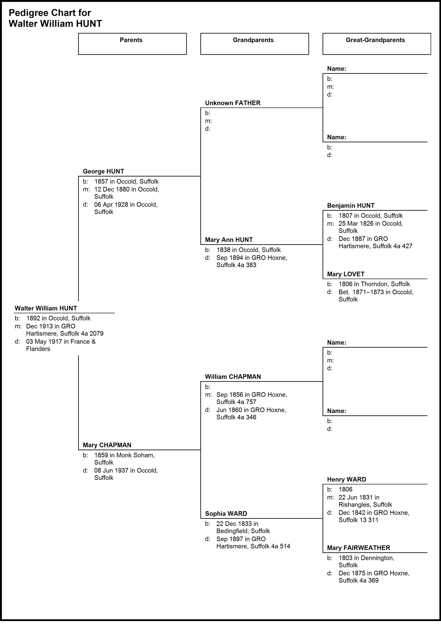
Pte James LISTER
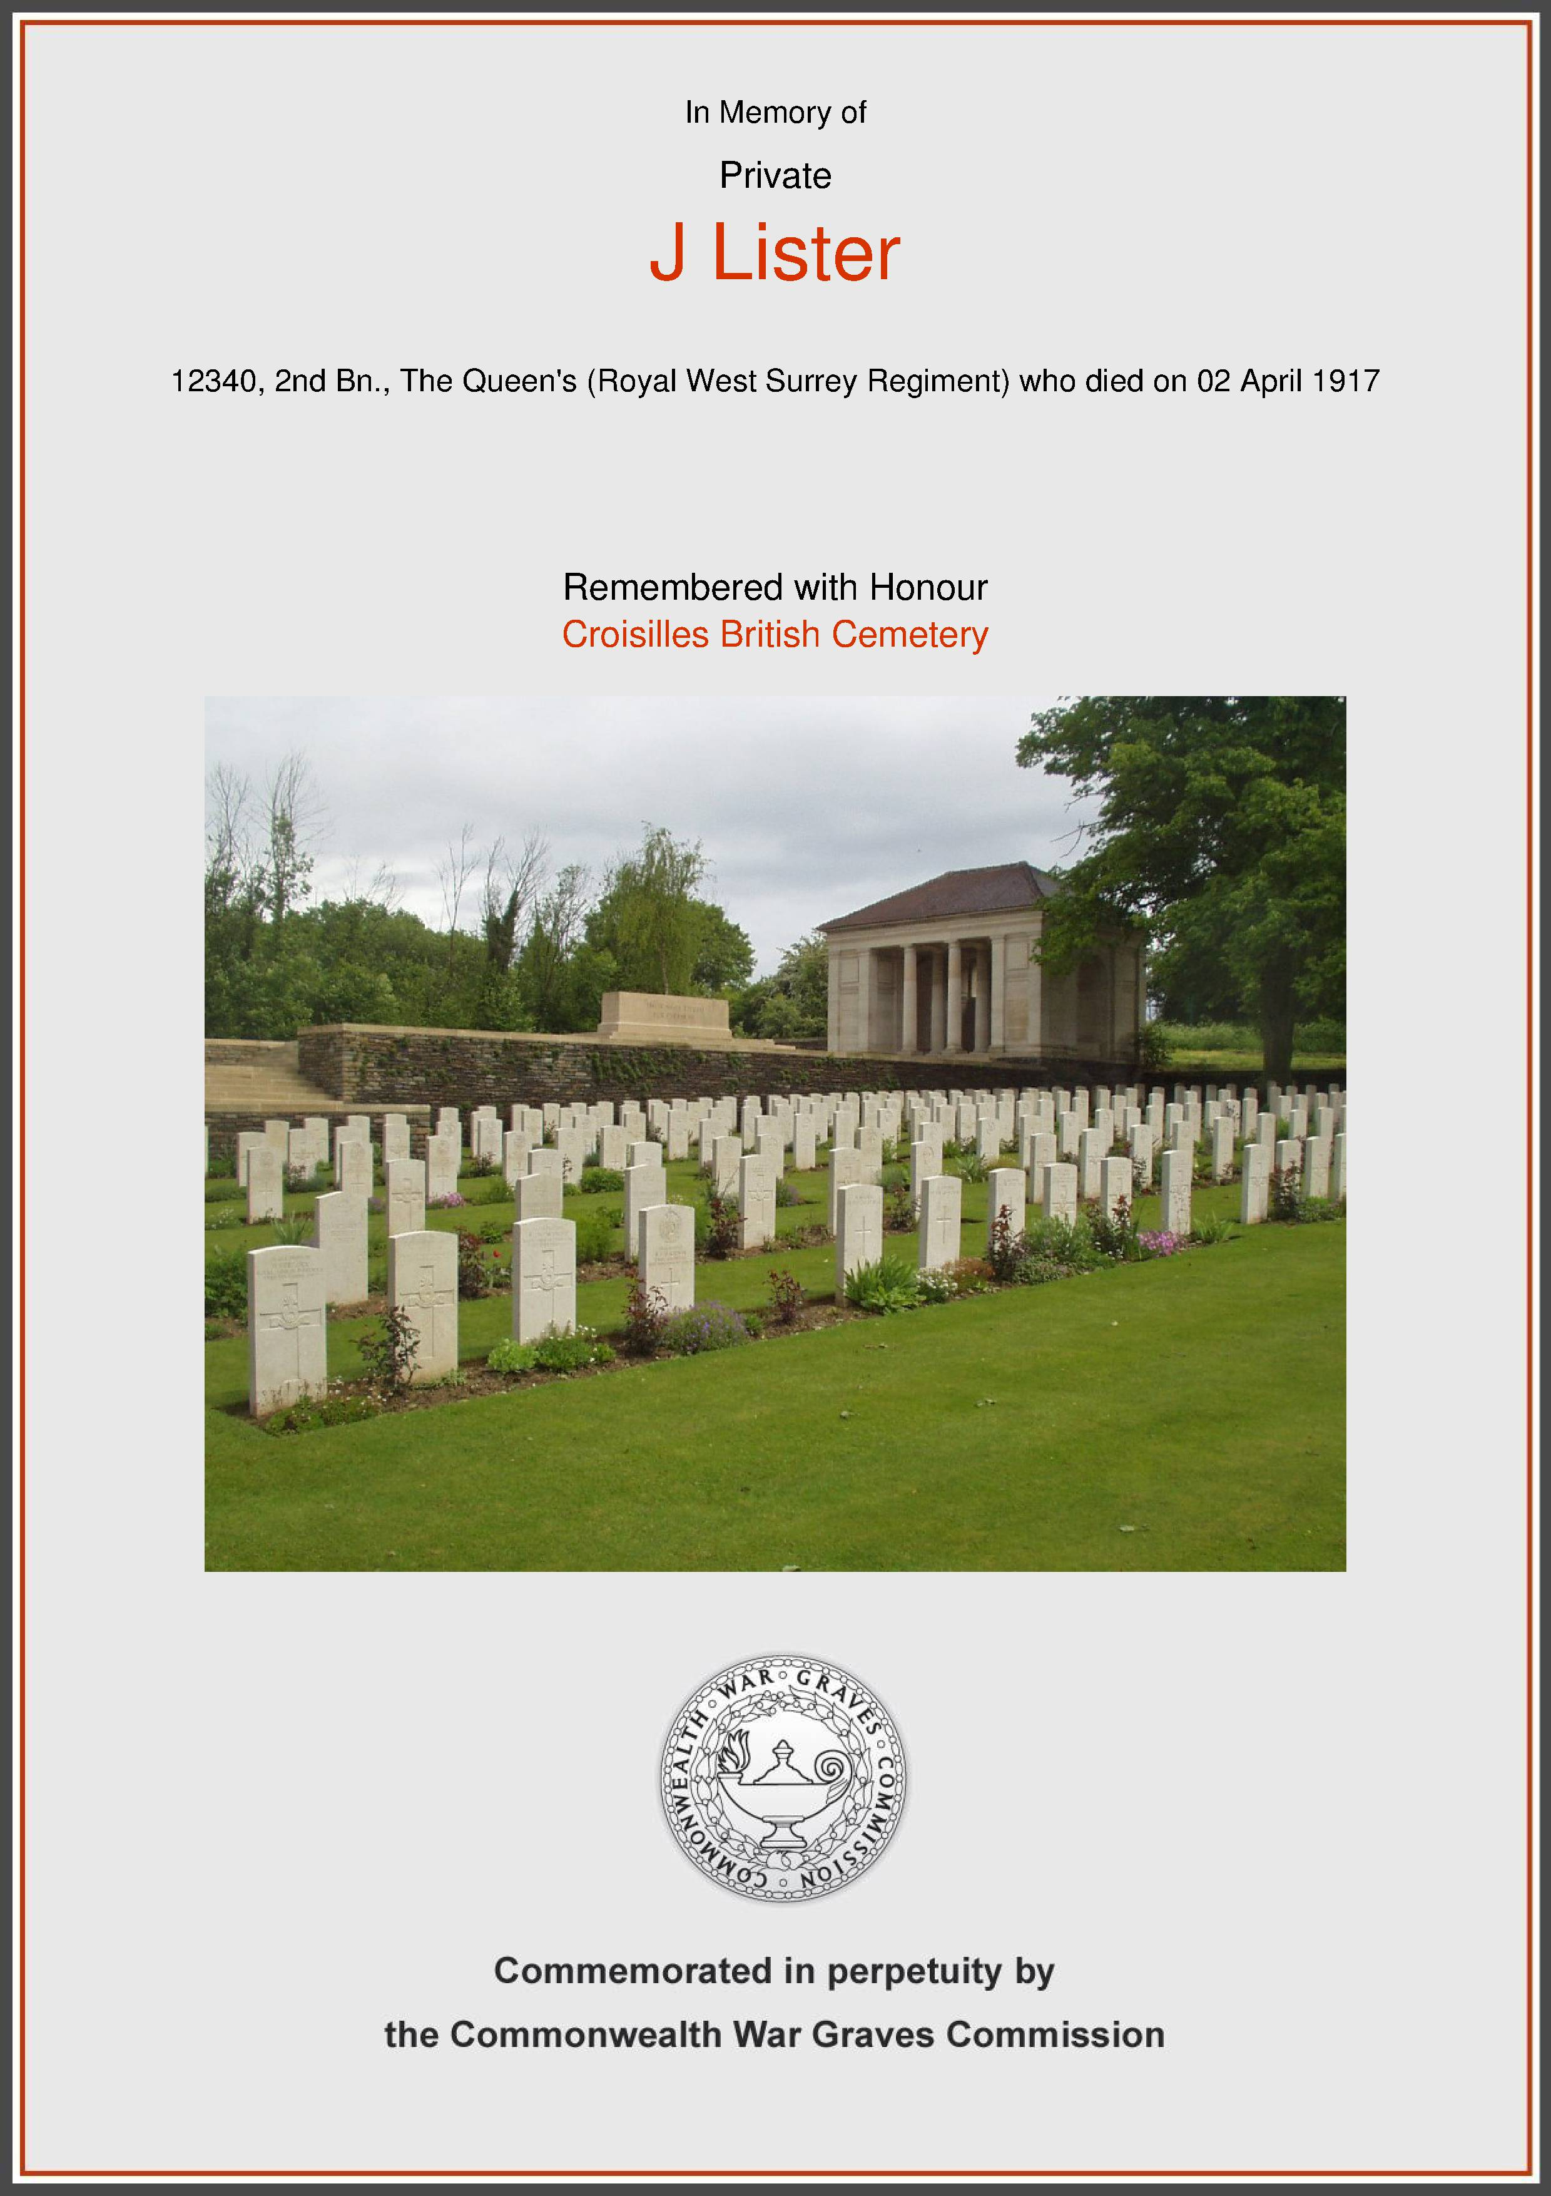
Self
James was born 1882 in Occold, the son of George LISTER and Caroline HUNT. He had 8 brothers and 4 sisters - William, Elizabeth, Walter, Ellen, Kate, Frederick, Charles, Reginald, Lewis, Arthur, Wallace and Ida.

In 1891, he was living at Grove Farm, Occold with his parents. In 1901 he was at Bulls Hall Road, Occold working as an ag lab. In 1911 he was a labourer on farm in Occold, most likely still at Bulls Hall Road.

He enlisted into the 2nd Battalion of The Queens (Royal West Surrey Regiment), serial number 12340 and served in France & Flanders but was KIA, Monday, 2 Apr 1917. He is commemorated at Croisilles British Cemetery, plot A, row 18. At the time of his death, he left effects of £4 17s 11d (£300 in 2015) to his father George. We would guess that this was largely his Army pay. In 1919, his father also received a War Gratuity of £3 10s 0d.

He did not marry and therefore has no direct descendants.
Parents: George LISTER and Caroline HUNT
His father George was born 1856 in Occold to parents William LISTER and Sarah KNIGHTS and in 1861 was living in Mill Rd. In 1871 he was working as a groom to James BREESE, farmer at Benningham Hall. In 1881 he was an ag lab in Occold and by 1891 had moved to Grove Farm, Occold again as an ag lab. In 1901 he had moved to Bulls Hall Road again as an ag lab and by 1911 was a labourer on farm. He died 8 Jan 1925 and is buried in Occold Cemetery, no known grave.

His mother Caroline HUNT was born 1860 in Occold to parents Lewis HUNT and Sophia LAST. She lived with her parents in Occold up until she married George in 1877 and had their 13 children. She died 25 Jul 1934 aged 74 and is buried in Occold Cemetery, no known grave.
Inter-relationships
As well as losing two of their sons, Caroline (but not George) was also related to 6 others on the Roll of Honour:

Frederick ELLIOTT – Husband of 1st cousin 1 x removed

Ernest Arthur MILLS – Brother-in-law of 1st cousin of wife of 1st cousin

George HAMMOND – Brother-in-law of 1st cousin 1 x removed

Walter William HUNT – 1st cousin 1 x removed

James HUNT – Nephew

Ernest Alfred HADDOCK – 1st cousin 1 x removed

Just goes to show how inter-related everyone was in a small community like Occold!
LISTER family in 1911
A short digression to take a closer look at the 1911 census, specifically for the LISTER family.

They lived in a 4 room cottage, possibly in Bulls Hall Road but we can’t pin it down. Living in the house were mother, father, 7 grown-up sons (14 yrs plus), plus 2 boys and 1 girl i.e. 12 people in total! Which begs the question, where did they all sleep? Where did they all eat? How long did the Saturday bath time take??

And the size of their shopping bill must have been eye watering! There were 8 grown-up men all working as farm labourers so their appetites must have been huge! And imagine mother Caroline having to cook for all those hungry mouths!

Having large families in relatively small properties was not uncommon but this one does top all the others that we know about.

They had 13 children and the fact that they all survived despite the infant mortality rate at the time is also a bit unusual. Three children not in the house in 1911 were his 3 daughters:

Elizabeth had married Arthur CASON in 1899 and in 1911 was living in Dragons Lane, Eye with 5 children – Maud, Florence, Elizabeth Rose, Arthur James and Hilda Violet.

Kate had married George Henry PLOWMAN in Occold on 8 Nov 1908 and in 1911 was living in Barracks Lane, Occold with two children George Henry and Wilfred Arthur.

Ellen was working as a housekeeper to Frank John SADD, retired, in Ipswich.

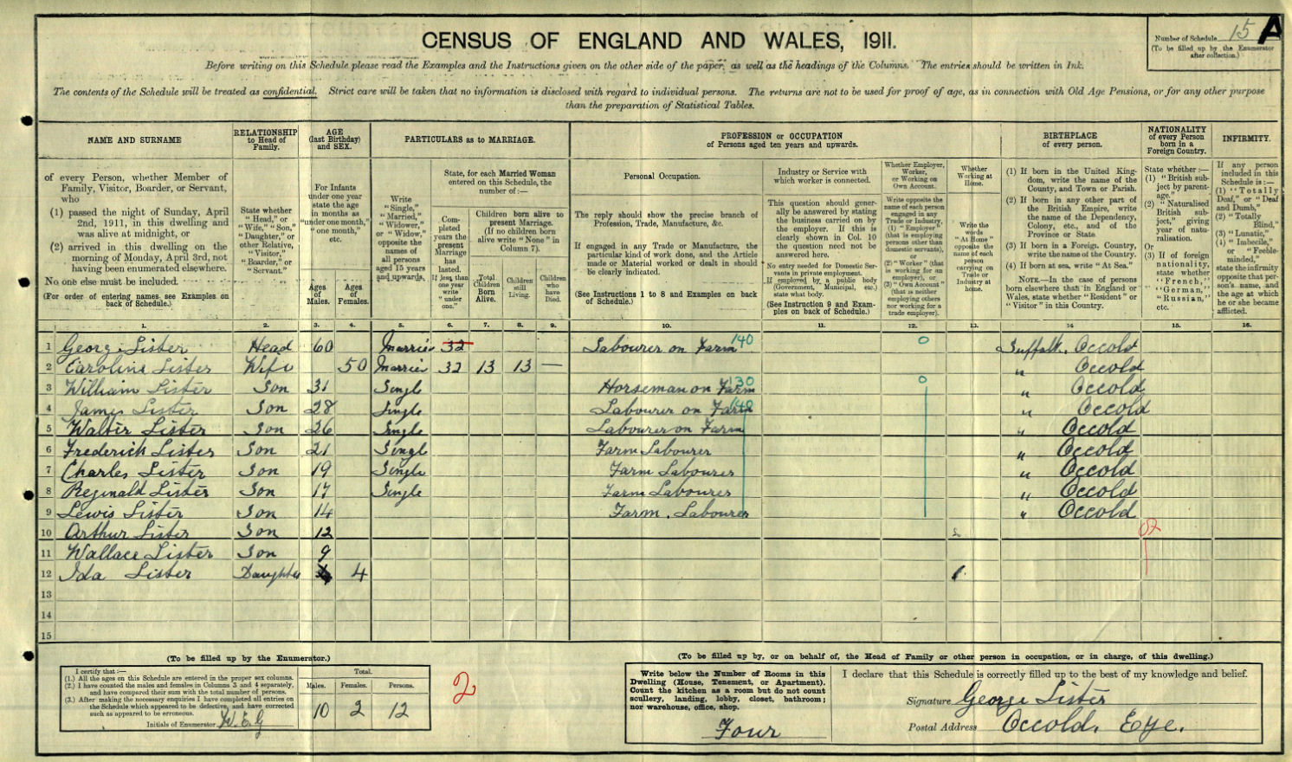
Paternal Grandparents: William LISTER and Sarah KNIGHTS
William was born 1816 in Burgate, the son of William LISTER and Charlotte RUDDOCK. He first married Maria LENNY, 1835 in Occold and they had 5 children – William, George (died 1843 aged 5), Hannah, Charlotte and Ann. In 1841, they were living in Benningham Rd where he was a shoemaker. Maria died ~Jul 1848 and a few months later William married Sarah KNIGHTS. Note - It was not uncommon for men who had lost their wives at an early age, often in childbirth, to re-marry very soon afterwards. After all, who was going to look after their children!!

They had moved to Redlingfield Rd by 1851 where William continued his trade as a boot and shoemaker. Over the next 15 years, they had 9 children – Rebecca, Jemma, Sarah, George (father of James LISTER), Ellen, James, Robert, Walter and Caroline. In 1861 they were living in Mill St, Occold and William was described as a cordwainer (shoemaker).

Both William and Sarah died on the same day (18 Jun 1866) and are buried in Occold Cemetery. Highly likely cause of death could have been an epidemic of which there was an outbreak at the time. And sure enough, both died of typhoid fever..

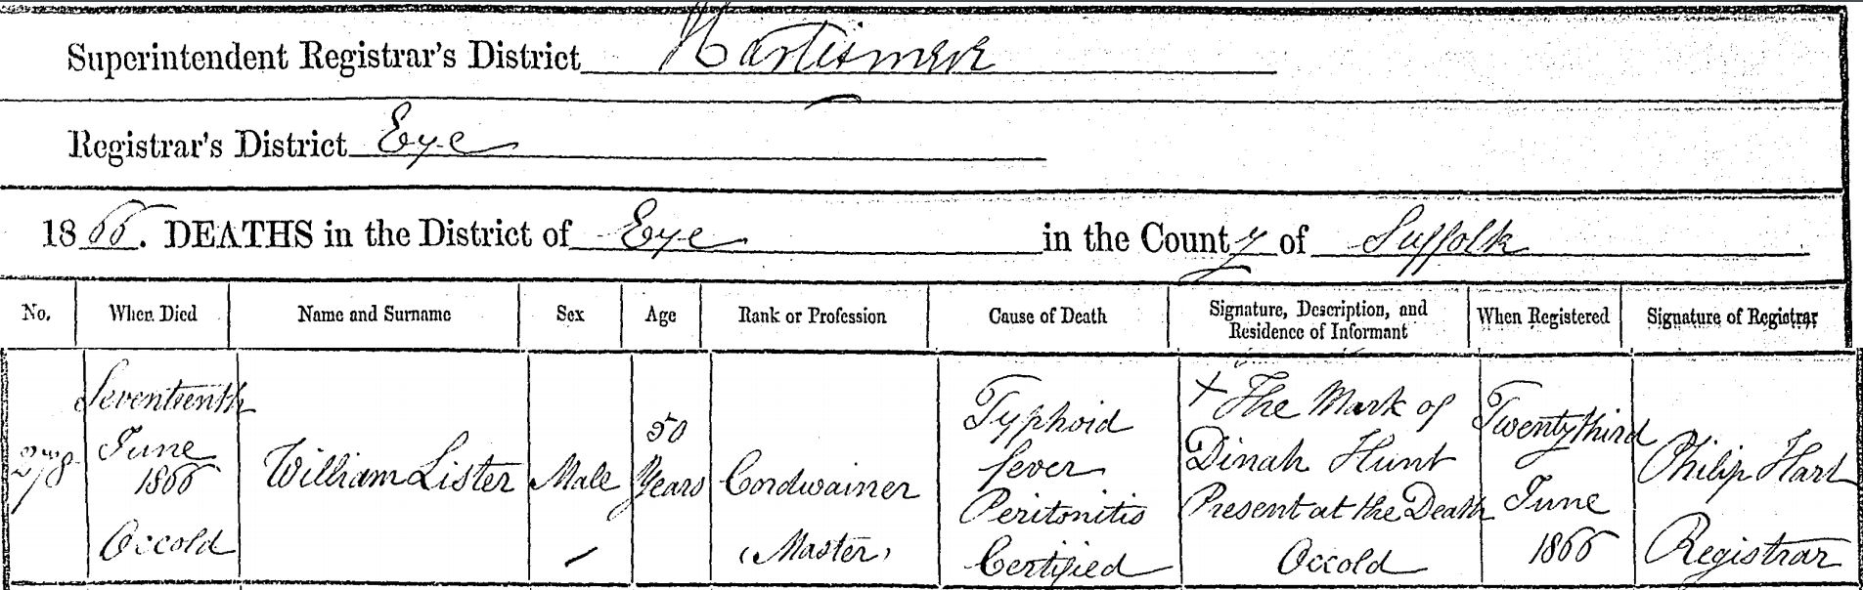

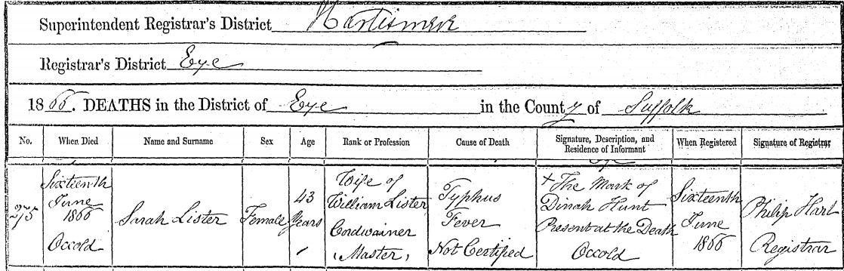

Sarah was born 1822 in Syleham to parents Stephen KNIGHTS and Sarah FIELD. It is possible, but not yet proven, that she was an ancestor of Kevin KNIGHTS, retired 2014 as Head Teacher of Occold Primary School.
Maternal Grandparents: Lewis HUNT and Sophia LAST
Lewis was born 1832 in Occold to parents Benjamin HUNT and Mary LOVET. Up until 1871 he was working as an ag lab and living in Redlingfield Rd. He married Sophia in 1854, probably in Occold, and they had 5 children – Maria, Walter William, Caroline, Anna and Lewis.

As well as being grandparents to James LISTER, they were also grandparents to James HUNT, KIA 1918 and who is also commemorated on the Occold Roll of Honour.

In 1881, he was described as an engine driver, most likely operating one of the increasingly popular traction engines being brought to Occold and which changed the face of farming. But in 1891 he was a coal seller probably supplying the other traction engines.

He died in 1896 aged 64 and is most likely buried in Occold as was his wife who died soon afterwards in 1896.
Brother: Reginald LISTER and Agnes E HARVEY
Reginald was 11 years younger than his brother James and had a similar past living with his parents in Occold and working as a farm labourer.

He married Agnes E HARVEY in 1915 and had a son Eric Reginald just a few months later (!).
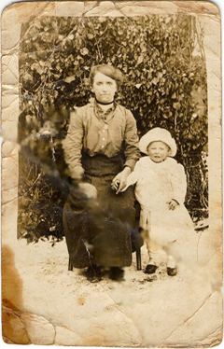
He enlisted in the 11th Battalion, Royal Fusiliers, service number 11362 and was KIA, 19 May 1918. He left effects of £12-1s-6d (worth £750 in 2015) to his widow and, in 1919, also received a War Gratuity of £8-10s-0d.

Soon after they married, they must have moved to Redlingfield since he is not commemorated on the Occold Roll of Honour but is on the Redlingfield Roll of Honour.

From the Redlingfield web site:
Aggie Harvey married Reggie Lister, who then served in the 1914-1918 war. The photograph of Aggie and son Eric (left) was sent as a postcard and on the back was written: “To my dear husband, from his loving wife, a little son Eric”. It was addressed to Private R Lister in France and dated November 7th 1918 (see Note below).

Reggie never returned from the war and it is believed never saw Eric. Aggie later married Reggie’s brother Arthur and had several more children. She lived in Mill Road in Redlingfield until her death (in 1966). Aggie’s daughter Margery Taylor, nee Lister, lives in Eye and her son Gordon Lister lives in Cratfield.

Note: A bit strange – Reginald died May 1918 so it seems a bit surprising that Aggie sent the postcard in Nov 1918 – so looks like she didn’t know of his death? I doubt this is true – the Army were very diligent about recording soldiers who fell and would send out the dreaded black bordered telegram very quickly. Eric was born in 1915 (just a few months after they married) and he looks, in the photo, to be about 2yrs old at most. So I suspect the send date was more likely 1916 or possibly 1917.

Their son, Eric Reginald, does not appear to have married but died in 1984 aged 69 whilst still living in the same house at 3 Mill Road, Redlingfield.
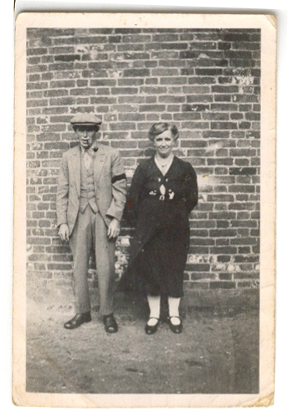
Brother: Arthur LISTER and Agnes HARVEY
Arthur was 16 years younger than his brother James. In 1921, he married Agnes E Harvey, widow of his brother James. They had 6 children between 1920 and 1934 – Cecil Arthur, Violet C, Maurice G, Raymond L, Marjorie M and Gordon K.

Right: Arthur and Agnes – circa 1960.

The reason I say from 1920 is that Cecil Arthur, according to his death certificate, was born 13 Dec 1920 but Arthur and Agnes did not marry until Jun-Sep 1921. So it is possible that he was base born to Agnes but, without a birth certificate, we have no way of knowing whether Arthur was the father. But even if he had been base born, he would still have the surname LISTER by virtue of it being Agnes’s surname at the time so no clues there!

In 1939 (from the recently released census), he was working as a farm labourer in Rickinghall but we cannot trace his movements until his death in 1966, aged 67.

Agnes HARVEY was born 1892 in Redlingfield to parents George HARVEY (1853-1934) and Caroline MUTTOCK (1848-1912). Her parents and grandparents all came from Redlingfield and worked as farm labourers albeit her grandfather Benjamin HARVEY was also the innkeeper at Redlingfield in 1871.

Of their children, Cecil Arthur LISTER married Ivy Dora CHAMBERS in 1956 and they had a son David. Cecil died 1992 and Ivy 2003, both buried in Occold Cemetery. We have not yet found any gravestone but recording the monumental inscriptions is a work in progress so their may be one.

And their son Raymond Leslie LISTER and his wife of a few months, Sylvia Joan CUTHBERT, were tragically killed when their motorcycle was in collision with a car at Southolt Park Corner, Southolt on 1 Jul 1956. There is a gravestone to them in Redlingfield churchyard.
Brother: Frederick LISTER and Annie KERRY
Frederick was 8 years older than his brother James. He lived at Grove Farm, Occold in 1891, Bulls Hall Road in 1901 and described as a labourer on farm in 1911. But what is remarkable is that he died at Green Farm, Occold in 1948 and left effects of £4,570 4s 5d (worth £159,641 in 2015 values). How did Frederick amass such a large sum as a humble farm labourer?

His executors were his step-son Percy KERRY, smallholder and his son Frank Herbert LISTER, farmer.
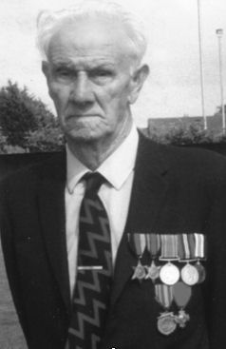
Note: Percy KERRY was base born to Annie, 1 Jan 1916 and then married Frederick just 4 months later. It is tempting to think that Frederick could have been the father but without the birth certificate, there is no way of knowing. However, since he kept the surname KERRY it is rather doubtful. In his 90’s, Percy wrote a booklet about Farming and Rural Life in Occold which makes fascinating reading.

Frederick and Annie had 5 children, 1912 – 1923, Walter J, Gladys (died age 2), Ruby Ai, Reginald Thomas and Frank Herbert.

Annie died 1978 (30 years after Arthur) in Occold and both are commemorated in Occold.
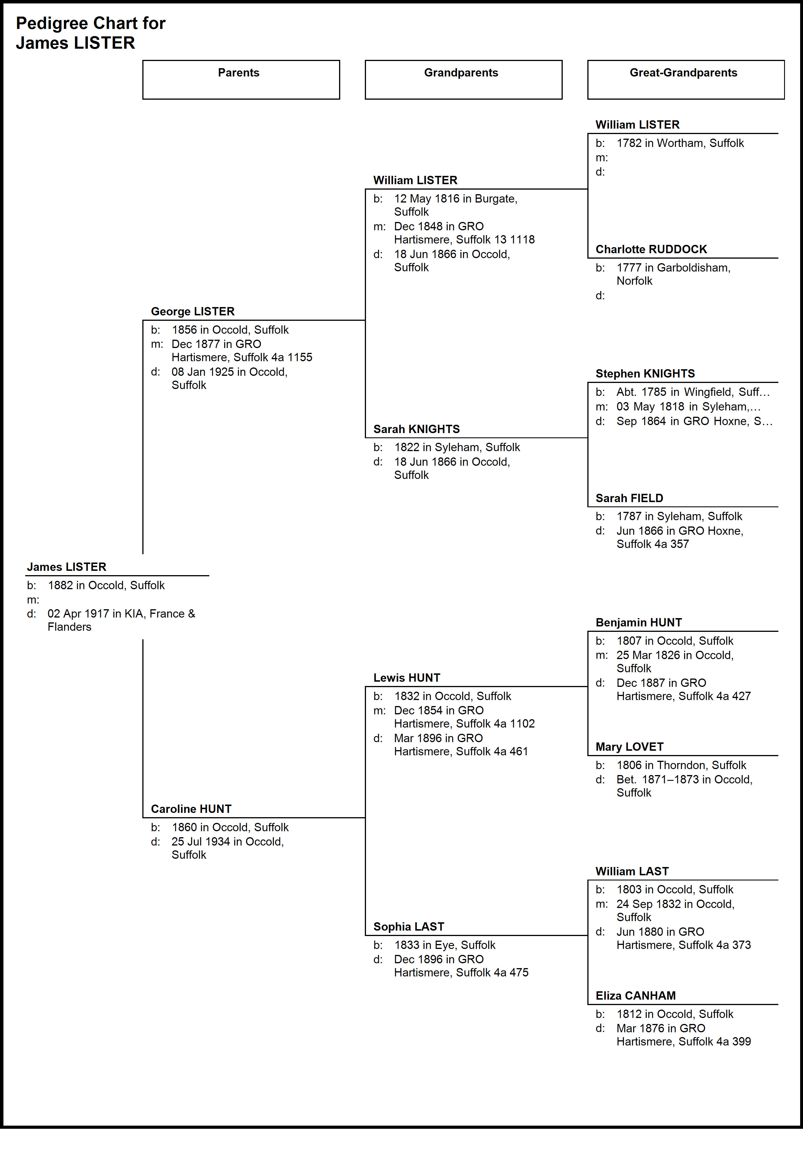
Pte Ernest Arthur MILLS
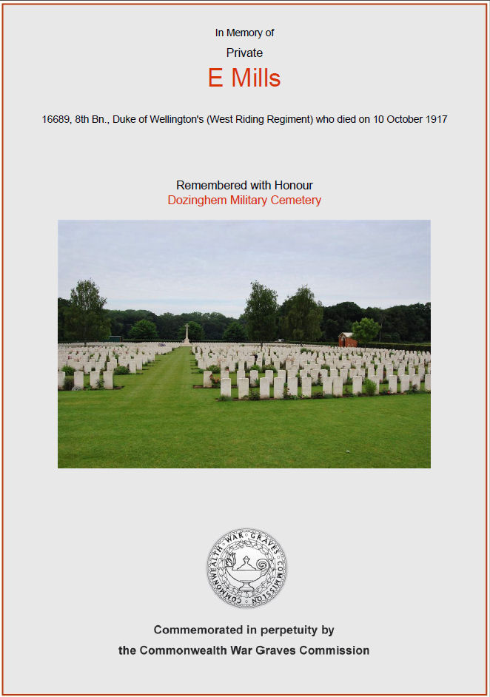
Self
Arthur was born 1893 in Eye to parents William Samuel MILLS and Fanny CHAMBERS. In 1901, he was living with his parents at The Duke of Wellington Inn, Back Lane, Eye where his father was a brewer’s salesman. In 1911, he had moved to Colchester to find work as a railway engine cleaner.

Like many other soldiers, he came from 3 generations of farm labourers, all from Eye, until his father became a publican. He had siblings Frederick, William, Florence and Charles.
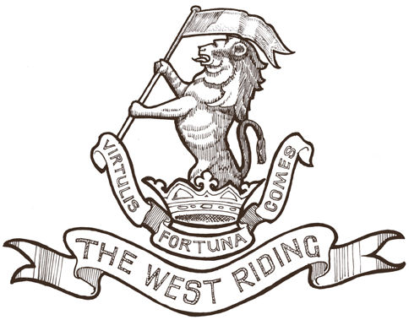
By 1917, he had enlisted in the 8th Battalion, Duke of Wellington’s (West Riding Regiment), serial number 16689. Any connection with where he grew up? Seems a strange regiment to join unless he moved to Yorkshire? He served in France & Flanders but was KIA on Wednesday, 10 Oct 1917.

He is commemorated at Dozinghem Military Cemetery, Poperinge, West-Vlaanderen, Belgium, grave number X. J. 9.

He was unmarried at the time of his death so leaves no direct descendants.
Parents: William Samuel MILLS and Fanny CHAMBERS
His father William Samuel was born 1864 in Eye to parents Charles MILLS and Elizabeth MARTIN. He spent his childhood and early life in Ludgate Causeway, Eye initially working as an ag lab and then as a brewer’s lab.

In 1911 he was a brewer’s salesmen at The Duke of Wellington Inn, Back Lane, Eye and we believe he took over as landlord at some point.
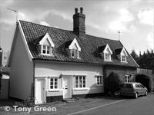
The pub is now 35 Wellington Rd, Eye but has been converted to residential use. It was previously near the Charles Fisher Brewery supposedly in Brewery St but no such street appears on maps of the period.

It was closed by Adnams Brewery, Southwold on 10th Oct 1908 ‘to reduce the number of “excess” alcohol licenses’! Look at the date – 10 Oct – the same date as Ernest Arthur was KIA.
Source: www.suffolkcamra.co.uk

With the closure of the Duke of Wellington, he took over as landlord of the Beaconsfield Arms, Occold. We do not know at what point he left there but he died 1934 and is buried in Occold, at the far end of the cemetery from the road and on the right hand side, along with his wife Fanny.

Arthur’s mother Fanny was born 1866 in Eye to parents George CHAMBERS and Maria CASON. She lived her early life in Ludgate Causeway, Eye – obviously a close neighbour to her future husband William whom she married in 1884.

She died 1955 and is buried with her husband in Occold cemetery.
Paternal grandparents: Charles MILLS and Elizabeth MARTIN
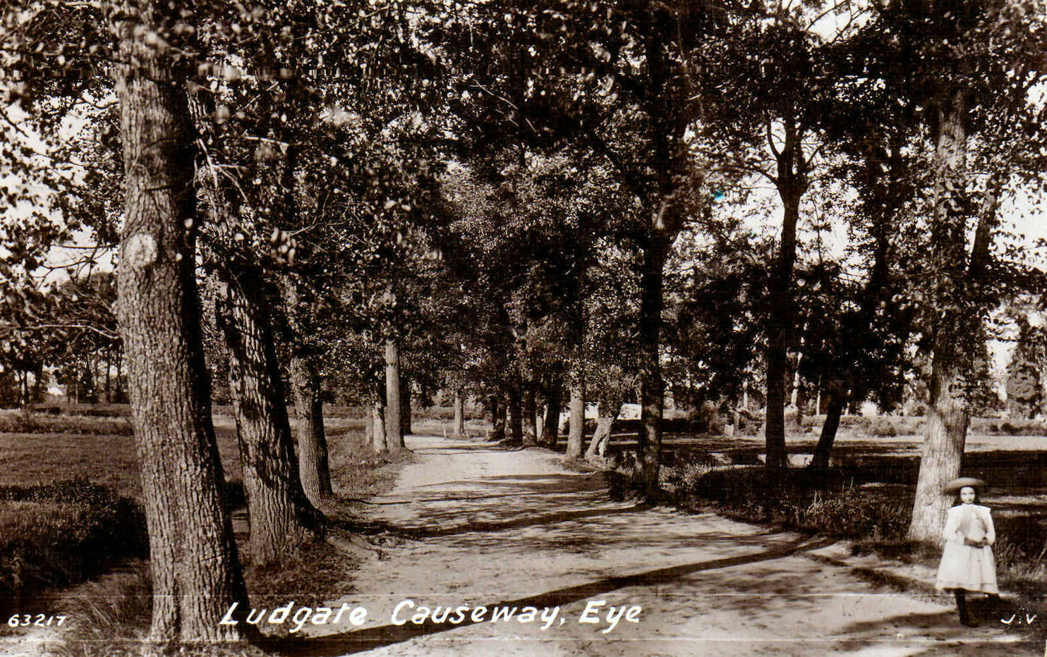
Charles was born 1842 in Eye to parents James MILLS and Mary Ann THURLOW. He lived initially in Lowgate St before spending his early years as an ag lab and then a coal porter at Ludgate Causeway.
He continued as an ag lab at Cranley Hill until his death in 1920 in Eye, probably living at Vine Cottage, Braiseworth Rd, Eye.
Elizabeth was born 1846 in Braiseworth to parents Noah MARTIN and Mary BOOTY. Before age 15, she was a house servant to Edward TRASKE, farmer of 72 acres living in Cock Rd, Eye until she married Charles in 1864. She died in 1910 leaving Charles as a widower until his death in 1920.
Maternal grandparents: George CHAMBERS and Maria CASON
George was born 1830 in Eye to parents Robert CHAMBERS and Sophia BURROWS. He led his entire life as an ag lab living in Ludgate Causeway (see above) until his death in 1894. He married Maria CASON in 1854 and they had 10 children over the following 24 years.
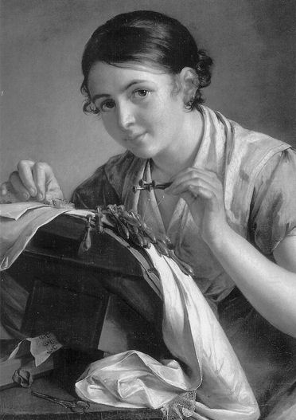
Maria CASON was born 1834, also in Eye, to parents John CASON and Mary HUNT. There are a large number of HUNT families in Occold but we have not connected this Mary to any one of these.

She spent her childhood years in Magdalene St, Eye and, at about age 12, became a lace weaver – a fairly common occupation for young girls as they entered their teens and was most prevalent around Occold, Eye and Yaxley.

Photo of a lace weaver is for illustration purposes only.

Descendants
Ernest did not marry so has no direct descendants. Of his siblings:

Frederick William was a blacksmith (veterinary). He married Rosa Winifred CANHAM in 1904 and they had one son Leslie in 1906.

He must have moved to Occold at some time as he in recorded in the burial registers and both are buried in the cemetery. Note that there are fresh flowers on the grave when the picture was taken in 2006. Perhaps there are some close relatives nearby?

William Ernest was a cowman on farm. He married Ellen CARTER in 1909 but, as far as we know, never had any children. With such a common surname, we have not tracked down either of their deaths.

Florence married Wallace WRIGHT in Occold 11 Jun 1911 but we have not managed to trace any children or their deaths.

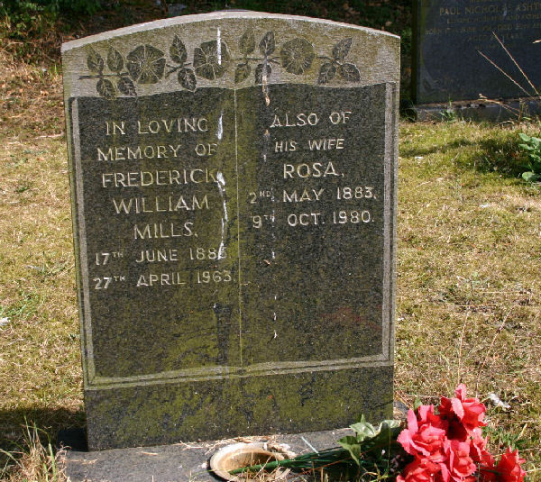
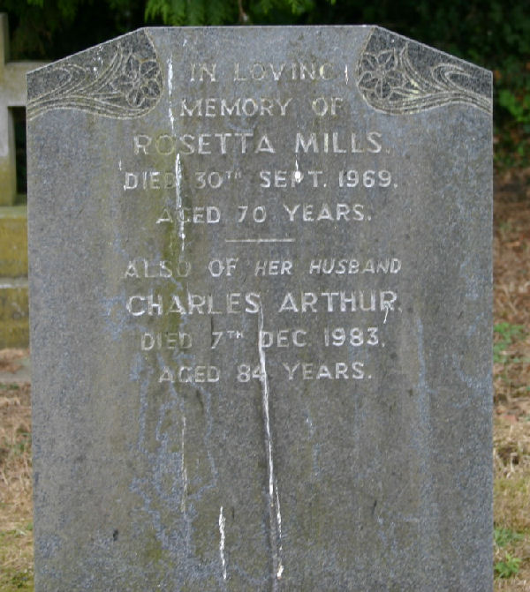
Charles Arthur married Rosetta WILDING in 1918. Again, we have not managed to find any children. But they both died in Occold and are buried in the cemetery.

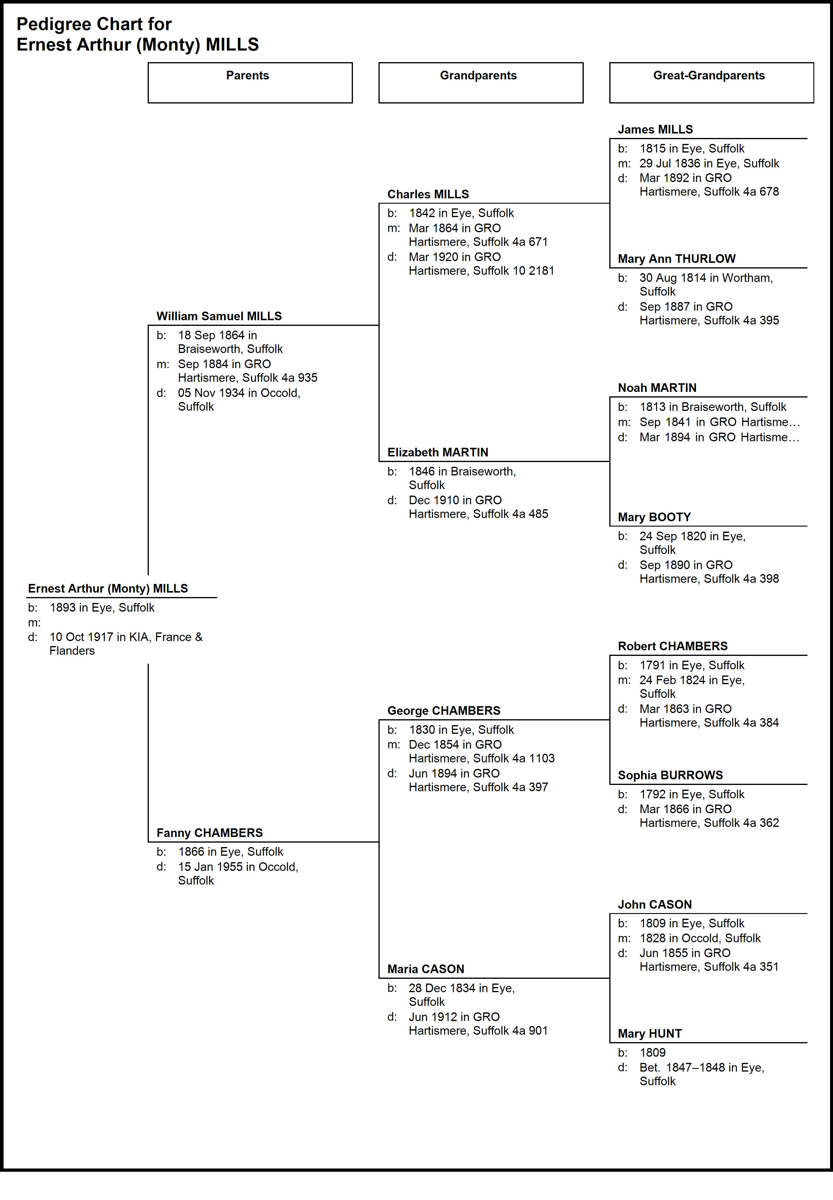
Pte Charles Robert MULLENGER

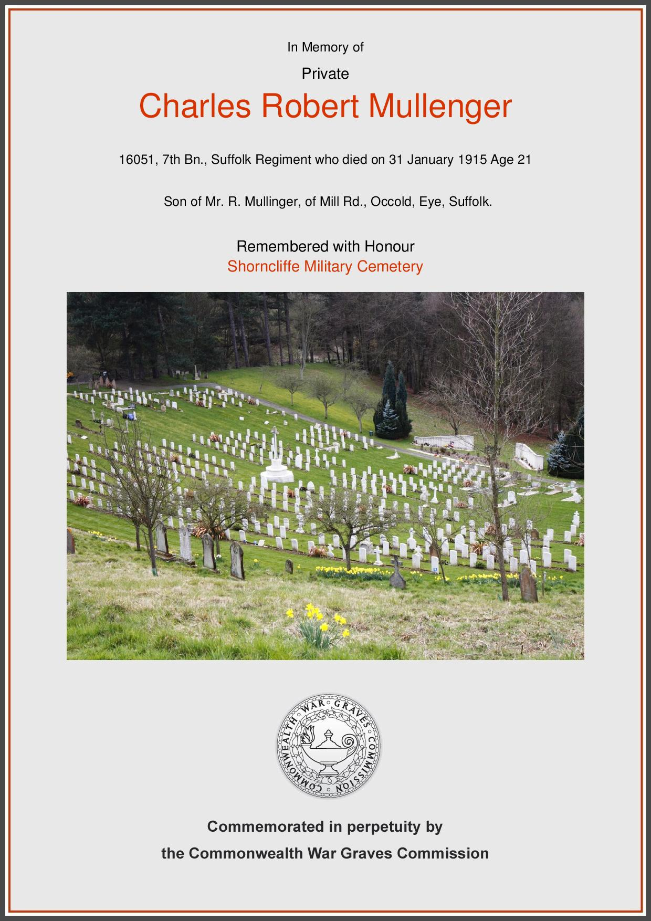
Pte George Frederick MULLENGER

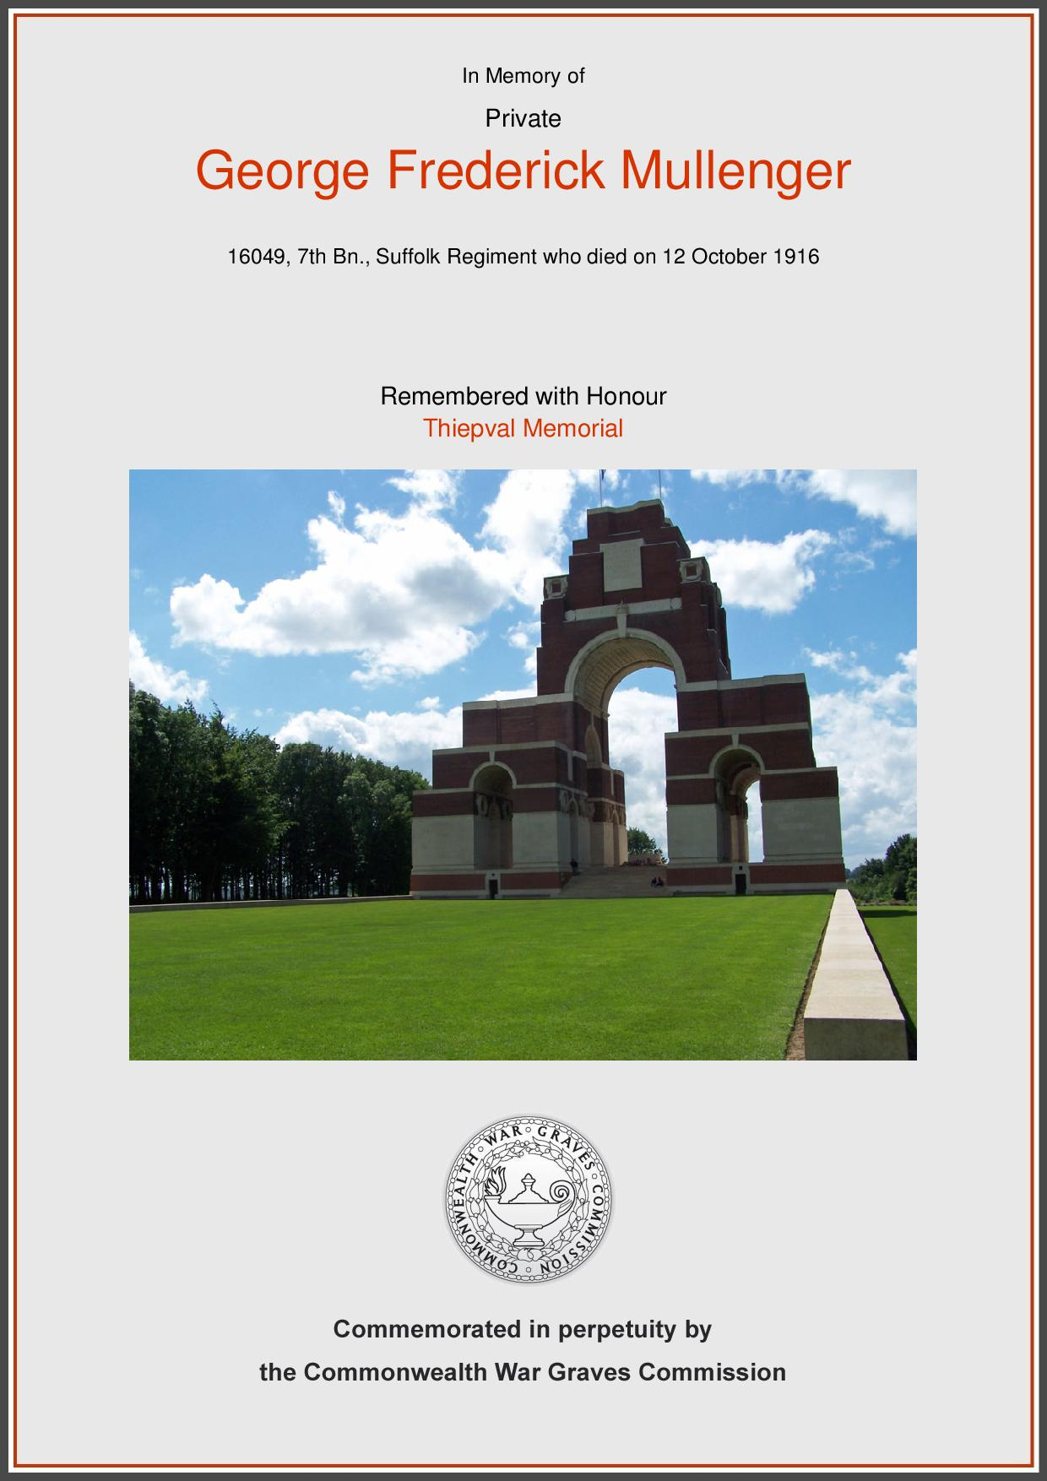
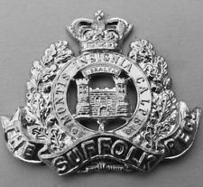
Selves
Charles Robert was born 1894 and George Frederick 1897 in Winfarthing, Norfolk to parents Robert MULLENGER and Mary Ann POTTER. In 1911 Robert, Mary Ann and their children are still living in Winfarthing. Their parents, grandparents and great-grandparents all came from Winfarthing which does rather begs the question ‘Why are they on the Occold Roll of Honour?’

There are some clues to suggest that sometime soon after 1911 they moved to Occold. When KIA in 1915, the Commonwealth War Graves Commission had the father of Charles Robert listed as Robert MULLENGER of Mill Road, Occold.

Additional clues would be in the form of the Occold Parish Registers which show that son Ephraim married Hannah Mary PALMER in 1922, daughter Annie Miranda married Walter Horace BREWSTER in1925, daughter Ruth married Benjamin William FISK in 1926 and daughter Alice Louisa married Charles FISK in 1928 (probably 2 sisters married 2 brothers!!).

Furthermore, Robert died in Occold in 1956, 12 years after his wife Mary Ann died in Occold in 1944. Both are buried in Occold Cemetery but no gravestone has yet been found.

Charles Robert, a farm labourer, enlisted in the 7th Battalion, Suffolk Regiment, Service no 16051. He was KIA on Sunday, 31 Jan 1915 but, strangely, is commemorated in Shorncliffe Military Cemetery, Folkestone, Kent – NOT on any of the France and Flanders memorials in France and Belgium. However, it does mean he had a death certificate…..

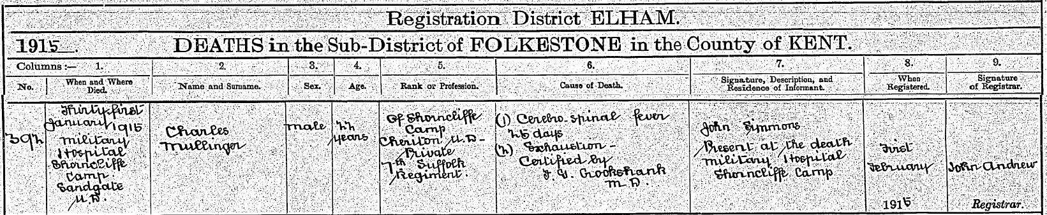

This shows he died of cerebro-spinal fever and exhaustion. Most likely scenario is that he fought in France & Flanders but was evacuated back to England. Because of his previous service, he was listed as KIA.

George Frederick, a farm labourer, also enlisted in the 7th Battalion, Suffolk Regiment, Service No 16049. Look at their Service numbers! They must have enlisted on the same day practically standing next to each other!! He was KIA on Thursday, 12 Oct 1916 and is commemorated at Thiepval Memorial.

Note: The name MULLENGER (MULLINGER) is believed to be of German origin since we have tracked MULLENGERS arriving in Suffolk back to early 1700’s.
Parents: Robert MULLENGER and Mary Ann POTTER
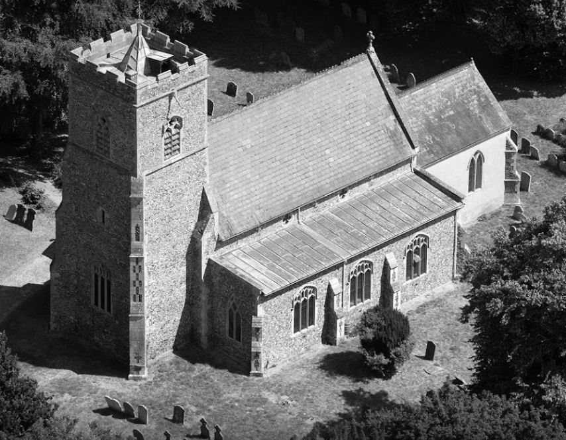
Robert was born 1872 in Winfarthing (right) to parents Matthew MULLENGER and Lucy FULCHER. He lived fairly typical labourer existence in Winfarthing being described as an ag lab in 1891, a horseman on farm in 1901 and a farm labourer in 1911. As already mentioned, he appears to have moved to Mill Rd, Occold around 1912 and would probably have continued in his rural occupation(s) until his death in 1956 and burial in Occold Cemetery.

He married Mary Ann (Anna) POTTER at the end of 1892, probably in Winfarthing. She was born 1875 in Winfarthing to parents Robert POTTER and Ruth WRIGHT. She spent her childhood in Winfarthing without any occupation. She died 1944 in Occold, aged 69 and is buried in Occold Cemetery.
Paternal grandparents: Matthew MULLENGER and Lucy FULCHER
Matthew was born 6 May 1836 in Winfarthing to parents George MULLENGER and Elizabeth WITTON. But was baptised at Shelfhanger Baptist Chapel on 14 Feb 1837. He was born, married and died in Winfarthing and his whole life as an ag lab.

He married Lucy FULCHER in 1864, most likely in Winfarthing and had 3 children Terah, Robert and George although there may have been others who passed away.

Lucy was born 1843 in Winfarthing to parents unknown but her grandmother was Lydia PECK born 1797 in Winfarthing.

Matthew died at the relative young age of 54 in 1890 in Winfarthing. Lucy survived another 46 years but died 1936, location unknown.
Maternal grandparents: Robert POTTER and Ruth WRIGHT
Robert was born 1833 in Winfarthing to parents Soloman POTTER and Phoebe BANHAM and, like many others, was born, married and died in Winfarthing having spent all his life as an ag lab until his death in 1901.

He married Ruth WRIGHT in 1855. She was born 1831 in Winfarthing to parents Elijah WRIGHT and Rebecca WOODS.

Robert and Ruth had at least 4 children Albert, Frederick, Emma and Mary Ann and we know that Mary Ann died 1944 in Occold. Ruth died 1892.

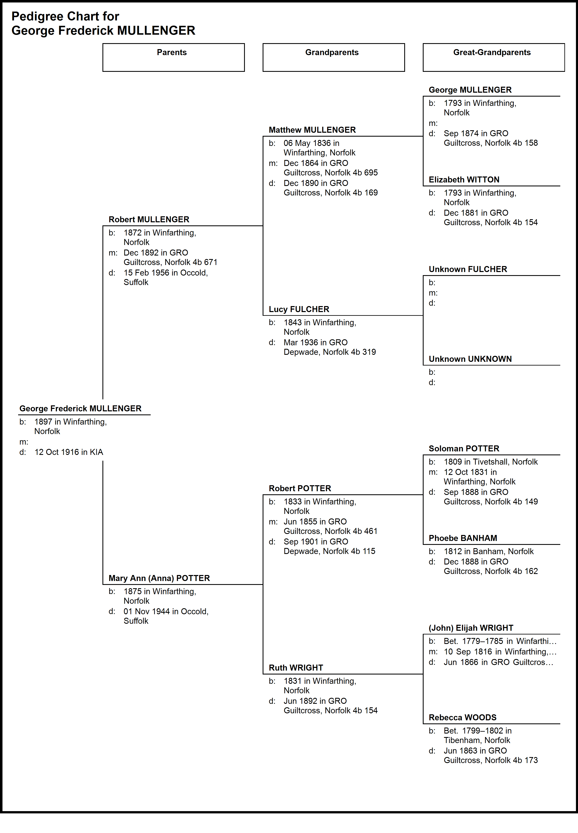
Pte William POTTER

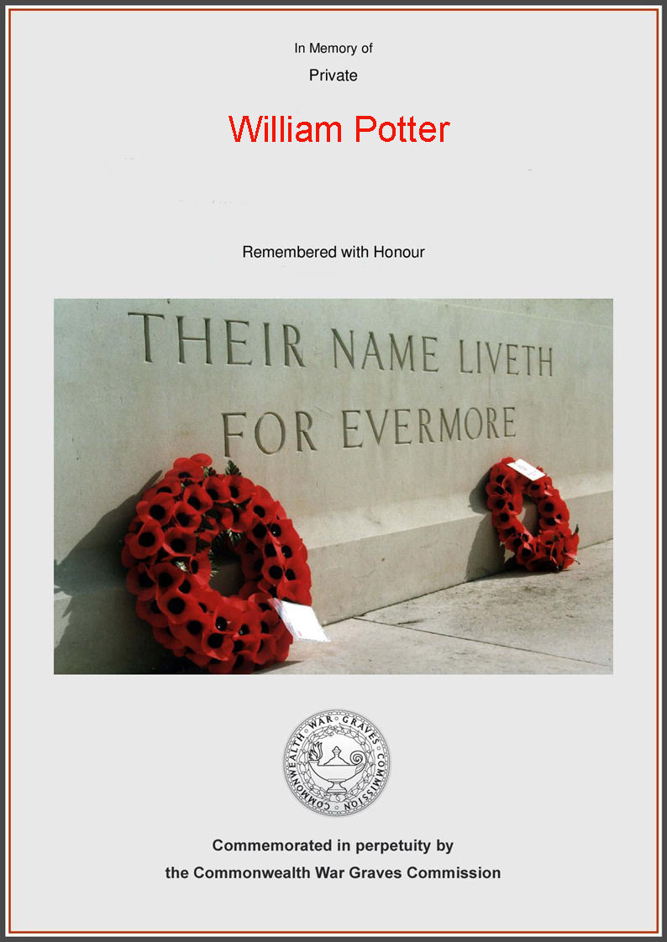
Self
William poses a bit of a problem! He is listed on the Occold Roll of Honour as KIA but he did, in fact, die in Occold. His death certificate (below) shows he died in East Suffolk Hospital on Saturday, 1 May 1918. Cause of death is shown as:

- Appendicitis and peritonitis
- Post operative shock

Neither of these suggests he was wounded or killed in action. However, it does show he was an ex-gunner in the Royal Garrison Artillery so he must have seen service in the Army and possibly in France & Flanders. However, his Army Service Record is not available so this cannot be proven. He is also shown as ex-gunner which would suggest he had been discharged from the Army before returning to Occold but whether this was because he was wounded in action we can only speculate.

His last address in Occold is shown as Red House Farm, Hartismere Road. Informant of the death was Kate Green, cousin of 110 Victoria St, Ipswich but we have not found out who she is.

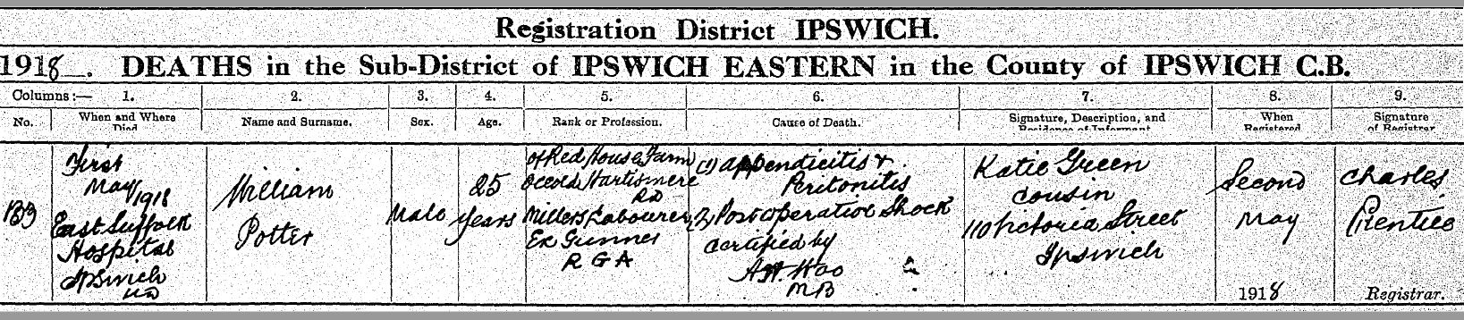
GRO Death Certificate

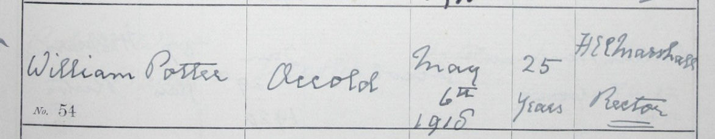
Occold Burial Register

He was born 1893 in Thorndon to parents Arthur George POTTER and Mary Ann TUFFS. In 1901 he was living with them in Wingfield Road, Occold. By 1911, he was still living in Occold and described as a miller carter. He had siblings Ethel (born 1890) and Dick (born 1891) both in Thorndon. He did not marry and therefore leaves no direct descendants.
Parents: Arthur George POTTER and Mary Ann TUFFS
Arthur was born 1865 in Thorndon to parents George POTTER and Emma GARRARD. He started and remained as an ag lab but moved to Wingfield Rd, Occold between 1891 and 1901. He lived to the ripe old age of 83 until his death in Occold in 1946. Surprisingly for an ag lab, he left effects of £173 5s 6d (£6,900 in 2017) to his executor Dick POTTER (his son). He is commemorated in Occold Cemetery.

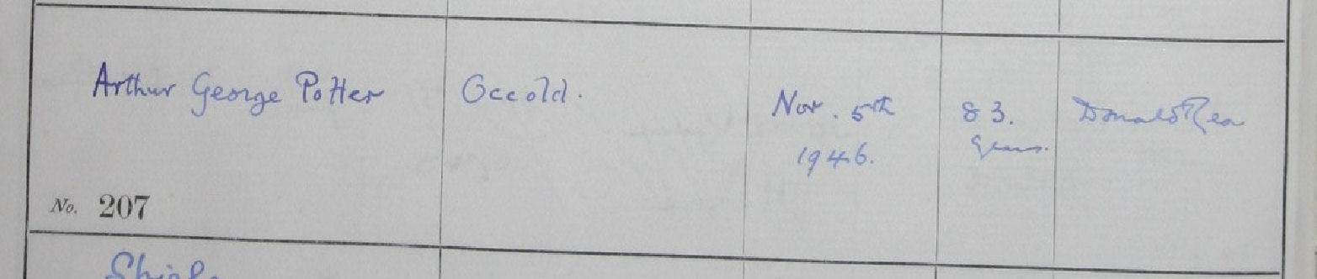

He married Mary Ann TUFFS in 1889. She was born 1868 in Eye to parents James TUFFS and Rebecca DYE. They only had 3 known children – Ethel, Dick and William.
Paternal Grandparents: George POTTER and Emma GARRARD
George was born 1837 in Thorndon – parents unknown since he could not be found on the 1841 census. He lived in Thorndon as an ag lab until going up in the world and moving to Benningham Green before 1891 as a farm steward – living next door to James LISTER (KIA) at Grove Farm. But in 1901 he had moved to Tongates Farm, Dennington. We assume this is where he died in 1911.

He married Emma GARRARD in 1859. She was born 1838 in Thorndon to parents John GARRARD and Hannah UNKNOWN. She remained in Thorndon until marrying George. Her last known address was Tannington, Suffolk before she passed away in 1933.
Maternal Grandparents: James TUFFS and Rebecca DYE
James was born 1836 in Eye to parents John TUFFS and Hannah HASSAM. He spent has entire life as an ag lab but moved around the Eye area several times – Park Cottage in 1841, Park Lodge in 1851, Lowgate St in 1861, Cranley Rd in 1871, Cranley Hill in 1881, Magdalene St in 1891, back to Cranley Hill in 1901 and 26 Cranley Hill in 1911 before his death in 1917.

In 1857 he married Rebecca DYE, parents unknown. They had 12 children between 1858 and 1881, all born in Eye – Walter, Hannah (deceased), Maria, Emily, Eliza, William, Mary Ann, Ellen (deceased), Ellen, Hannah, Emma and John – 3 boys and 9 girls!!! The 1911 census shows that 3 of the children died.

Rebecca died 1911 aged 76.
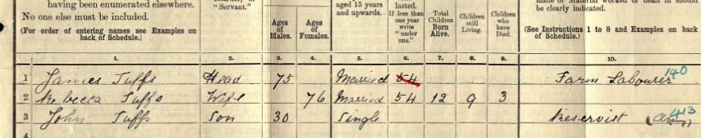

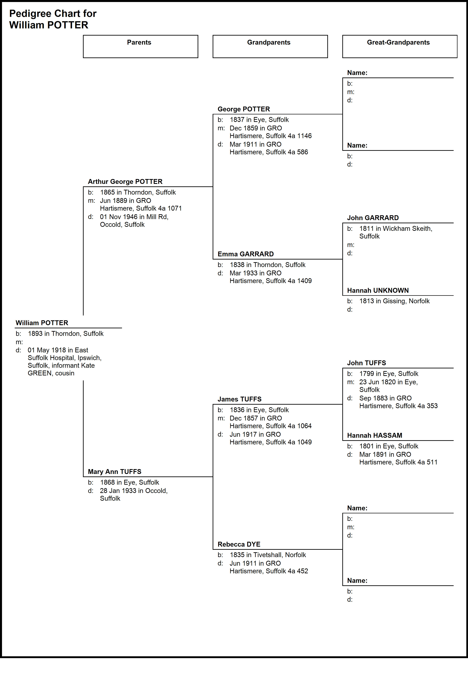
Pte William ROOT, MM
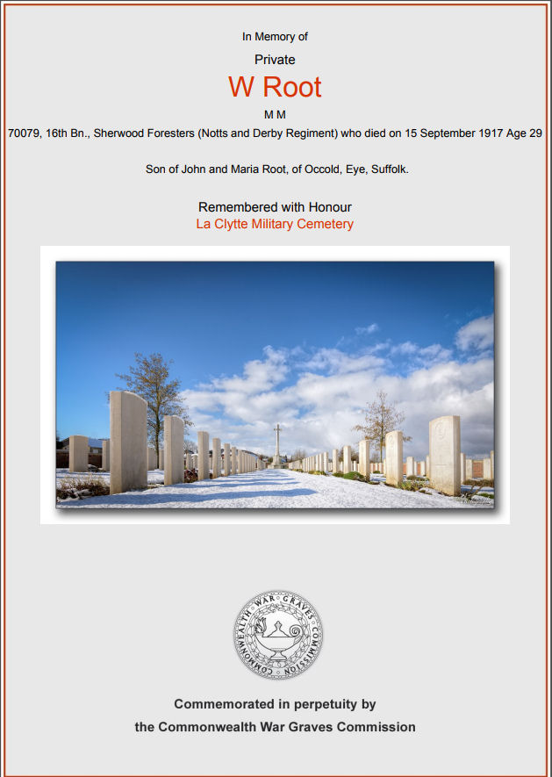
Self
William was born 1888 in Occold to parents John Walter ROOT and Maria S ELVISH, the youngest of 8 children. He had 6 sisters - Elizabeth, Sarah, Jane, Ann, Kate, Bessie and 1 brother John. In 1891 he was living in Bedingfield Rd before moving to Mill Road in 1911 and working as a farm labourer.
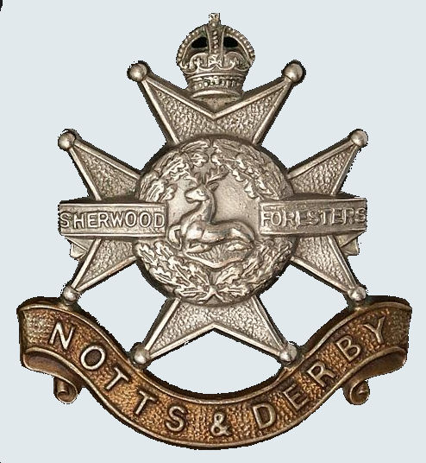
In 1917, he joined the 16th Battalion (Chatsworth Rifles) of the Sherwood Foresters (Notts & Derby Reg), Service no 70079.

On Saturday, 15 Sep 1917, he was KIA and is commemorated at La Clytte, West-Vlaanderen, Belgium, Grave No II. D. 4.

He was awarded the Military Medal for his gallant action on the 13th November 1916 in the attack on St. Pierre Divion after entering the German trench system. This marked the beginning of the end of the battle of the Somme.

Details from his Battalion’s War Diary for that attack are shown at Annex A.

Promulgation of his award in the London Gazette is shown at Annex B.

He was unmarried at the time of his death so leaves no direct descendants. Unlike many on the Roll of Honour, he is not related to any of the others KIA.

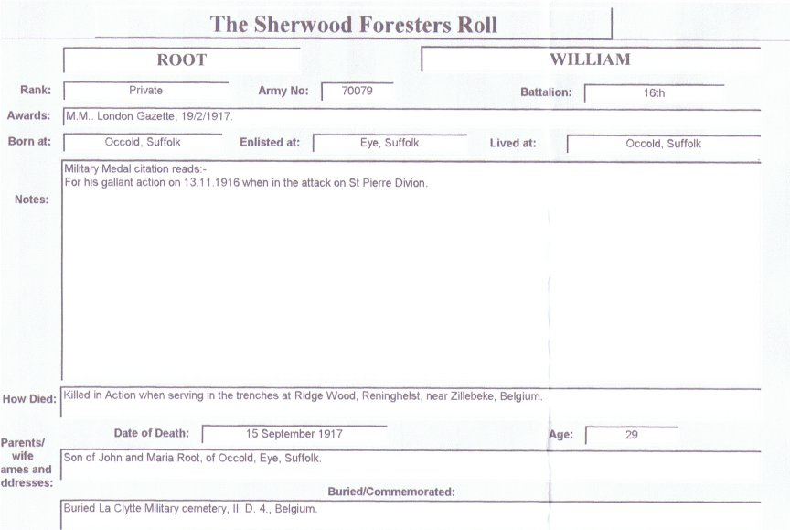

Military Medal - Ribbon colours from left to right are BLUE, WHITE, RED, WHITE, RED, WHITE, BLUE

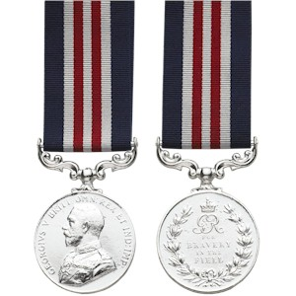

Parents: John Walter ROOT and Maria Sophia ELVISH
John Walter was born 1845 in Occold, son of Walter ROOT and Jane (Jemima) SALTER. He lived in Occold until age 15 before getting being an ag lab in Calveston, Norfolk after his parents moved there – reason unknown but possibly because work was easier. After getting married in 1867, they moved back to Occold and by 1871 were living in Mill Rd, Occold and continuing to work as an ag lab.

He and Maria had 8 children (Elizabeth, Sarah, Jane, Ann, Kate, Bessie, John over William) over a 20 year period, fairly typical of the time. Note - going back over 2 previous generations, the ROOT’s had families with a pre-dominance of girls as far back as the late 1700’s. They also moved around Occold a few times, living at Mill Rd, then ‘near White House’, Bedingfield Rd and back to Mill Rd.

He passed away in 1908 aged 63 and is buried in Occold but no known grave.

Maria Sophia was born 1847in Dovercourt, Essex to parents Daniel ELVISH and Maria GANT. She lived in Dovercourt during her youth but eventually went to work as a dairymaid in Yaxley at age 14 and where her father was a farmer of 69 acres.

She was still living in Occold in 1911 before passing away in 1917 aged 72 years – buried in Occold but no known grave.

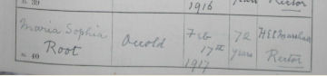
Burial Register entry for Maria signed by The Rev Herbert Edward Champion MARSHALL, Rector of Occold (1908 – 1939)
Paternal Grandparents: Walter ROOT and Jane SALTER
Walter was born 1818 in Occold to parents John ROOT (abt 1791 – 1851) and Sarah THROWER (1789 – pre-1837). We know little about his early life except that he moved to Calveston, Norfolk as an ag lab by 1861. From there, he moved to Brome in 1871 and ended up in Braiseworth Rd, Eye in 1881.

There is a little clue here as, in 1881, his next door neighbour was Harry POTTER, age 30 from Bacton, described as the Engine Cleaner and lived in the Engine Shed, Railway Yard, Eye – part of the ill-fated Mid Suffolk Light Railway. Walter continued to work as an ag lab until his death in 1896.

During their lifetime, Walter and Jane had 5 (known) children between 1845 and 1856 – John Walter, Samuel, Sarah, Ann and Elizabeth.

Jane was born 1820 in Kenninghall, Norfolk to parents John SALTER and Jemima BETTS. But she was not baptised until 18 Oct 1839 so presumably her parents were members of a Non-Conformist Church – fairly usual at the time.

She remained in Kenninghall until she somehow met and married Walter but how they met will never be known! Following Walter’s death in 1896, she moved back to Norfolk where she passed away in 1898 aged 78 years – possibly ending her years living with one of her children which is what normally happened.
Maternal Grandparents: Daniel ELVISH and Maria GANT
Daniel was born 1816 in Ramsey, Essex to parents John ELVISH (1789 – 1851) and Sarah UNKNOWN (1790 – 1844). In 1851, he is shown as a gardener living in Dovercourt but by 1861 he is a farmer of 69 acres in Yaxley employing 1 man (his son-in-law) and 1 boy – a surprising upgrade in status as farmers tended to be in the higher affluence classes.

He continues to progress and is shown as a farmer in Yaxley in 1871, this time with 77 acres. He continues as a farmer in Wilby in 1881, in Kelsale in 1891 and in Saxmundham in 1901 – so he moved around a bit! He passed away in 1910 aged 94 but surprisingly left no probate to determine his wealth – so was probably just a successful tenant farmer.

He married Maria GANT (born 1818 and daughter of John GANT and Mary) in 1840 in Dovercourt and they had 9 children Maria, Sarah, Thomas, Harriett, Elizabeth and Eliza all born in Dovercourt and then Jane and William in Yaxley. Notice again the predominance of 6 girls to 3 boys which seems to have run through the family.

She passed away in 1890 aged 72 years.
Annex A – Battalion War Diary
According to orders the Battalion marched from MARTINSART WOOD to the LEFT RIVER ANCRE SECTION.

CAPTURE of St. PIERRE DIVION. On November 13th the Battalion was ordered to make a subsidiary attack from the South up the River ANCRE in conjunction with a main attack by the 118th Infantry Brigade.

The objective of the Battalion was a line running east from the SUMMER HOUSE and short of St. PIERRE DIVION. The 4/5th Black Watch were to join up with us from the East. The 1/6th Cheshire Regt. were to capture St. PIERRE DIVION. The main attack was to start at 5.45am.

The 16th Sherwood’s were to advance with three Companies at 6.13am - one Company being left in Reserve. A Tank was to co-operate on our right.

The assembly was successfully carried out without incident and the troops advanced at the scheduled time in a thick mist.
The Battalion successfully entered the German First Line trench, but here met with a certain amount of opposition and the right was held up.

At 6.30 a.m. the reserve Company was sent up to reinforce the right. Their arrival helped to clear the situation and the Battalion advanced bombing and driving the enemy before them into their dugouts.

The Objective allotted to the Battalion was secured but nothing could stop our men, who advanced with the greatest dash and finally secured the whole of St. PIERRE DIVION including the German Battalion Headquarters and the famous tunnel dugouts.

A party under 2nd Lt. A.HOLLAND continued their advance as far as the HANSA LINE joining up with the 1/1st Herts Regt on the extreme right of the 118th Brigade.
At 8.15 a.m. owing to our running short of bombs and to so many men being required to guard the entrances of dugouts and guard prisoners, a Company of the 17th Sherwood Foresters were sent up to this Company and rendered most useful assistance. By 9 o’clock however the whole position was in our hands and there remained only to clear the dugouts of prisoners.

At 9.15a.m. Battalion Headquarters moved forward to the German Battalion Headquarters taking with them two more Companies of the 17th Battalion Sherwood Foresters to consolidate the line.

13 Officers including the Battalion Commander and 720 other ranks were taken prisoners.

Our casualties were slight and consisted of Lieut. S.G. BURCH and 4 Other Ranks were killed. 67 Other ranks including Company Sergeant Major J.H. ROBINSON wounded.

The 1/1st HERTS. Regt. lost direction to the right and took no part in the capture of the fortress.

The 4/5th BLACK WATCH lost direction in the mist and only two Officers and 10 men arrived at their objective. This party rendered useful assistance.

The Tank arrived at the German Front Line before its scheduled time and unfortunately subsided into a dugout and was put out of action.

Many fine feats were performed by the Battalion notably by:-

Captain R.L.ILLINGWORTH who with his orderly entered the famous tunnel dugout and brought out 81 Germans. It was necessary to advance 150 yards down this deep tunnel to reach the dugout where the enemy had taken refuge.

2nd Lieut. HOLLAND who advanced with great dash and secured the German Battalion Headquarters and took prisoner the German Battalion Commander and 60 Other Ranks.

Sergt. Cook. C MONKS who despite his 56 years entered a defended dugout single-handed and brought out 6 prisoners.

Many other Officers, N.C.O's and men performed feats of exceptional gallantry which have been brought to the notice of Higher Authority.

At 9.30 a.m. we started to dig in a new line and to consolidate the position. A large amount of booty fell into our hands but it was not possible to enumerate it.

The Battalion was relieved at 7.l 5p.m. and proceeded to PAISLEY AVENUE. It may be stated that the 4 assaulting Companies attacked each about 90 strong. The wire was admirably cut by our artillery, and the barrage of the 85th Battery 18th Division was beyond all praise.

The Battalion's war diary also records an entry for 15th September 1917 as follows:

The Battalion was relieved by the 13th Battalion Royal Sussex Regiment and proceeded to the Bivouac Camp N.6.d (Sheet 28) near Ridge Wood, Reningheist, near Zillebeke, Belgium.
Casualties - O.R. 1 Killed, 4 wounded, 2 missing.

The 1 Killed was Private William ROOT who died whilst leaving the trenches.

Annex B – London Gazette 19 Feb 1917

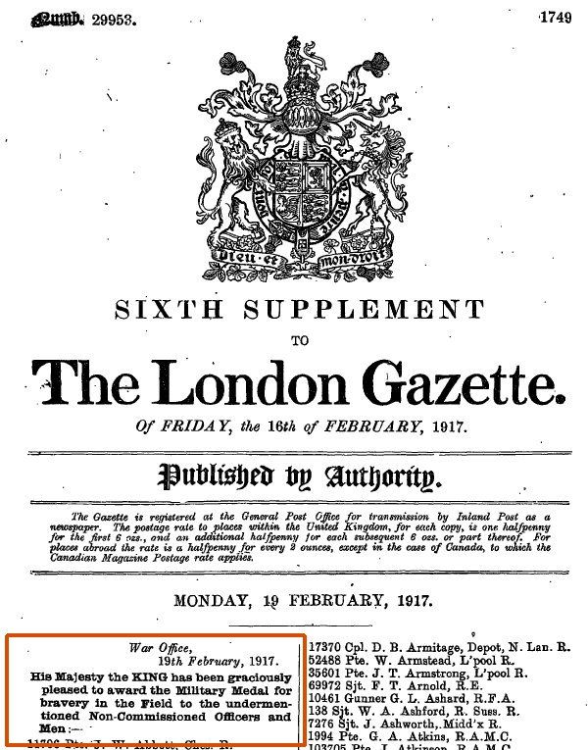
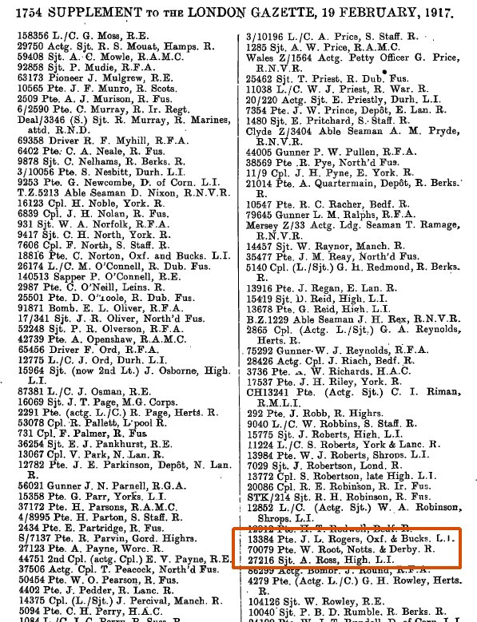
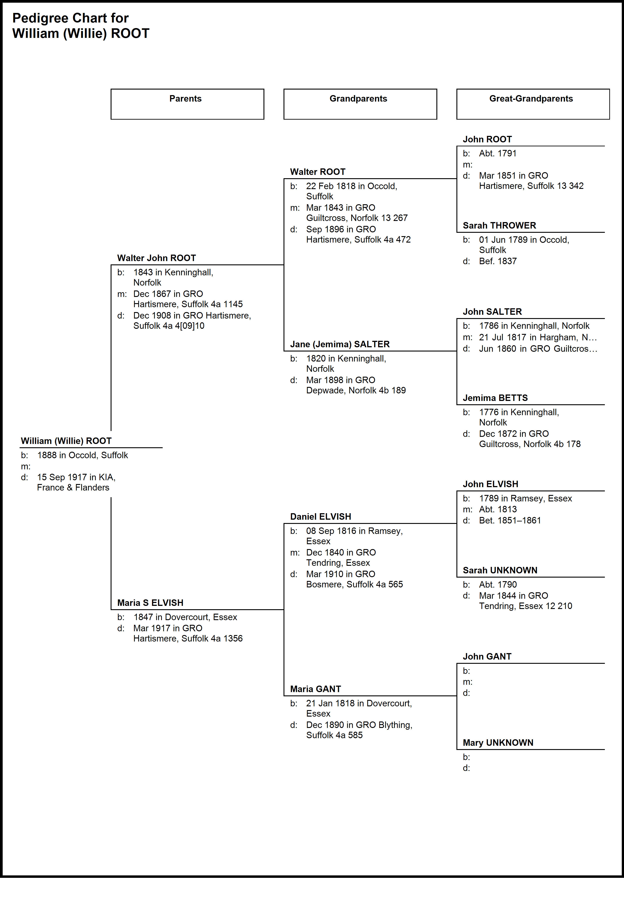
Pte Nicholas Herbert TODD
- 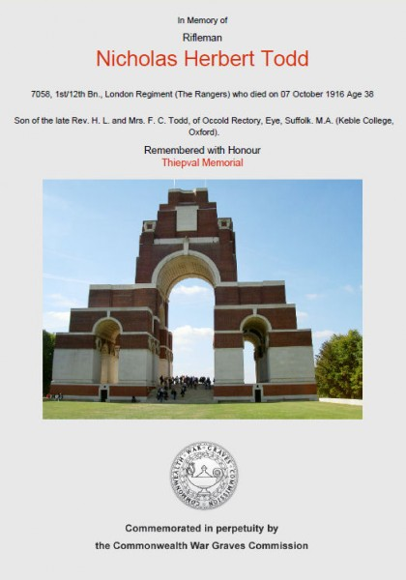
Tribute

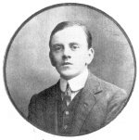
As the son of the Rector of Occold, Nicholas would have had a privileged upbringing as indeed it was.
He was educated firstly at Felsted, Essex and then gaining an MA at Keble College Oxford. After leaving Oxford in 1901 he devoted his life to education and became an exceptional schoolmaster first at Balham in London and finally at Sedbergh Preparatory School in North Yorkshire.
He was a poet and a playwright in keeping with the self-effacing man that he was. He never intended that his poems and plays should be published beyond the school, but after his death his school collected and published them as a tribute to a man small in stature but large in talent and love of children. When NHT enlisted in the summer of 1916 his headmaster wrote:
“We have also lost a very good friend in Mr Todd, who had felt it his duty to join the army and was at Winchester training for something that he entirely unfitted”.
His life ended tragically young on the Somme in the winter of 1916.
The Sedbergh School Obituary
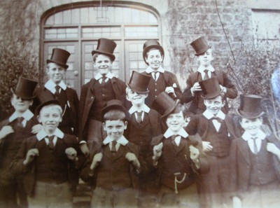
Sedbergh Prep School Pupils c1895
Here and there in the world is found a man who seems to bear a mysterious passport to the intimacy of children. For him the barrier of age does not exist: consciously or unconsciously he is as though in his own passage through the house of childhood he had hit on some hidden door that opened upon a garden of rare delight: and whilst his companions had passed ere noonday far beyond the walls of that fair place, evening had found him still wandering there, content to ask no other home for all his days, if only the happiness be his of welcoming to the wonders of that garden some few fortunates at least of that daily succession of children.
Such a one was Nicholas Herbert Todd. What his life had been before he came to Sedbergh - save that he wore on his blazer the arms of Keble College, and spoke of Suffolk as a native - we did not know, nor did it occur to us to wonder; It was scarcely conceivable that he could ever have done other than teach small boys to call wild flowers by their names, to write painful Latin elegiacs, to love the becks and the fells, birds and beast, the satire of Gilbert and Sullivan, the human sympathy of Dickens.
For all this was something more to him than a profession, a thing to be laid aside in leisure hours. His long days work was devoted to boys; how much they claimed of his idle thoughts will appear in these pages: for this whimsical little play was conceived, that naïve little verse was scribbled down, in the odd moment before a French lesson, or in the brief hour of freedom after lights out.
So when in his eleventh year at Sedbergh, the war claimed this gentle and vivacious little figure, with the merest shrug of the shoulders he gave a Childs uncomprehending obedience to that authority which banished him from his comrades of a lifetime. After a few months training at Winchester he crossed to France in the autumn of 1916 and fell on October 7th, a rifleman in the Queens Westminsters.
A Tribute from a Schoolmaster Colleague
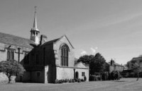
I think there must be strange delightful stir
Along the flower-girl ways of Paradise
As each hour brings another sojourner
Earth-dusty still and redolent with sighs.
All breathless with a gratified surprise.
So surely in the moment that you died,
There must have passed a flicker of the news
Along the stirring sun-swept avenues;
And as you came, with quick and impulsive stride
And deprecating smile, wild to deride
The fluttering acclamations that would rise
From all the waving trees, and nodding grass,
I fancy through the shade the word would pass
“This man knew joy and grief, was wise
Where others stumbled, loved the fragrant earth
And flowers and winds and quiet Autumnal skies;
He gave men laughter, nursed the frailest birth
Of fancy-joyed in comradeship: his mind
Was quick in mystery, pondered in the shade,
Loathed war and cruelty - was unafraid.”
And as the whisper passed, the dreaming ways,
Perchance, awoke as magic; all your days
Came hurrying with phantom feet, to bind
A wreath of flowers on your reluctant head.
I like to think how you, who loved not praise,
Endured the welcome of the clear-eyed dead.
Bronze Plaque in Ss Michael & All Angels
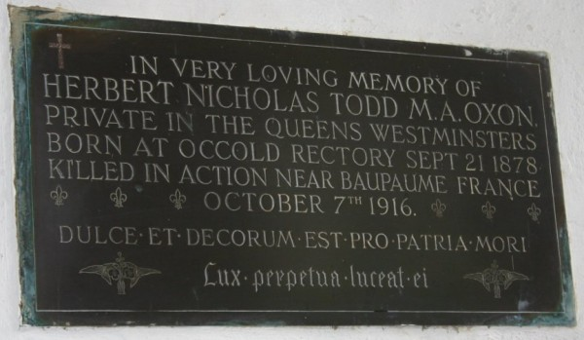
IN VERY LOVING MEMORY OF
HERBERT NICOLAS TODD M.A. OXON.
PRIVATE IN THE QUEENS WESTMINSTERS
BORN AT OCCOLD RECTORY SEPT 21 1878
KILLED IN ACTION NEAR BAPAUME FRANCE
OCTOBER 7TH 1916
DULCE ET DECORUM PRO PATRIA MORI ⁽¹⁾
LUX PERPETUAL LUCEAT EC ⁽²⁾
His Poetry
During his time of training at Hazeley Down, Winchester he still found time to write his poetry
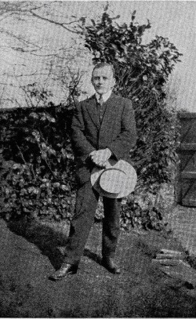
Dear Geoff I wonder if you'd like to be
A soldier of King George, the same as me.
To live in Huts arranged in long straight rows,
Or if you'd rather, call them Bungalows.
Your bed, three boards, on which you rest at night,
Which you're required by order to keep white.
To rise at six-or usually much later
And wash, and dress, and shave at such a rate, a
Bedroom at the P.S.S. would hardly equal,
Then marching; about for hours as a sequel.
To listen to advice from N.C.O's
How to stick bayonets inside your foes,
And many other military jaws,
And all the mysteries of forming fours.
A change indeed from that old room I sat in
Trying to teach the elements of Latin,
And bringing boys, whose names I will not mention,
In army parlance " to strict attention."
I hope when I return, if e'er I do,
You'll know your Latin Grammar all right through!
And have no trouble, when I am a civvy,
In reading off at sight a page Livy.
Meanwhile I wander sometimes up and down,
Along the ridges circling, Winton Town
Finding the orchids bending to the breeze,
Or lying on the wild thyme at my ease,
Or hearing ill the Minster's giant pile,
The throb of glory thrilling up the aisle,
And Dreaming of the Princess Who, years past,
Built their memorials, and only asked
Those who came after just one prayer to say
For those who went into the eternal day
For ever, where the tracery of I heaven
Lets in the light from all file planets seven.
And so farewell much love, and may we meet,
Where the swift Rawthey splashes round the feet
Of laughing boys, and Winder's dear old crest
Catches the sunlight dying in the West.
And laden with the spoils, the P.S.S.
Return with shouting in the usual mess.
Now I am a Tommy, a soldier of the King,
I find my muse, my rhythmic muse, most disinclined to sing,
It doesn't foster poetry, this everlasting drill,
Nor can I write a single line when doubling up a hill.
If you've slept between rough blankets in an army “bungalow”
And hear each morn at 6 O'clock the beastly bugles blow
And get ticked off on parade for spots upon your belt,
You certainly enjoy some things the poets never felt.
I cannot well Imagine Old Homer forming fours,
Nor Vergil at his post all night Guarding, the O.S. stores,
Nor Tennyson or Swinburne writing a pretty trifle
Upon the various beauties of the new Service Rifle.
If Hood had cleaned a boiler out or spent three hours in scrubbing
Or Shakespeare had to do his boots with special army dubbing,
I know that they'd have found their muse exceedingly retiring
Horace had never made a name for verse at rapid firing!
There is no Inspiration in the peeling onion "stunt",
Nor can you feel poetic when "looking to your front"
A heavy pack, a dusty road, a burning summer sun
Suggest my course to Helicon is very nearly run.
But if at last the day will dawn, when I can wear a tie,
And in the dust of memory my jagged putties lie,
When I return to civil things and have a decent meal
Perhaps I shall be able to write down all the things I feel.
Conclusion
In the last verse of his poem Memories he looks forward to a time when he will be able to return to his life and write what he was feeling. He never returned and he never wrote of his feelings.
He is commemorated on our memorial but his time at Sedbergh and his influence on the boys there will also be his memorial.
What follows are entries in the school magazine through the years showing his influence and interest in giving the boys at Sedbergh a full and rounded education.
- Mr Todd has to thank all of the boys very much for the microscope slides they gave him for his birthday (Dec 1912)
- At the prize giving Mr Todd's play ‘The King of Lazilee'. At the end there was enthusiastic applause, and Mr Todd was presented by each of the actors with a book for which he is truly grateful.
- At the Christmas concert ‘The harbour' was composed by Mr Todd, and set to music by Mr Thomas (Dec 1906)
- The prize giving play “The isle of Misogynists” was written by Mr Todd It was warmly cheered (Aug 1907)
- Mr Todd presented the museum with a few fossils of Suffolk clay found in Norsey Wood Essex (Apr 1908)
- Mr Todd showed us slides and talked to us about Rome (Apr 1910)
- With his play “The Luck of Idelnesse” Mr Todd provided us as usual with a very good bill of fare (Apr 1911)
- Mr Todd gave a very interesting lantern lecture on Astronomy (Dec 1911)
- Mr Todd gave a lantern lecture on Cornwall and Africa (Nov 1911)
- Mr Todd gave a very interesting lantern lecture on London (Apr 1912)
- Mr Todd gave a very interesting lantern lecture on history from Edward I - Richard III (Apr 1912)
From an article by Alan Moore
Self
Nicholas was born 1878 in Occold to parents Horatio Lovell TODD and Frances Catherine TODD. He would have been born at the old Rectory…..
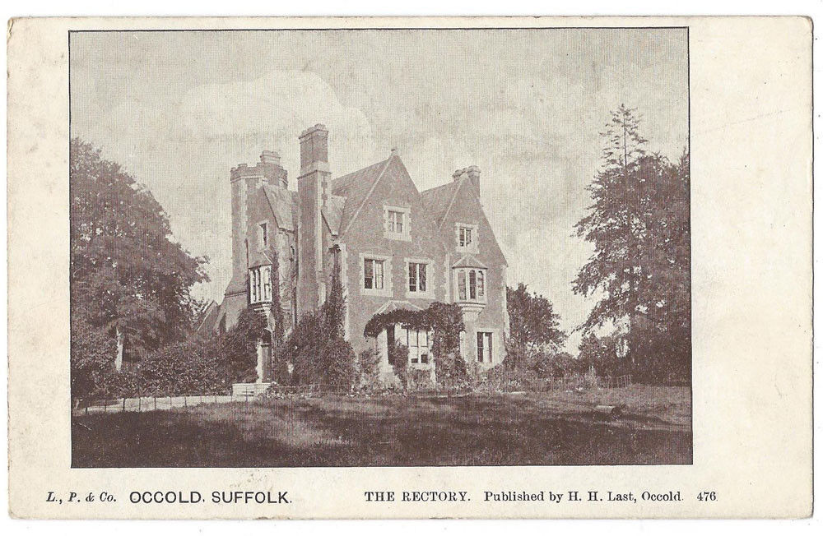
The Rectory was built in 1864 with 18 rooms. A smaller Rectory was built circa 1956 at which time the old Rectory passed into private hands. It was eventually demolished circa 1986 to make room for Old Rectory Gardens.

He entered Keble College, Oxford in 1897. 3rd History and B.A., 1900. M.A., 1904 before serving as a schoolmaster at 197 Bedford Hill, Wandsworth, Surrey. By 1911, he had moved to Sedbergh Preparatory School, Northumberland as an Assistant Master.

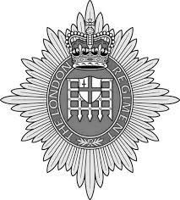
He enlisted at Richmond, Surrey in April 1916 as a Rifleman in the 16th Battalion, London Regiment; 12th (County of London) Battalion (The Rangers) serving in France.

Service number 7058 but was Killed in Action just 6 months later on Saturday, 7 Oct 1916. He is commemorated at Thiepval, France.

Probate shows he had effects of £1,448 9s 9d (£12,000 in 2017) to his executor George Vincent TODD, grain broker his brother.
Parents: Horatio Lovell TODD and Frances Catherine TODD
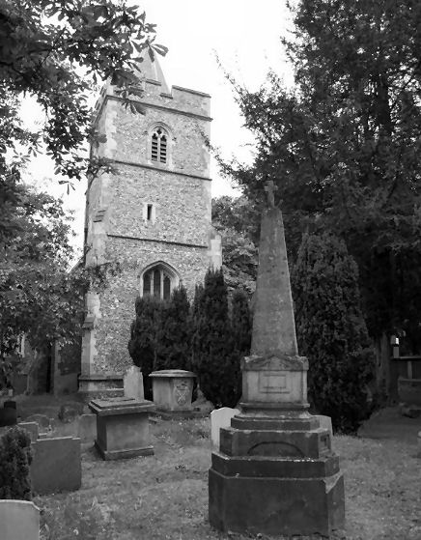
Horatio was born 1833 in Breage, Cornwall to parents Horatio TODD and Rhoda Maria BLUETT albeit we cannot find his whereabouts in 1841. In 1851, he was in Occold where his father was the Rector. He obvious continued in his father’s footsteps and was Curate at Armwell, Herts in 1861 (right).

He returned as Rector of Occold in1868 where he remained until his death in 1901. Note – He was actually living in Ealing, Middlesex when he passed away but was buried in Occold.

He married Frances Catherine TODD, born 1836 as a British Subject in the British Church in Riga, Latvia, Russia to parents John TODD and Frances HILL. Her father John and Horatio’s father Horatio were brothers which means Horatio and Catherine are first cousins.

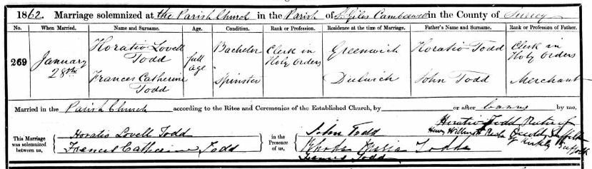
They were married 28 Jan 1862 at the Parish Church of St Giles Camberwell where he was described as a Clerk in Holy Orders. Frances was living in Dulwich and her father is shown as a merchant.

They were actually married by Horatio’s father Horatio, Rector of Occold in conjunction with Henry Williams. Rector of Kirkly, Suffolk.

She died 1908 in Occold at the age of 71. St Catherine's Hall (Old Reading Room) was erected in 1909 in memory of Mrs Frances Catherine TODD and she is commemorated on the Occold Village Sign.

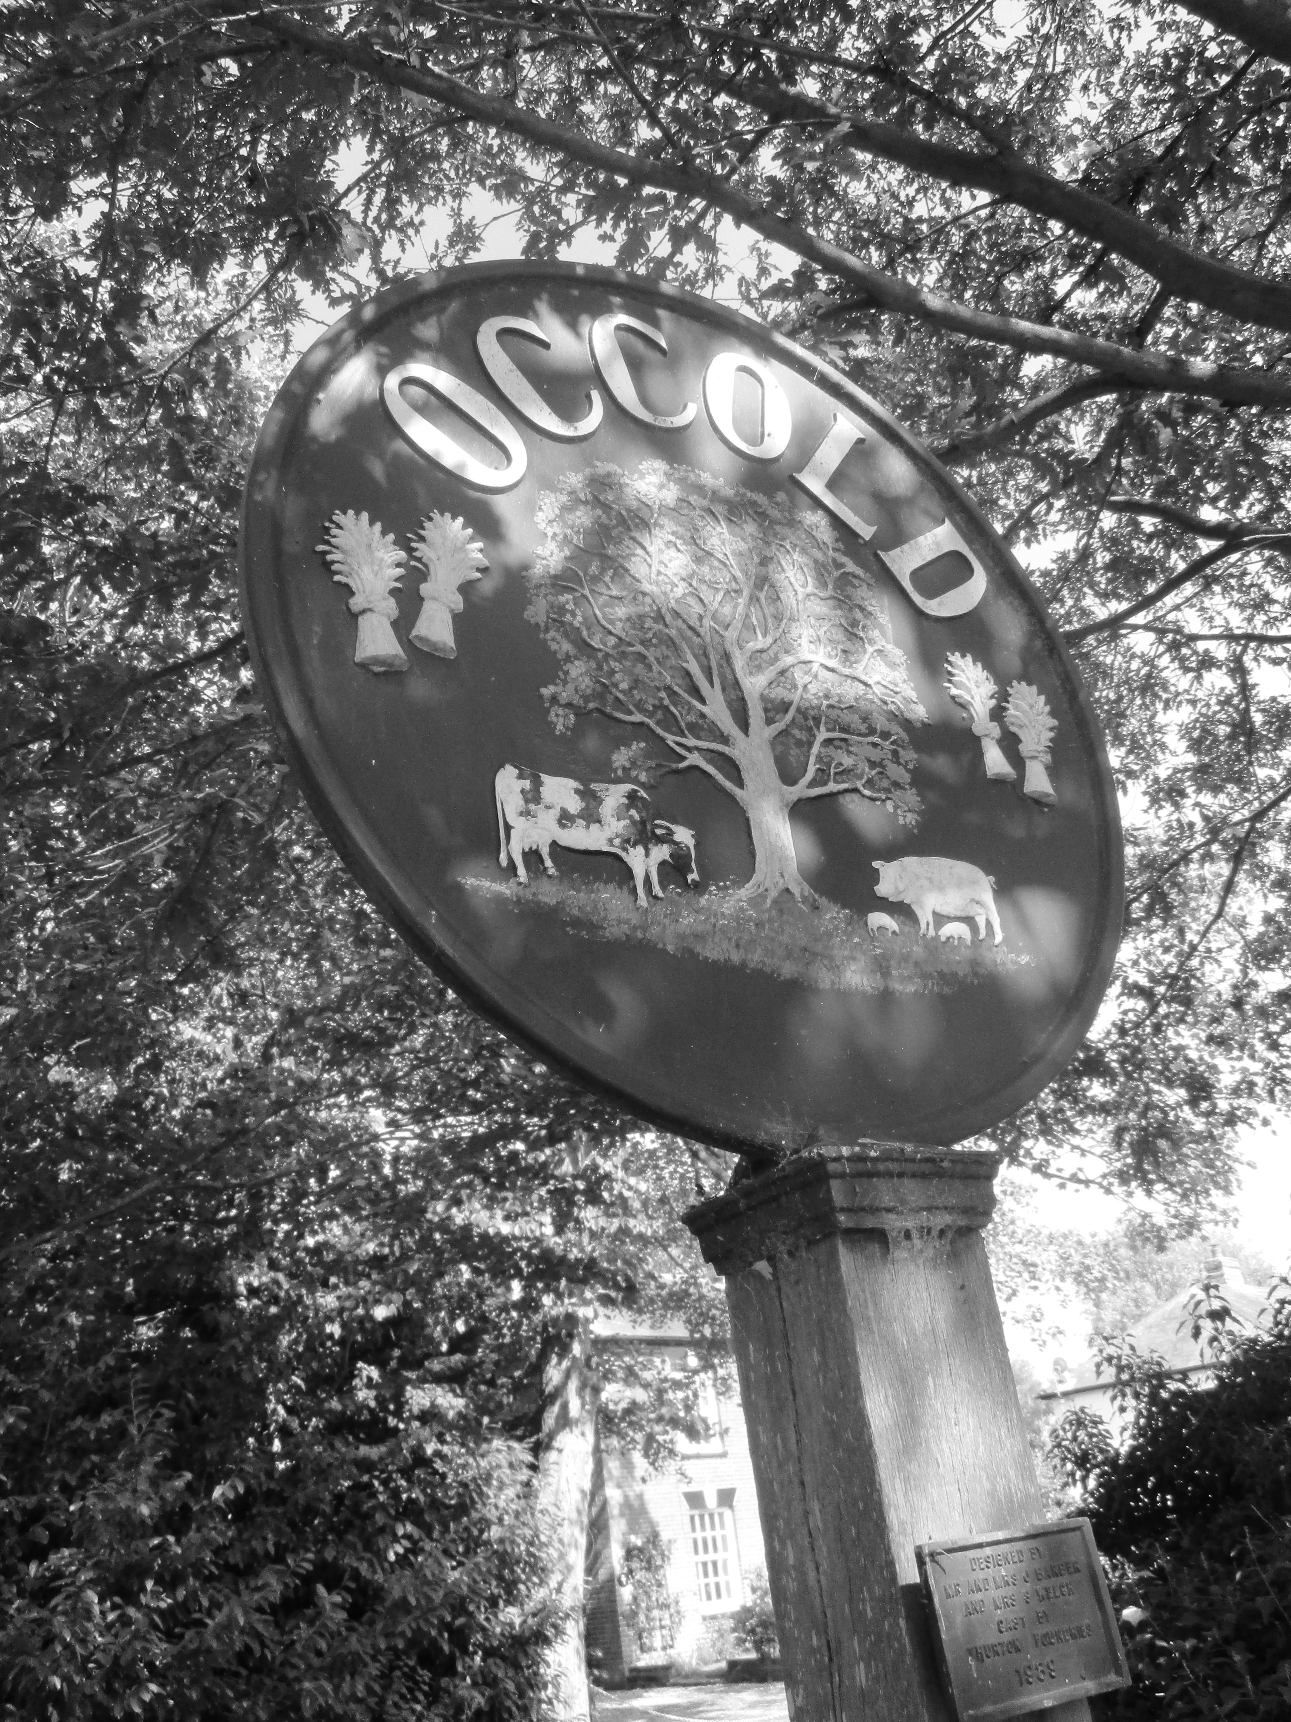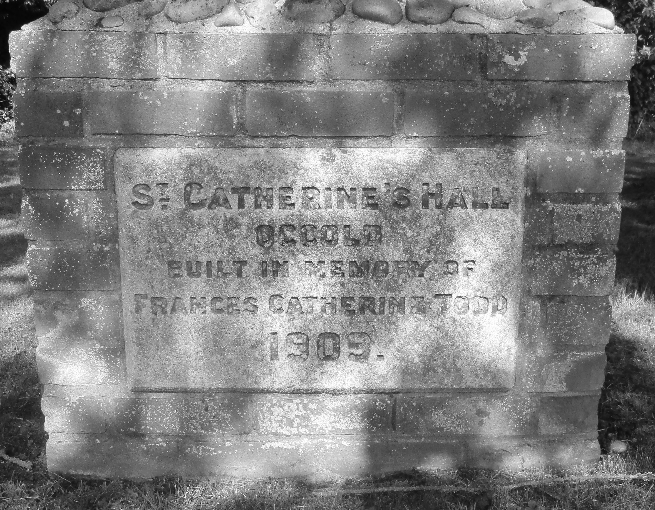
Paternal Grandparents: Horatio TODD and Rhoda Maria (Vigurs) BLUETT
Horatio was born about 1803 in Hampstead, Middlesex to parents George TODD and Sophia Helena Frederick STEGMANN. He became Rector of Occold in 1845 upon the death of the then incumbent, the Rev John WARD. There he remained until his death in 1868, buried in Occold.

He married Rhoda Maria BLUETT (parents of Rev Thomas Lovell BLUETT and Sarah VIGURS) in 1831 at Mullion, St Gluvias, Cornwall. From The Spectator, 12 Feb 1831, confirming his father as George TODD:

On the 3rd inst. at St. Gluvias, Cornwall, the Rev. HORATIO TODD, A.M. second son of the late George Todd, Esq. of Bellsize, Hampstead, to RHODA MARIA, youngest daughter of the Rev. J. L. Bluett, A.B. of Penrhyn.

They had 11 children - Rhoda Maria, Horatio Lovell, Helen Sophia, Elizabeth St Leger, Caroline, John Frederick, Thomas Lovell and Amelia. All of the surviving children lived at the Rectory until they moved en masse to 36 St James St, Chelsea, Middlesex including grandmother Rhoda Maria presumably after the death of Horatio. A bit surprising they didn’t remain in Occold Rectory where Horatio Lovell became the Rector!!

Rhoda died in London in 1870.

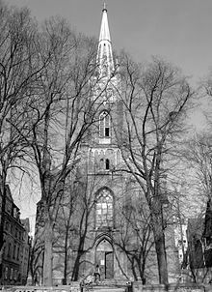
Maternal Grandparents: John TODD and Frances HILL
John was born 1807 Hampstead, Middlesex to parents George TODD and Sophia Helena Frederick STEGMANN – brother to Horatio Lovell. He married Frances HILL (parents of Nicolas HILL and Helena Lisette NIELSEN) in 1834 at the British Church, Riga, Latvia, Russia (left). Frances was born 1819 as a British Subject in British Church, Riga, Latvia, Russia.
In 1851, John was at a convention at the Scarborough Hotel, Leeds as a wine merchant. But Frances remained in Hampstead and described as a Gentlewoman.

They moved around quite a bit as they were shown in Dulwich Wood House, Camberwell, Surrey in 1861 – he is shown as a Russian merchant. In 1871, he was again a Russian merchant living at 1 Northwick Terrace (below), Marylebone, Middlesex but by 1881 he had moved to 5 Princes Mews, Marylebone, Middlesex. In 1891, he is still showing as a Russian merchant but living at 1 Honeyden, North Cray, Kent.

He passed away there in 1898. Frances lived at Walton-on-Thames, Surrey in 1901 after John’s death but died in 1904 at Groombridge, Carrs Lane, Hersham, Surrey.

Surprisingly, bearing mind they’re apparent wealth, neither left probate.

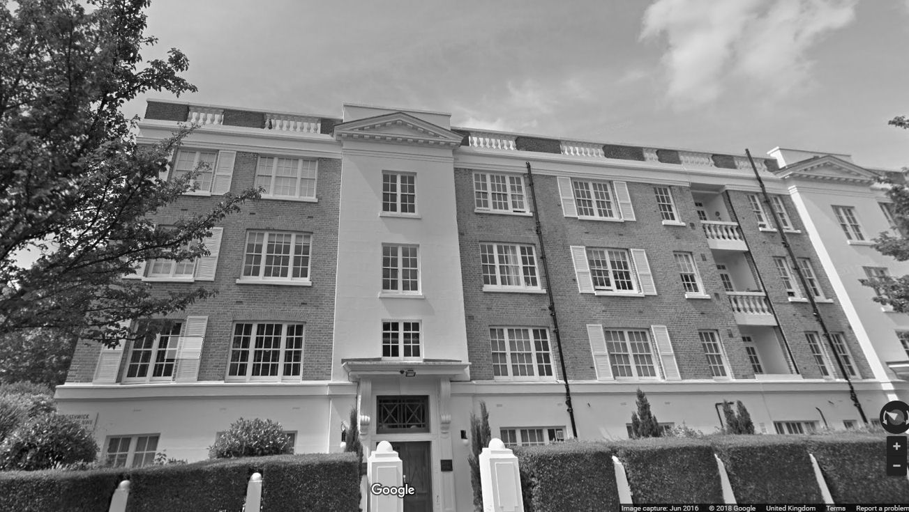
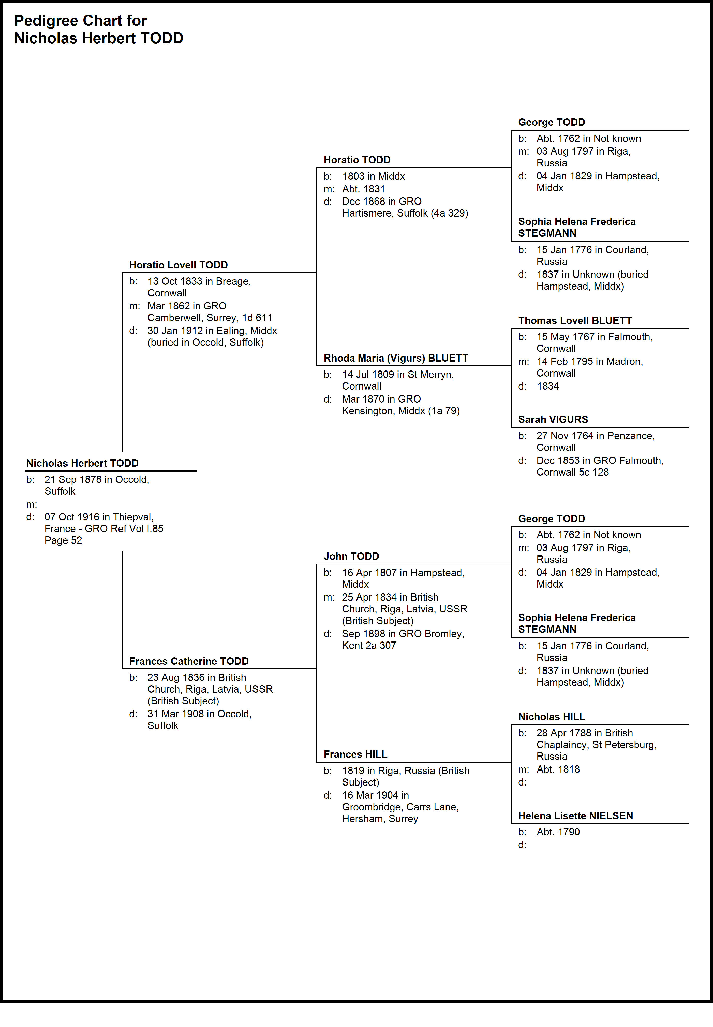

Sgt Frank Carter WOODS

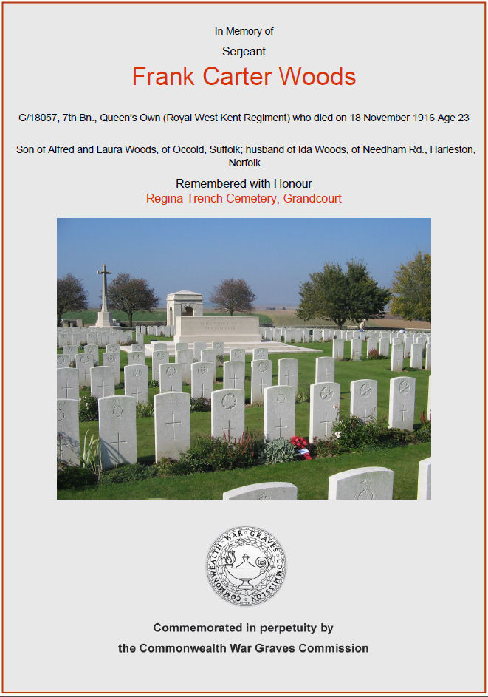
Self
Unlike the other names on the Roll of Honour, Frank Carter came from three generations of relatively affluent farmers and millers. So unlike the other names, he was not related to any of them.

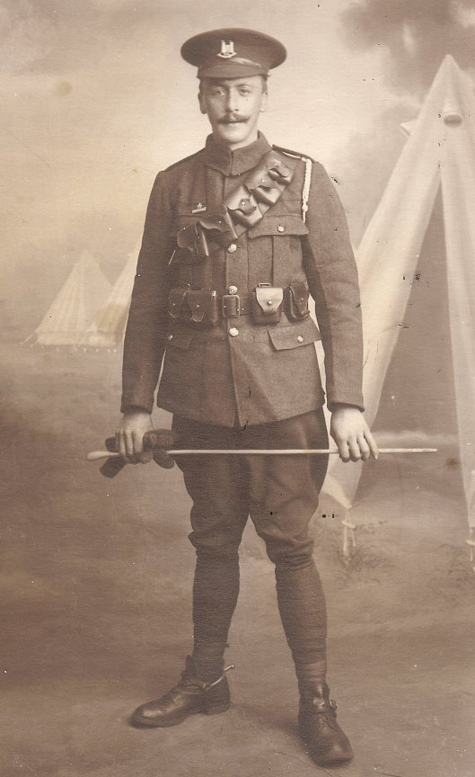
He was born 1893 in Denham to parents Alfred WOODS and Laura Ann CARTER and moved to live at The Cedars, Occold by 1901. In 1911, he had moved to White House Farm and was working on the farm for his father. He had siblings Charles William, Kathleen Mary, Beatrice Clara, Bilham Edward, Grace Edith, Alfred Arthur and Thomas Walter.

In mid 1916, just before he was KIA, he married Ida CUTTING and they had a daughter, Frances Ida who Frank was never to see as she was not born until Apr 1917.
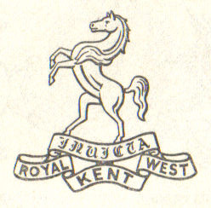
By 1916, he had enlisted in the 7th Battalion, Queen’s Own (Royal West Kent Regiment), service number G/18057 – his rank of Sergeant probably partly due to his family background. We’ve no information that he had any connection to Kent so maybe a strange choice? He was killed Saturday, 18 Nov 1916 in France, aged 23, and is commemorated at Regina Trench Cemetery, Somme, France, grave no II. A. 32.
Wife: Ida CUTTING
Ida was born 1894 whilst living at Church Farm, Eye where her father, William Copeman CUTTING and mother Alice Sophia PAGE were living. Prior to that, William was living at Castle St, Eye and described himself as a farmer and butcher.

In Jun 1916, she married Frank Carter just before he was KIA and their daughter Frances Ida was born 9 months later in 1917. She married again, but not until 1939, to Frederick Walter LOCKWOOD, a farmer from Thorndon. They had no children. Frederick had been previously married to Alice Agnes GARDINER in Thorndon and had 3 children – Derek, Sybil and Kenneth Aubrey. In 1940, Kenneth Aubrey married Ida’s daughter Frances Ida.
Parents: Alfred WOODS and Laura Ann CARTER
Alfred was born 1865 in Eye, the son of Isaac Tipple WOODS and Mary Ann BILHAM. They lived in Cranley Rd, Eye where he was working on his father’s farm up to the 1880’s. In 1891, he was a farmer in Denham before moving to The Cedars, Occold by 1901, again describing himself as a farmer. By 1911, he had moved to White House Farm (13 rooms) before moving to Benningham Grange by 1925. He passed away in 1939 but there is no record of his burial in Occold.

Laura Ann CARTER was born 1870 in Cotton to parents David CARTER and Drusilla LARTER. She spent her early years at the Railway Tavern in Cotton where her father was both a farmer and the innkeeper. Just before she married in 1892, she had moved with her parents to Street Farm, Wickham Skeith. She survived her husband by 14 years before passing away in 1953.
Paternal grandparents: Isaac Tipple WOODS and Mary Maria BILHAM
Isaac was born 1824 in Tibenham, Norfolk to parents Robert WOODS and Elizabeth TIPPLE, Norfolk farmers. By 1851, he had moved to Rishangles, where he was the miller and then to Cranley Rd, Eye by 1861 where he was the miller and maltster (brewer). By 1881, he was a farmer of 157 acres in Cranley Hill, Eye and by 1891 had retired as a farmer to live with his son at White House Farm. He died in 1903 leaving effects of £3,384 (£367,000 in today’s value). He married in 1860 to:

Mary Maria BILHAM was born 1837 in Banham, Norfolk, the daughter of James BILHAM and Maria TIPPLE. Note the surname – it is quite likely (but unproven) that Maria was the sister of Elizabeth TIPPLE , mother of Isaac. She spent her early years with her parents at New Buckenham, Norfolk where her father was a farmer and local grocer.

Isaac and Maria had children Alfred, Bilham, William, Thomas and James – all boys!
Maternal grandparents: David CARTER and Drusilla LARTER
David was born 1833 in Bacton to parents John Mayhew CARTER and Mary MAYHOW. He spent his early years with his parents originally in Bacton but then in Westhorpe where his father was a farmer of 117 acres. By 1871, he had moved to the Railway Tavern, Cotton where he was both innkeeper and farmer of 190 acres employing 9 men before going to Street Farm in Wickham Skeith. He died in 1897, location unknown but within the district of Hartismere. He married in 1865 to Drusilla and then re-married in 1888 to Mary Ann JACOB following Drusilla’s death in 1887.

Drusilla was born 1837 in Syleham to parents James LARTER and Ann (maiden name unknown). She lived with her parents in Church Farm, Fressingfield where her father was the farmer of 148 acres employing 4 labourers. She died in 1887 aged just 50.

David and Drusilla had children William John, Walter Edward, Herbert Thomas, Laura Ann, Ernest, Augustus and John.
Descendant: Daughter: Frances Ida WOODS
Frances Ida was born 1917 in Occold, In 1940, she married Kenneth Aubrey LOCKWOOD, son of Frederick Walter LOCKWOOD and Alice Agnes GARDINER, a farmer from Thorndon.

Fredrick Walter LOCKWOOD was, in fact, Frances Ida’s step father-in-law – since he married Frances Ida’s mother in 1939. So Kenneth Aubrey was her step-brother!!

They had two girls Nina and Madeline. Of interest is that Alice Agnes was born in Winfarthing, Norfolk – the birthplace of the MULLENGER brothers (George Fredrick and Charles Robert) who are commemorated on the Occold Roll of Honour.

Frances Ida passed away in 1983 in Yaxley just after moving into their retirement home. Kenneth Aubrey re-married in 1986 to Joan WRIGHT but passed away 2009 in Yaxley where he had become a prominent citizen.

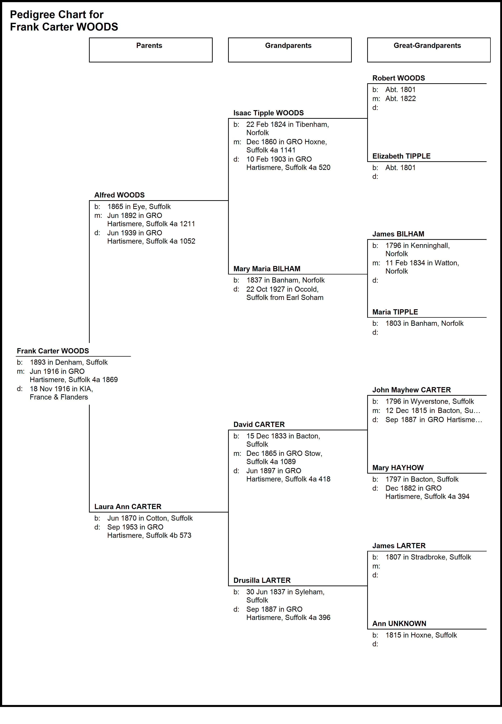

Pte William BROWN
With such a common surname, it has not been possible to pin down the right William with any degree of certainty.
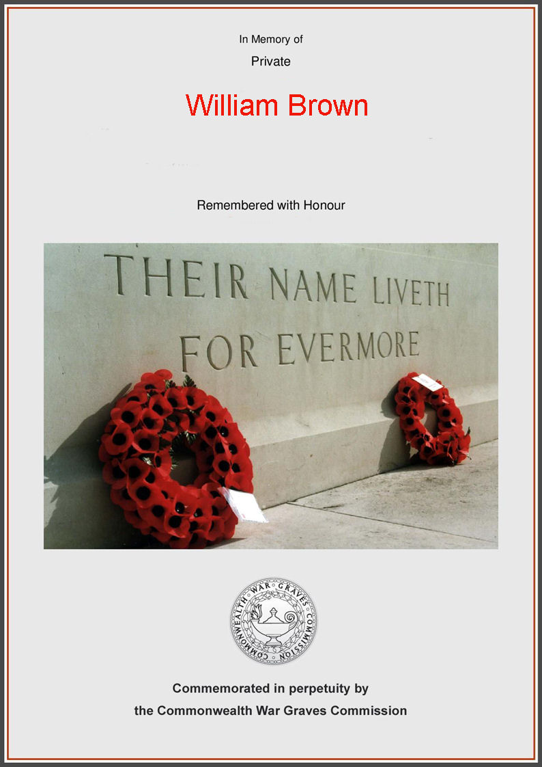
Pte Frederick William SMITH
With such a common surname, it has not been possible to pin down the right Frederick with any degree of certainty.

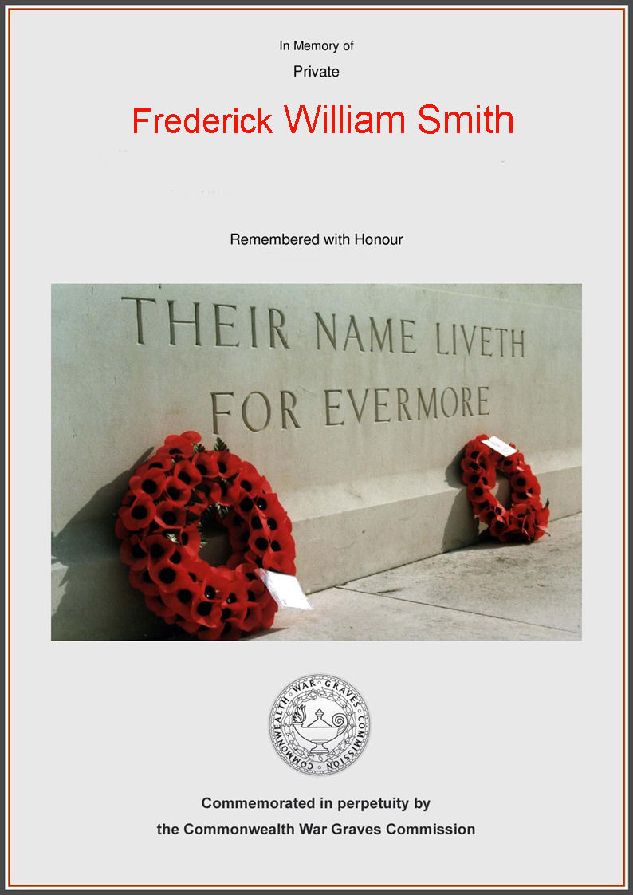
Index of Surnames and Place Names

ABBOTT 25
ALLUM 26
Armwell 87
Bacton 15, 74, 94
Badingham 15, 33
BAILEY 8, 42, 44
BAKER 12
Balham 81
BALLS 13
Banham 94
BANHAM 48, 65
BARHAM 20
BARNES 8, 37, 42, 44
Beaconsfield Arms 13, 58
Bedingfield 15, 19, 20, 30, 32, 33, 48, 72, 73
Benningham Grange 13, 93
Benningham Green 12, 13, 69
Benningham Hall 13, 51
BETTS 74
BILHAM 9, 93, 94
BISHOP 24
BLUETT 9, 87, 88
BOOTY 59
BOSWORTH 13
BOYCE 44
Braiseworth 15, 26, 42, 44, 59, 74
BREESE 13, 51
BREWSTER 64
Brome 15, 74
BROWN 6, 9, 96
BRUNDLE 13
Bulls Hall Rd 51
Bulls Hall Road 52, 55
BURROWS 12, 59
Calveston 73, 74
CANHAM 7, 30, 32, 33, 44, 47, 60
CAPON 13
CARTER 9, 60, 93, 94
CASON 8, 52, 59
CATLING 21
CHAMBERS 8, 55, 58, 59
CHAPMAN 8, 12, 19, 47, 48
Cotton 15, 93, 94
CRACKNELL 32
CUTHBERT 55
CUTTING 9, 93
Denham 15, 44, 93
Dennington 15, 69
DONALDSON 26
Dovercourt 73, 74, 75
Driffield 37
DYE 9, 69
EBBAGE 7, 32, 33
ELLIOTT 6, 7, 18, 19, 20, 21, 24, 43, 47, 51
ELVISH 9, 72, 73, 74
EVERSON 7, 13, 19, 20, 24, 26, 27
Eye 11, 12, 15, 19, 24, 25, 44, 52, 54, 58, 59, 69, 74, 93, 94
FAIRWEATHER 48
Felsted 81
FIELD 53
FISK 64
Framlingham 33
Fressingfield 15, 94
FULCHER 8, 65
Gallipoli 31
GANT 9, 73, 74, 75
GARDINER 93, 94
GARRARD 9, 68, 69
Gislingham 15, 20
GOOCH 13
GRAY 20
Grove Farm 13, 51, 55, 69
HADDOCK 6, 7, 23, 24, 25, 27, 43, 51
HAMMOND 6, 7, 8, 24, 29, 30, 31, 32, 43, 47, 48, 51
Hampstead 88, 89
Hartismere 10, 11, 15, 68, 94
HARVEY 8, 53, 54, 55
HASSAM 69
HAVERS 13
HILL 9, 87, 89
HINES 13
HUNT 6, 7, 8, 19, 24, 25, 26, 32, 36, 37, 40, 42, 43, 44, 46, 47, 48, 51, 53, 59
JACOB 94
Kelsale 74
Kenninghall 74
KERRY 8, 55
KNIGHTS 8, 51, 53
LARTER 9, 93, 94
LAST 8, 13, 42, 44, 51, 53
LENNY 53
LISTER 6, 8, 24, 37, 43, 44, 50, 51, 52, 53, 54, 55, 69
LOCKWOOD 93, 94
LOVET 25, 44, 48, 53
Malta 31
MARSHALL 12, 13, 40, 74
MARTIN 8, 58, 59
MAYHOW 94
Mill Road 54, 64, 72
Mill St 47, 53
MILLER 12
MILLS 6, 8, 13, 24, 43, 51, 57, 58, 59
Monk Soham 15, 19, 20, 48
MOORE 13
MOYSE 13
MULLENGER 6, 8, 62, 63, 64, 65, 94
Mullion 88
MUTTOCK 55
NIELSEN 89
Occold 2, 3, 6, 7, 10, 11, 12, 13, 15, 19, 20, 21, 24, 25, 26, 27, 30, 31, 32, 33, 37, 38, 40, 42, 43, 44, 47, 48, 51, 52, 53, 54, 55, 58, 59, 60, 64, 65, 68, 72, 73, 74, 81, 86, 87, 88, 89, 93, 94
OFFORD 26
OLIVER 13
Oxford 81, 86
Palgrave 15, 20
PALLANT 13
PALMER 13, 64
Parkeston Quay 31, 32, 47
PATRICK 12, 13
PECK 65
PENDLE 48
PLOWMAN 47, 52
POTTER 6, 8, 9, 64, 65, 67, 68, 69, 74
PRETTY 19
Red House Farm 68
Redlingfield 15, 37, 42, 44, 53, 54, 55
REYNOLDS 13, 42
Richmond 87
Rickinghall 55
Riga, Latvia 87, 89
Rishangles 13, 15, 19, 30, 31, 32, 47, 93
ROOT 6, 9, 37, 71, 72, 73, 74
RUDDOCK 53
RUSH 44
SADD 52
Salonika 31
SALTER 9, 73, 74
Saxmundham 74
Sedbergh 9, 81, 82, 85, 87
SELF 26
SHELDRAKE 19
Shelfanger 20
SHIP 33
SHULVER 13
SMITH 6, 9, 33, 97
South Walsham 33
Southolt 13, 15, 20, 55
STEGMANN 88, 89
Stoke Ash 15, 42
Stradbroke 15, 21
Syleham 15, 42, 44, 53, 94
TALBOT 26
Tannington 15, 69
Thandeston 20
The Bottles Inn 13, 25, 42
The Causeway 31, 32, 33, 40, 42, 47
The Cedars, 93
Thorndon 15, 19, 30, 31, 68, 69, 93, 94
THROWER 74
THURLOW 59
Tibenham 93
TIPPLE 93, 94
TODD 6, 9, 12, 42, 80, 83, 86, 87, 88, 89
TRASKE 59
TUFFS 9, 68, 69
Valetta 31
VIGURS 88
Walthamstow 32
WARD 7, 8, 32, 33, 48, 88
WARREN 7, 19, 20
WELLS 20
Westhorpe 15, 94
Wetheringsett 15, 26
White House Farm 13, 20, 93, 94
Wickham Skeith 15, 93, 94
WILDING 7, 24, 26, 60
Winfarthing 64, 65, 94
Witham 25, 26
WITTON 65
WOODS 6, 9, 13, 65, 91, 93, 94
WRIGHT 8, 60, 65, 94
Yaxley 15, 59, 73, 74, 75, 94



